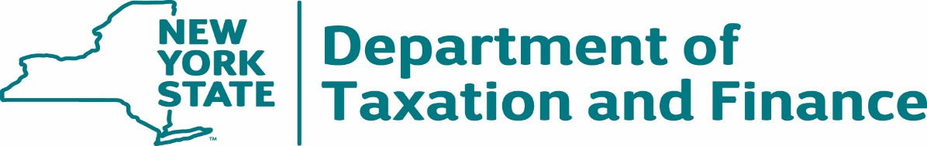

**INVITATION FOR BIDS**

|  |  |  |  |  |  |  |  |  |  |  |  |
| --- | --- | --- | --- | --- | --- | --- | --- | --- | --- | --- | --- |
| **BID DUE DATE:** | January 15, 2025 | | | | **TITLE**: | Rolled Check Stock | | | | **IFB #**: | 24-201 |
| **CONTRACT PERIOD:** | | | One-time purchase | | | | | | | | |
| **The bid must be fully and properly executed by an authorized person. By signing you certify your express authority to sign on behalf of yourself, your company, or other entity and full knowledge and acceptance of this INVITATION FOR BIDS, Appendix A (*Standard Clauses For New York State Contracts*) and all other appendices, attachments and exhibits and that all information provided is complete, true and accurate. By signing, Bidder also affirms that it understands and agrees to comply with the Department of Taxation and Finance (“DTF” or “Department”)** **procedures relative to permissible contacts as required by State Finance Law §139-j (3) and §139-j (6) (b). Information may be found at:** <http://www.tax.ny.gov/about/procure>. | | | | | | | | | | | |
| **Bidder’s Federal Tax Identification Number:**  *(Do Not Use Social Security Number)* | | | | | | **NYS Vendor Identification Number:**  *(See “New York State Vendor File Registration” clause)* | | | | | | |
|  | | | | | |  | | | | | | |
| **If applicable, place an “x” in the appropriate box (*check all that apply*):** | | |  | **NYS Small Business \*** | |  | **NYS Certified Minority Owned Business** |  | | **NYS Certified Women Owned Business** | | |
| ___ | **# of Employees** | |
| **Legal Business Name of Company Bidding:** | | | | | | | | | | | | |
|  | | | | | | | | | | | | |
| **D/B/A - Doing Business As (*if applicable*):** | | | | | | | | | | | | |
|  | | | | | | | | | | | | |
| **Street, City, State, Zip, County:** | | | | | | | | | | | | |
|  | | | | | | | | | | | | |
| **If you are not bidding, place an “x” in the box and return this page only:** | | | | | | | | |  | | | |
| **WE ARE UNABLE TO BID NOW BECAUSE:** | |  | | | | | | | | | | |
| **Printed or Typed Name:** | | | | | | **Title:** | | | | | | |
|  | | | | | |  | | | | | | |
| **Bidder’s Signature:** | | | | | | **Date:** | | | | | | |
|  | | | | | |  | | | | | | |

* Note: *A “New York State Small Business” is defined as a company that is a resident to New York State, independently owned and operated, with 100 or fewer employees, and not dominant in its field. There is no certification process to be considered a New York State Small Business.*

**TABLE OF CONTENTS**

**INVITATION FOR BIDS** 1

1. NOTICE TO BIDDERS - BID SUBMISSION REQUIREMENTS 3

2. SCOPE 4

3. SCHEDULE OF EVENTS 4

4. QUESTIONS/INQUIRIES 4

5. MINIMUM QUALIFICATIONS AND MANDATORY REQUIREMENTS 5

6. DOCUMENT TESTING REQUIREMENTS 6

7. DELIVERY 7

8. METHOD OF AWARD 8

9. FEES AND PAYMENTS 8

10. ADMINISTRATIVE REQUIREMENTS 9

11. GENERAL TERMS AND CONDITIONS 22

**APPENDICES**

Appendix A – Standard Clauses for New York State Contracts 25

Appendix B – Bid Protest Policy 32

**EXHIBITS**

Exhibit A – Detailed Specifications 36

Exhibit B – Check Stock Security Features 42

Exhibit C – Workforce Utilization Report 44

Exhibit D – New York State Office of the State Comptroller Substitute Form W-9 45

**ATTACHMENTS**

Attachment 1 – Bidder’s Checklist 47

Attachment 2 – Offerer Understanding of, and Compliance with, Procurement Lobbying Guidelines 48

Attachment 3 – Offerer Disclosure of Prior Non-Responsibility Determinations 49

Attachment 4 – Offerer Certification of Compliance with State Finance Law 139-k(5) 52

Attachment 5 – Plant Locations 53

Attachment 6 – Experience and Reference Form 54

Attachment 8 – Minority and Women-Owned Business Enterprises – Equal Employment Opportunity Policy Statement 56

Attachment 7 – [RESERVED]

Attachment 9 – Staffing Plan 58

Attachment 10 – Vendor Responsibility Response Form 60

Attachment 11 – Encouraging Use of New York State Businesses in Contract Performance 61

Attachment 12 – Vendor Assurance of No Conflict of Interest or Detrimental Effect 62

Attachment 13 – EO 177 Certification 64

Attachment 14 – Public Officers Law Form 65

Attachment 15 – Public Officers Law – Post Employment Restrictions 66

Attachment 16 – Contractor Sales Tax Certification Forms 67

Attachment 17 – Sexual Harassment Prevention Certification 68

Attachment 18 – EO 16 Certification 69

Attachment 19 – Bidder’s Financial Response Form 70

**IMPORTANT NOTICE TO POTENTIAL BIDDERS: Receipt of these bid documents does not indicate that the Department of Taxation and Finance has pre-determined your company's qualifications to receive a contract award. Such determination will be made after the bid opening and will be based on our evaluation of your bid submission compared to the specific requirements and qualifications contained in these bid documents.**

1. **NOTICE TO BIDDERS - BID SUBMISSION REQUIREMENTS**

Pursuant to the provisions of Article XI of the State Finance Law, sealed bids will be received by DTF at the address in **Section 1.4** for furnishing the items listed in this IFB. When submitting a bid, you must:

* 1. Prepare and submit your bid in accordance with this IFB and **Attachment 1, *Bidder’s Checklist***. This IFB and Attachment 1 outlines the terms and conditions, and all applicable information required for submission of a bid.
  2. Submit sample paper stock with the proposed water mark in accordance with the detailed specifications contained in **Exhibit A, *Detailed Specifications* and Exhibit B, *Check Stock Security Features***. The water mark design must be acceptable to the State.
  3. Submit detailed specifications, circulars and all necessary data on the product to be furnished. Failure to submit any of the above data may result in rejection of the bid.
  4. Mail the bid promptly to the address below for it to be received by the due date. Late bids may be rejected. E-mail and fax bid submissions are not acceptable and will be considered non-responsive.

Bids are to be mailed to:

Attn: Amber Alexander, Procurement Director

Procurement Services Unit

New York State Department of Taxation and Finance

W. A. Harriman State Office Building Campus

Albany, NY 12227

Please note, if you are using a delivery service, the bid response should be addressed to the Department’s campus address, but the delivery service should be instructed to deliver the bid documents to the following address:

90 Cohoes Avenue

Green Island, New York 12183

* 1. State "**BID ENCLOSED**" and record the **IFB Number (24-201)** and **Bid** **Due** **Date** on the envelope containing the sealed bid. Failure to complete all information on the bid envelope may necessitate the premature opening of the bid which may compromise its confidentiality. An improperly submitted bid resulting in a **LATE** **BID** may not be considered.

All amendments, clarifications, and any announcements related to this IFB will be posted on the Department’s website at: <http://www.tax.ny.gov/about/procure>.

It is the responsibility of the Bidder to check the website for any amendments, clarifications or updates. All applicable amendment information must be incorporated into the Bidder’s bid. Failure to include this information may result in the Bidder’s bid being deemed non-responsive.

1. **SCOPE**

Through this Invitation for Bids (“IFB”), the New York State Department of Taxation and Finance is seeking competitive bids from qualified Bidders (the “Offerer” or the “Bidder”) to produce and supply Rolled Check Stock in accordance with the detailed specifications outlined in this document.

Product specifications for the Rolled Check Stock are included in ***Exhibit A,* *Detailed Specifications*** and ***Exhibit B, Check Stock Security Features.***

1. **SCHEDULE OF EVENTS**

|  |  |
| --- | --- |
| December 11, 2024 | Issuance of IFB |
| January 3, 2025 | Deadline for Filing Offer Understanding of, and Compliance with, Procurement Lobbying Guidelines (**Attachment 2**) |
| January 3, 2025 | Deadline for Submission of Written Questions |
| January 8, 2025 | Department Response to Bidder Questions Posted |
| January 15, 2025  by 2:00 PM ET | Deadline for Submission of Bids/Bid Due Date |
| January 16, 2025 | Anticipated Bid Opening |
| January 22, 2025 | Anticipated Notification of Intent to Award |
| March 21, 2025 | Anticipated Start Date of Contract |

1. **QUESTIONS/INQUIRIES**

Prospective bidders should note that all clarifications and exceptions including those relating to the terms and conditions of the IFB are to be resolved prior to the submission of a bid. Bidders entering into a Contract with the State are expected to comply with **all** the terms and conditions contained herein.

Prospective bidders have the opportunity to submit written questions and requests for clarifications regarding this IFB. All questions regarding this IFB must be submitted by e-mail and received **by the date specified on the Schedule of Events**. Bidders are cautioned to read this document thoroughly to become familiar with all aspects of the bid. Questions should cite the specific bid section and page number and the bidder should indicate the name, address, telephone number and e-mail address of the individual submitting questions.

The Department will respond, in writing, to all substantive questions by the date specified in the Schedule of Events. All amendments, clarifications, bidder questions with the Department’s responses and any announcements related to this bid will be posted on the Department’s Procurement Opportunities website at:

<https://www.tax.ny.gov/about/procure/current-bid-opportunities.htm>.

It is the responsibility of the bidder to check the website for any amendments, clarifications or updates. All applicable amendment information must be incorporated into the bidder’s proposal. Failure to include this information in your proposal may result in the bidder’s proposal being deemed non-responsive.

3. 1. **DESIGNATED CONTACTS**

All inquiries concerning this bid solicitation must be addressed to the following Designated Contacts and issuing office:

Gabrielle Lansburg, Contract Management Specialist 2

Amber Alexander, Procurement Director

Phone No: (518) 530-4484

[bfs.contracts@tax.ny.gov](mailto:bfs.contracts@tax.ny.gov)

Contacting someone else may result in disqualification of the Bidder’s bid – please refer to ***Procurement Lobbying* (Section 10.2.12)** for more information.

**IT IS INCUMBENT ON THE PROSPECTIVE BIDDER TO NOTIFY THE DESIGNATED CONTACT(S) OF ANY TERM, CONDITION, ETC. THAT PRECLUDES THE VENDOR FROM SUBMITTING A BID.**

Any request by a bidder regarding changes in any part of the Contract must be made in writing to the Designated Contact(s) noted above, prior to the Questions Deadline noted in the above Schedule of Events.

* 1. **AFFIRMATION OF UNDERSTANDING OF, AND COMPLIANCE WITH PROCUREMENT LOBBYING GUIDELINES**

New York State Finance Law 139-j(6)(b) requires that the DTF seek written affirmation from all Offerers as to the Offerer’s understanding of, and agreement to comply with the DTF procedures relating to permissible contacts during a Government Procurement. Information related to the Procurement Lobbying Law and DTF guidelines can be found on the Department’s Procurement website at: <https://www.tax.ny.gov/about/procure/>. Offerers are required to sign and submit **Attachment 2, *Offerer Understanding of, and Compliance with, Procurement Lobbying Guidelines***, and are requested to do so by the date specified in the Schedule of Events.

1. **MINIMUM QUALIFICATIONS AND MANDATORY REQUIREMENTS**
2. 1. **MINIMUM QUALIFICATIONS OF BIDDER**

No bid will be considered unless the firm submitting the bid can meet the following qualifications. The Bidder must:

* + 1. Have successfully produced similar product with a volume of at least two (2) million checks within the last three (3) years:
* for a state or federal agency; and
* must have been check stock containing security features similar to those found in **Exhibit B, *Check Stock Security Features***;
* and must have been of Eccentric Z-Fold construction.

Bidder must list the organization(s) on **Attachment 6, *Experience and Reference Form***, including: Agency name, contact name and title, telephone number, e-mail address, contract term and volume;

* + 1. Be the original manufacturer of the Product and ensure the consistency of the Product; and
    2. Have a disaster recovery plant of manufacture to start production of the Product as specified herein within 24-hours of disaster. Bidder must complete **Attachment 5, *Plant Locations***, to indicate the plant location(s) where work is to be done.

**NO SUBCONTRACTING IS ALLOWED.**

* 1. **MANDATORY PRODUCT REQUIREMENTS**

Product must:

* + 1. Conform to the specifications outlines in **Exhibit A, *Detailed Specifications***;
    2. Meet all the Department’s security features on **Exhibit B, *Check Stock Security Features***.
    3. Any non-recycled or virgin content of proposed Product shall be derived from a sustainably managed renewable resource and certified as such through an appropriate third-party certification program recognized by the paper industry, such as the Forest Stewardship Council (FSC) or Sustainable Forestry Initiative (FSI) and Programme for the Endorsement of Forest Certifications (PEFC). Confirmation of compliance with this requirement should be attached to and submitted with the Bid.

**BIDS WILL BE CONSIDERED ONLY FROM BONA FIDE COMPANIES POSSESSING EQUIPMENT CAPABLE OF PRODUCING THE PRODUCT IN ACCORDANCE WITH THE SPECIFICATIONS DESCRIBED IN THIS IFB.**

1. **DOCUMENT TESTING REQUIREMENTS**

The Bidder selected for Award will be required to provide the Department with the following:

* 1. Three (3) sets of a colored proof for the Product in accordance with **Exhibit A, *Detailed Specifications*,** within ten (10) days of receiving the pdf file with a copy of the form from the Department (see **Exhibit A**); and
  2. Once DTF accepts the selected Bidder’s colored proof, it will notify the selected Bidder of such approval. The selected Bidder must then provide DTF with a sample test roll within 14 calendar days of receipt of DTF’s approval. The sample test roll must contain a minimum of 12,500 forms (two wide). DTF will advise the selected Bidder of roll orientation. DTF requires stock to test the registration of the form, MICR alignment, imaging capability; and check deposit functions (requires approval from the Bank Contractor responsible for deposits). Test documents will not be approved unless laser printing, folding sealing testing, and all other testing required by DTF has been successfully completed in accordance with the specifications outline in this IFB.

If DTF determines that the test rolls do not meet the IFB requirements, it will notify the selected Bidder of its disapproval and provide the selected Bidder with an opportunity to resubmit the test roll within 10 calendar days of the DTF’s notice of disapproval.

If the selected Bidder is unable to provide a sample test roll that meet DTF’s requirements, DTF may disqualify the awarded Bidder and begin testing with the responsive and responsible Bidder with the next lowest Total Bid Price.

1. **DELIVERY**

The Department has an immediate need for this product and requests an expedited delivery guarantee from the selected Bidder.

Guaranteed Delivery shall be indicated on **Attachment 19, *Bidder’s Financial Response Form*** and shall be expressed in number of calendar days required to begin making delivery after receipt of Department approval of the colored proof. Delivery is requested to begin no later than 60 calendar days after receipt of approved production sample test stock. The Department will accept partial deliveries.

If shipment will not be made within the Guaranteed Delivery date stated on the Bidders Financial Response Form, the Contractor is required to notify DTF in writing at least two weeks prior to the latest date of the original delivery obligation. This notification must include the reasons for the delay and the latest date the items will be shipped. Should the delay be not acceptable to DTF, appropriate Contract default proceedings will be initiated. Failure to supply timely written notification of delay may be cause for default proceedings.

All correspondence for the aforementioned shall be directed to:

ATTN: Amber Alexander, Procurement Director

New York State Department of Taxation and Finance

Bureau of Fiscal Services

Procurement

Building 9 Room 234

W A Harriman Campus

Albany, NY 12227

Deliveries will be accepted only at the DTF Printing Facility, 90 Cohoes Avenue, Green Island, NY 12183 between the hours of 7:00 A.M. and 2:00 P.M. Monday through Friday except on New York State and legal holidays.

Contractor is to notify the DTF Printing Facility at [PMCU-GREEN.ISLAND@tax.ny.gov](mailto:PMCU-GREEN.ISLAND@tax.ny.gov) at least 48 hours in advance of an anticipated delivery. The purchase order number assigned must be on all invoices, packing slips and bill of lading.

Additional Delivery information is contained on **Exhibit A, *Detailed Specifications***.

1. **METHOD OF AWARD**

Award will be made to the Bidder who successfully meets all the Minimum Qualifications and Mandatory Product Requirements and provides the lowest Total Bid Price listed on **Attachment 19, *Bidder’s Financial Response******Form***.

In the event of a tie bids, the DTF Commissioner, or their designee, at their sole discretion, will determine the winning Bidder.

The Bidder selected for Contract Award will be required to supply documents in accordance with the **Section 6, *Document Testing Requirements*** and ***Exhibit A, Detailed Specifications***.

1. **FEES AND PAYMENTS** 
   1. **PRICE**

Price shall include all customs duties and charges and be net, F.O.B. New York State Dept. of Taxation and Finance, 90 Cohoes Ave., Green Island, NY 12183 including unloading on the dock.

Prices are to be provided by the Bidder on **Attachment 19, *Bidder’s Financial Response Form***. A Bidder’s failure to provide a complete pricing response will result in the Bidder’s proposal being deemed non-responsive. Bidders must provide all pricing information requested on **Attachment** **19** and should not modify or change the Attachment. Any pricing information or add-on costs that do not conform to the presentation allowed on **Attachment** **19** cannot be evaluated, will be disregarded as extraneous, and cannot be charged to the Department after award of a Contract.

Quantity listed on **Attachment 19, *Bidder’s Financial Response Form***, is based anticipated need. The Department will be invoiced only for actual quantities ordered and received.

Prices quoted shall be good for 180 days from date of bid submission indicated on the IFB cover page.

The Bidder must complete **Attachment 19, *Bidder’s Financial Response Form***, to affirm understanding of, and agreement to comply with, the mandatory financial provisions of this IFB. Bidders must only use this form to present their pricing, and Bidders must not modify or change the form. All costs associated with the mandatory requirements of this IFB must be incorporated into the Bidder’s financial response.

* 1. **ELECTRONIC PAYMENT**

Payment for invoices submitted by the Contractor shall only be rendered electronically unless payment by paper check is expressly authorized by the Commissioner, at the Commissioner’s sole discretion, due to extenuating circumstances. Such electronic payment shall be made in accordance with ordinary State procedures and practices. The Contractor shall comply with the State Comptroller’s procedures to authorize electronic payments. Authorization forms are available at the State Comptroller’s website at [www.osc.state.ny.us/epay/index.htm](http://www.osc.state.ny.us/epay/index.htm), by email at [helpdesk@sfs.ny.gov](mailto:helpdesk@sfs.ny.gov), or by telephone at (855)-233-8363. The Contractor acknowledges that it will not receive payment on any invoices submitted under this Contract if it does not comply with the State Comptroller’s electronic procedures, except where the Commissioner has expressly authorized payment by paper check as set forth above.

* 1. **PROPERLY SUBMITTED INVOICES**

Payment will be made only upon submission of proper invoices by the Contractor, and in accordance with Article 11-A of New York State Finance Law.

Required Information on properly submitted invoices:

* Contractor's Name and SFS Vendor Number.
* Name of NYS Agency to which goods or services related to the invoice were provided.
* Description of goods or services requesting payment for.
* Quantity of goods, property, or services delivered or rendered.
* Amount Requested.
* A valid NYS Purchase Order (PO) Number and/or Contract number associated with the invoice.
* Line item details that match the corresponding PO line item.

All invoices and payments therefore are subject to the State’s review, approval, and acceptance of the product for which billing is being made.

* 1. **INVOICE SUBMISSION**

Preferred Method: Submit invoices through the SFS Vendor Portal. (Note: Do **not** email or send a paper copy, in addition to submitting an invoice via the SFS Vendor Portal.)

Alternate method: Email invoices to the OGS-BSC at: [accountspayable@ogs.ny.gov](mailto:accountspayable@ogs.ny.gov) including the invoice number and the name of the agency being billed in the subject field. (Note: Do not send a paper copy in addition to the electronic invoice.)

OR

Mail invoices to OGS-BSC at the following U.S. postal address:

New York State Department of Taxation and Finance

c/o NYS OGS Business Services Center

1220 Washington Avenue

Building 5, 5th Floor

Albany, NY 12226-1900

1. **ADMINISTRATIVE REQUIREMENTS**
2. 1. **ADMINISTRATIVE BID CONDITIONS**

With the submission of a response to this Invitation for Bid, the Bidder agrees to the Bid conditions outlined in this Section.



#### Issuing Entity

This IFB is issued by the New York State Department of Taxation and Finance who is responsible for all criteria stated herein and for evaluation of all Bids submitted.

#### Solicitation

This IFB is a solicitation to Bid, not an offer of a contract.

#### Liability

The State of New York is not liable for any costs incurred by a Bidder in the preparation and production of any Bid, or for any work performed prior to the approval by the AG (if applicable) and OSC of a formal contract.

#### Bid Ownership

All Bids and accompanying documentation become the property of the State of New York and will not be returned. The State reserves the right to use any portions of the Bidder’s Bid not specifically noted as proprietary.

#### Bid Security

Bids will be held in strict confidence by Department staff and will not be disclosed except to the Office of the Attorney General and/or the Office of the State Comptroller as may be necessary to obtain approvals of those agencies for the final Agreement and except as required by law.

Public inspection of the Bids is regulated by the Freedom of Information Law (Article 6 of the New York State Public Officers Law (“Public Officers Law”)). Bids are presumptively available for public inspection. If this would be unacceptable to a Bidder, the Bidder should apply to the Department for trade secret protection for those portions of the Bid which the Bidder believes would qualify for such exemption.

Section 74 of the Public Officers Law contains the code of ethics which sets forth that no officer or employee of a State agency should disclose confidential information that he acquires during the course of his official duties. This code controls the confidentiality of a Bidder’s Bid unless the Department grants a petition for records access in accordance with the Freedom of Information Law.

Bidders should be advised that the confidentiality of their Bids is founded upon statute, as described above. A nondisclosure agreement, whether prescribed by the Department or the Bidder, would not alter the rights and responsibilities of either party under the Freedom of Information Law. A Bidder should not propose a nondisclosure agreement for Department employees, for that would be legally ineffective to alter any legal responsibility under the Freedom of Information Law or the code of ethics.

The provisions of the Freedom of Information Law will also govern the confidentiality of any and all products or services supplied by the successful Bidder.

#### Timely Submission

The Bidders are solely responsible for timely delivery of their Bid to the location set forth by the stated Bid due date/time and are solely responsible for delays in receipt, including but not limited to those due to third-party carriers.

#### Bid Effective Period

Bids must be firm and binding for a period of at least 180 days following the Bid due date.

#### Bid Opening

Bids will not be opened publicly. The State reserves the right at any time to postpone or cancel a scheduled Bid opening.

#### Bid Clarification

Prior to award, the State reserves the right to seek clarifications, request Bid revisions, or to request any information deemed necessary for proper evaluation of Bids from all Bidders deemed to be eligible for Contract award. Failure of a Bidder to cooperate with the State’s effort to clarify a Bid may result in the Bid being labeled as non-responsive and being given no further consideration.

Additionally, the State reserves the right to use information submitted by the Bidder in response to the State’s request for clarifying information in the course of evaluation and selection under this IFB.

#### Bid Evaluation and Selection

Submitted Bids may be reviewed and evaluated by any personnel or agents of the State, other than one associated with a competing Bidder.

#### Contract Negotiations and Authorized Negotiators

During contract negotiations, the State must have direct access to Bidder personnel who have full authority to make commitments on behalf of the Bidder. Bidders must include, as part of their Bid, any restrictions under which their primary negotiators will operate.

#### Bidder Notification of Intent to Award

Upon completion of the evaluation process, the successful Bidder will be advised of selection by the State through the issuance of a “Notification of Intent to Award” letter. Bidders who have not been selected by the State in response to this IFB shall be notified of such non-selection.

#### Proposal Review and Contract Approval

Any Agreement resulting from this IFB will not be effective until approved by the Office of the Attorney General and/or the Office of the State Comptroller, as applicable.

#### Debriefing Sessions

Bidders will be notified in writing of selection or non-selection and, within fifteen (15) calendar days of such notification, may request the opportunity for a debriefing session. Such sessions will be limited to discussions of evaluation results as they apply to the Bidder receiving the debriefing.

#### Bid Protest Policy

The procedures for handling protests of Bid awards are set forth in **Appendix B, *Bid Protest Policy***.

#### Reserved Rights

The Department of Taxation and Finance reserves the right to exercise the following:

1. Change any of the scheduled dates herein.
2. Prior to the bid opening, amend IFB specifications after their release to correct errors or oversights, or to supply additional information as it becomes available and so notify all Bidders.
3. Withdraw the IFB, at its sole discretion.
4. Eliminate a mandatory requirement when all Bidders cannot meet such requirement.
5. Evaluate, accept and/or reject any and all proposals, in whole or in part, and to waive technicalities, irregularities, and omissions if, in the Department’s judgment, the best interests of the Department will be served. In the event compliant bids are not received, the Department reserves the right to consider late or non-conforming bids as offers.
6. Require the Bidder to demonstrate, to the satisfaction of the Department, any information presented as a part of their proposal.
7. Determine a tie breaking mechanism for award of the contract, to be set prior bid opening, to serve the best interests of the State.
8. Disqualify any Bidder whose conduct and/or proposal fails to conform to the requirements of the IFB.
9. Prior to the bid opening, direct Bidders to submit proposal modifications addressing subsequent IFB Amendments.
10. Require clarification at any time during the procurement process and/or require correction of arithmetic or other apparent errors for the purpose of assuring a full and complete understanding of an offerer’s proposal and/or to determine an offerer’s compliance with the requirements of the solicitation.
11. Use proposal information obtained through the Department’s investigation of a Bidder’s qualifications, experience, ability or financial standing, and any material or information submitted by the Bidder in response to the Department’s request for clarifying information, in the course of evaluation and selection under this IFB.
12. Negotiate with the successful Bidder within the scope of the IFB to serve the best interests of the State.
13. Conduct contract negotiations with the next lowest cost responsible Bidder should the Department be unsuccessful in negotiating an Agreement with the selected Bidder.
14. Utilize any and all ideas submitted in the proposals received.
15. Make an award under the IFB, in whole or in part.
16. Seek clarifications and revisions of proposals.
    1. **ADMINISTRATIVE CONTRACT CONDITIONS**

With the submission of a response to this Invitation for Bid, the Bidder agrees to all contract conditions outlined in this Section.

* + 1. Appendix A

**Appendix A, *Standard Clauses for New York State Contracts*** (dated June 2023) will be incorporated, in its entirety, into any Agreement resulting from this IFB.

* + 1. Conflict of Terms and Conditions

Conflicts between documents shall be resolved in the following order of precedence:

1. Appendix A
2. This Invitation for Bid including all Amendments, Questions and Answers, Appendices, Exhibits and Attachments, excluding Appendix A
3. Contractor’s Bid
   * 1. Public Announcements

Public announcements or news releases relating to this IFB or the resulting Agreement shall not be made by any Bidder or its agent without the prior approval of the State. All requests for public announcements should be directed to one of the designated contacts specified herein. Such request for approval shall not be considered until an approved Agreement is in place.

* + 1. New York State Vendor File

Prior to being awarded a contract pursuant to this Solicitation, the Bidder(s) and any designated authorized resellers who accept payment directly from the State, must be registered in the New York State Vendor File (Vendor File) administered by the Office of the State Comptroller (OSC). This is a central registry for all vendors who do business with New York State Agencies and the registration must be initiated by a State Agency. Following the initial registration, unique New York State ten-digit vendor identification numbers will be assigned to your company and to each of your authorized resellers (if any) for usage on all future transactions with New York State. Additionally, the Vendor File enables vendors to use the Vendor Self-Service application to manage all vendor information in one central location for all transactions related to the State of New York.

If Bidder is already registered in the New York State Vendor File, list the ten-digit vendor ID number on the first page of the Proposal document. Authorized resellers already registered should list the ten-digit vendor ID number along with the authorized reseller information.

If the Bidder is not currently registered in the Vendor File, complete the enclosed **Exhibit D, N*ew York State Office of the State Comptroller Substitute Form W-9***, and submit it with your Bid. In addition, if authorized resellers are to be used, an OSC Substitute W-9 form should be completed and filed by each of the designated authorized resellers. The DTF Procurement Services Unit will initiate the vendor registration process for all Bidders recommended for contract Award and their authorized resellers. Once the process is initiated, registrants will receive an email from OSC that includes the unique ten-digit vendor identification number assigned to the company and instructions on how to enroll in the online Vendor Self-Service application.

For more information on the vendor file please visit the following website:

<https://www.osc.state.ny.us/state-vendors/portal/enroll-vendor-self-service-portal>

* + 1. Contractor Requirements and Procedures for Participation by New York State-Certified Minority and Women-Owned Business Enterprises and Equal Employment Opportunities for Minority Group Members and Women

**New York State Law**

Pursuant to New York State Executive Law Article 15-A and Parts 140-145 of Title 5 of the New York Codes, Rules and Regulations, the Department is required to promote opportunities for the maximum feasible participation of New York State-certified Minority- and Women-owned Business Enterprises (“MWBEs”) and the employment of minority group members and women in the performance of the Department’s contracts.

**Business Participation Opportunities for MWBEs**

For purposes of this solicitation, the Department of Taxation and Finance hereby establishes an overall goal of 0% for MWBE participation, 0% for New York State-certified Minority-owned Business Enterprise (“MBE”) participation and 0% for New York State-certified Women-owned Business Enterprise (“WBE”) participation (based on the current availability of MBEs and WBEs).

* + 1. Equal Employment Opportunity Requirements

By submission of a Bid or Proposal in response to this solicitation, the respondent agrees with all of the terms and conditions of **Appendix A, *Standard Clauses for New York State Contracts*** including Clause 12 - Equal Employment Opportunities for Minorities and Women. The respondent is required to ensure that it and any subcontractors awarded a subcontract for the construction, demolition, replacement, major repair, renovation, planning or design of real property and improvements thereon (the "Work"), except where the Work is for the beneficial use of the respondent, undertake or continue programs to ensure that minority group members and women are afforded equal employment opportunities without discrimination because of race, creed, color, national origin, sex, age, disability or marital status. For these purposes, equal opportunity shall apply in the areas of recruitment, employment, job assignment, promotion, upgrading, demotion, transfer, layoff, termination, and rates of pay or other forms of compensation. This requirement does not apply to: (i) work, goods, or services unrelated to the Contract; or (ii) employment outside New York State.

The respondent will be required to submit a ***Minority and Women-Owned Business Enterprise*** *-* ***Equal Employment Opportunity Policy Statement*,** **Attachment 8**, to the State with its Bid or Proposal.

The Contractor shall submit **Attachment 9, *Staffing Plan*** to document the composition of the proposed workforce to be utilized in the performance of the Contract by the specified categories listed, including ethnic background, gender, and Federal occupational categories. The Contractor shall complete **Attachment 9** and submit it as part of their Bid or Proposal or within a reasonable time, as directed by the Department.

If awarded a Contract, the respondent shall submit a **Workforce Utilization Report** (**Exhibit C**), and shall require each of its subcontractors to submit a Workforce Utilization Report, in such form as shall be required by the State on a quarterly basis during the term of the Contract.

Pursuant to Executive Order #162, contractors and subcontractors are also required to report the gross wages paid to each of their employees for the work performed by such employees on the contract on a quarterly basis.

Further, pursuant to Article 15 of the Executive Law (the “Human Rights Law”), all other State and Federal statutory and constitutional non-discrimination provisions, the Contractor and sub-contractors will not discriminate against any employee or applicant for employment because of race, creed (religion), color, sex, national origin, sexual orientation, military status, age, disability, predisposing genetic characteristic, marital status or domestic violence victim status, and shall also follow the requirements of the Human Rights Law with regard to non-discrimination on the basis of prior criminal conviction and prior arrest.

**Please Note: Failure to comply with the foregoing requirements may result in a finding of non-responsiveness, non-responsibility and/or a breach of the Contract, leading to the withholding of funds, suspension or termination of the Contract or such other actions or enforcement proceedings as allowed by the Contract.**

* + 1. Participation Opportunities for New York State Certified Service-Disabled Veteran-Owned Business Enterprises

Article 3 of the New York State Veterans’ Services Law provides for more meaningful participation in public procurement by certified Service-Disabled Veteran-Owned Businesses (“SDVOBs”), thereby further integrating such businesses into New York State’s economy. The Department of Taxation and Finance recognizes the need to promote the employment of service-disabled veterans and to ensure that certified service-disabled veteran-owned businesses have opportunities for maximum feasible participation in the performance of the contracts.

In recognition of the service and sacrifices made by service-disabled veterans and in recognition of their economic activity in doing business in New York State, Bidders/Contractors are strongly encouraged and expected to consider SDVOBs in the fulfillment of the requirements of the Department of Taxation and Finance contracts. Such participation may be as subcontractors or suppliers, as protégés, or in other partnering or supporting roles.

For purposes of this procurement, the Department conducted a comprehensive search and determined that the Contract does not offer sufficient opportunities to set specific goals for participation by SDVOBs as subcontractors, service providers, and suppliers to Contractor. Nevertheless, Bidder/Contractor is encouraged to make good faith efforts to promote and assist in the participation of SDVOBs on the Contract for the provision of services and materials. The directory of New York State Certified SDVOBs can be viewed at: https://ogs.ny.gov/veterans/

Bidder/Contractor is encouraged to contact the Office of General Services’ Division of Service-Disabled Veteran’s Business Development at 518-474-2015 or VeteransDevelopment@ogs.ny.gov to discuss methods of maximizing participation by SDVOBs on the Contract.

* + 1. Permission to Investigate

In the event that the State determines it necessary to investigate evidence relative to a possible or actual 1) crime or 2) breach of confidentiality or security, Contractor and its Subcontractors shall cooperate fully with the State to the extent permitted by law to investigate and identify the responsible individuals. Contractor and its Subcontractors shall, to the extent permitted by law, make their employees and all relevant records, including personnel records and employee photographs, available to State and/or other Investigators upon request by the State.

* + 1. Required Insurance Coverages/ Workers’ Compensation and Disability Benefits Certifications

1. General Insurance Requirements

The Contractor shall procure, at its sole cost and expense, all insurance as described in this IFB. Bidders are encouraged to review the insurance requirements set forth herein, along with all other provisions of this IFB.

1. Workers’ Compensation and Disability Benefits Certifications

Sections 57 and 220 of the New York State Workers’ Compensation Law (WCL) provide that the State shall not enter into any contract unless proof of workers’ compensation and disability benefits insurance coverage is produced. Prior to entering into a contract with the State, successful Bidders will be required to verify for the State, on forms authorized by the New York State Workers’ Compensation Board, the fact that they are properly insured or are otherwise in compliance with the insurance provisions of the WCL. The forms to be used to show compliance with the WCL are listed below. Any questions relating to either workers’ compensation or disability benefits coverage should be directed to the State of New York Workers’ Compensation Board, Bureau of Compliance at (518) 462-8882 or (866) 298-7830. Failure to provide verification of either of these types of insurance coverage by the time an Agreement is ready to be executed will be grounds for disqualification of an otherwise successful Proposal.

The successful Bidder must submit the following documentation within a reasonable period after notification of selection for award:

1. **Proof of Workers’ Compensation Coverage**

Upon notification of award, the successful Bidder will be requested to submit ONE of the following forms as Workers’ Compensation documentation:

* + 1. Form C-105.2 – Certificate of NYS Workers’ Compensation Insurance Coverage issued by private insurance carrier (or Form U-26.3 issued by the State Insurance Fund); or
    2. Form SI-12 – Certificate of NYS Workers’ Compensation Self-Insurance Coverage (or Form SIG-105.2 Certificate of Participation in Workers’ Compensation Group Board-Approved Self-Insurance); or
    3. Form CE-200 – Certificate of Attestation of Exemption from NYS Workers’ Compensation and/or Disability Benefits Coverage.

1. **Proof of Disability Benefits Coverage**

Upon notification of award, the successful Bidder will be requested to submit ONE of the following forms as Disability documentation:

* + 1. Form DB-120.1 – Certificate of Insurance Coverage under the NYS Disability and Paid Family Leave Benefits Law; or
    2. Form DB-155 – Certificate of Self-Insurance Coverage under the NYS Disability and Paid Family Leave Benefits Law; or
    3. Form CE-200 – Certificate of Attestation of Exemption from NYS Workers’ Compensation and/or Disability Benefits Coverage.

Further information is available at the Workers’ Compensation Board’s website, which can be accessed through this link: <http://www.wcb.ny.gov>.

**NOTE:** **An ACORD form is not acceptable proof of New York State Workers’ Compensation or Disability Benefits insurance coverage.**

* + 1. Vendor Responsibility Questionnaire

Article XI §163(10) of the State Finance Law states that “contracts for commodities shall be awarded on the basis of lowest price to a responsive and responsible offerer.”

Upon identification of the Bidder with the lowest price, the Bidders’ Vendor Responsibility will be analyzed to ensure that the Bidder is responsible.

In the event that a Bidder is found to be not responsible, the Bidder may be disqualified.

Bidders must complete a Vendor Responsibility Questionnaire. Bidders are invited to file the required Vendor Responsibility Questionnaire online via the OSC New York State VendRep system or may choose to complete and submit a paper questionnaire. To enroll and use the New York State VendRep system, see the VendRep system instructions available at: [www.osc.state.ny.us/vendrep](http://www.osc.state.ny.us/vendrep). For direct VendRep System user assistance, the OSC Help Desk may be reached at (866) 370-4672 or (518) 408-4672 or by email at [ITSERVICEDESK@OSC.NY.GOV](mailto:ITSERVICEDESK@OSC.NY.GOV). Bidders opting to file a paper questionnaire can obtain the appropriate questionnaire from the VendRep website at [www.osc.state.ny.us/vendrep](http://www.osc.state.ny.us/vendrep) or may contact one of the Department’s designated contacts.

Bidders that have filed a Vendor Responsibility Questionnaire online that has been certified/updated within the last six (6) months or Bidders opting to file online must complete **Attachment 10, *Vendor Responsibility Response Form***. If a Vendor Responsibility Questionnaire has been filed online and has not been certified within the last six months, the Bidder must either update/recertify the online questionnaire or submit a new paper Vendor Responsibility Questionnaire.

Bidders filing paper questionnaires must submit a copy of the completed questionnaire with their Proposal.

* + 1. Non-Collusive Bidding Certification

*(Reference: State Finance Law Section 139-d and Appendix A, Clause 7)*

By submission of this bid, each bidder and each person signing on behalf of any bidder certifies, and in the case of a joint bid each party thereto certifies as to its own organization, under penalty of perjury, that to the best of its knowledge and belief:

(1) The prices in this bid have been arrived at independently without collusion, consultation, communication, or agreement, for the purpose of restricting competition, as to any matter relating to such prices with any other bidder or with any competitor;

(2) Unless otherwise required by law, the prices which have been quoted in this bid have not been knowingly disclosed by the bidder and will not knowingly be disclosed by the bidder prior to opening, directly or indirectly, to any other bidder or to any competitor; and

(3) No attempt has been made or will be made by the bidder to induce any other person, partnership or corporation to submit or not submit a bid for the purpose of restricting competition.

* + 1. Procurement Lobbying

Pursuant to State Finance Law §§139-j and 139-k, this solicitation includes and imposes certain restrictions on communications between the State and an Offerer/Bidder during the procurement process. An Offerer/Bidder is restricted from making contacts from the earliest notice of intent to solicit offers/Bids through final award and approval of the Procurement Contract by the State and, if applicable, the Office of the State Comptroller (“restricted period”) to other than designated staff unless it is a contract that is included among certain statutory exceptions set forth in State Finance Law §139-j (3) (a). Designated DTF staff, as of the date hereof, are identified in **Section 4.1** of the Invitation for Bids. DTF employees are also required to obtain certain information when contacted during the restricted period and make a determination of the responsibility of the Offerer/Bidder pursuant to these two statutes. Certain findings of non-responsibility can result in rejection for contract award and, in the event of two findings within a four-year period, the Offerer/Bidder is debarred from obtaining governmental Procurement Contracts. Information related to the Procurement Lobbying Law and the guidelines can be found on the Department’s Procurement website at: <http://www.tax.ny.gov/about/procure>.

Contacting individuals other than the designated contacts listed in **Section 4.1** of this document during the restricted period may result in disqualification of the Bidder’s Proposal – please refer to the Procurement Lobbying Law and the guidelines posted on the Department’s website at: <http://www.tax.ny.gov/about/procure>.

1. Offerer Disclosure of Prior Non-Responsibility Determinations

New York State Finance Law §139-k(2) obligates a Governmental Entity to obtain specific information regarding prior non-responsibility determinations with respect to State Finance Law §139-j. This information must be collected in addition to the information that is separately obtained pursuant to State Finance Law §163(9). In accordance with State Finance Law §139-k, an Offerer must be asked to disclose whether there has been a finding of non-responsibility made within the previous four (4) years by any Governmental Entity due to: (1) a violation of State Finance Law §139-j or (2) the intentional provision of false or incomplete information to a Governmental Entity. The terms “Offerer” and “Governmental Entity” are defined in State Finance Law §139-k(1). State Finance Law §139-j sets forth detailed requirements about the restrictions on Contacts during the procurement process. A violation of State Finance Law §139-j includes, but is not limited to, an impermissible Contact during the restricted period (for example, contacting a person or entity other than the designated contact person, when such contact does not fall within one of the exemptions).

As part of a Governmental Entity’s responsibility determination, State Finance Law §139-k(3) mandates consideration of whether an Offerer fails to timely disclose accurate or complete information regarding the above non-responsibility determination. In accordance with law, no Procurement Contract shall be awarded to any Offerer that fails to timely disclose accurate or complete information under this Section, unless a finding is made that the award of the Procurement Contract to the Offerer is necessary to protect public property or public health or safety, and that the Offerer is the only source capable of supplying the required Article of Procurement within the necessary timeframe. See State Finance Law §§139-j(10)(b) and 139-k(3).

A Governmental Entity must include a disclosure request regarding prior non-responsibility determinations in accordance with State Finance Law §139-k in its solicitation of Proposals or Bid documents or specifications or Contract documents, as applicable, for Procurement Contracts. The attached form is to be completed and submitted by the individual or entity seeking to enter into a Procurement Contract. It shall be submitted to the Governmental Entity conducting the Governmental Procurement.

The Bidder is responsible for reading, signing, and submitting **Attachment 3, *Offerer Disclosure of Prior Non-Responsibility Determinations*.**

1. Offerer’s Certification of Compliance with State Finance Law §139-k(5)

New York State Finance Law §139-k(5) requires that every Procurement Contract Award subject to the provisions of State Finance Law §§139-k or 139-j shall contain a certification by the Offerer that all information provided to the procuring Governmental Entity with respect to State Finance Law §139-k is complete, true and accurate.

The State reserves the right to terminate any Contract award as a result of this IFB in the event it is found that the certification filed by the Offerer/Bidder in accordance with New York State Finance Law §139-k was intentionally false or intentionally incomplete.

The Bidder is responsible for reading, signing, and submitting **Attachment 4, *Offerer’s Certification of Compliance with State Finance Law*** *§****139-k(5).***

1. Procurement Lobbying Termination

DTF reserves the right to terminate this Contract in the event it is found that the certification filed by the Offerer/bidder in accordance with New York State Finance Law §139-k was intentionally false or intentionally incomplete. Upon such finding, The DTF may exercise its termination right by providing written notification to the Offerer/bidder in accordance with the written notification terms of this Contract.

* + 1. Ethics Compliance

All Bidders/Contractors and their employees must comply with Public Officers Law §§73 and 74 to the extent applicable, Chapter 1 of the Laws of 2005, the Procurement Lobbying Reform Act, and other State statutes, rules, regulations and executive orders establishing ethical standards for the conduct of business with New York State. In signing the Bid, the Bidder certifies full compliance with those provisions for any present or future dealings, transactions, sales, Contracts, services, offers, relationships, etc., involving New York State and/or its employees. Failure to comply with those provisions may result in disqualification from the bidding process, termination of Contracts, and/or other civil or criminal proceedings as required by law.

The Bidder is responsible for reading, signing, and submitting **Attachment 14, *Public Officers Law Form*** and **Attachment 15, *Public Officers Law – Post Employment Restrictions*** which addresses business or professional activities by current or past state officers and employees and party officers. These forms shall be made part of the resultant Agreement.

* + 1. Sales and Compensating Use Tax Documentation

Pursuant to Tax Law Section 5-a, Bidders will be required to complete and sign, under penalty of perjury, **Attachment 16, *Contractor Sales Tax Certification Forms*.** Bidders must also submit a copy of the Certificate of Authority, if available, for itself, any affiliates, and any Subcontractors required to register to collect state sales and compensating use tax. If Certificates of Authority are unavailable for a particular entity, each such Contractor, affiliate, Subcontractor or affiliate of Subcontractor must represent that it is appropriately registered with the Department.

**Attachment 16** provides the Contractor Certification Forms and Instructions for completing the forms. ST-220-TD must be filed with and returned directly to the Department address provided on the form. Unless the information upon which the ST-220-TD is based changes, this form only needs to be filed once with the Department. If the information changes for the Contractor, its affiliate(s), or its Subcontractor(s), a new form ST-220-TD must be filed with the Department. Completion of the form at the time of Bid submission is not required; however, Form ST-220-TD must be filed and returned to the Department upon notification of Contract award.

Form ST-220-CA must also be provided to the Department’s Office of Budget and Management Analysis upon notification of Contract award certifying that the Contractor filed ST-220-TD. Proposed Contractors should complete and return the certification form(s) within two business days of request.

Failure to make either of these filings may render a Bidder non-responsive and non-responsible. Bidders shall take the necessary steps to provide properly certified forms within a timely manner to ensure compliance with the law.

Vendors may call the Department at 1-518-485-2889 for any and all questions relating to Section 5-a of the Tax Law and relating to a company’s registration status with the Department. For additional information and frequently asked questions, please refer to DTF Publication 223 (Questions and Answers Concerning Tax Law Section 5-a) available at the Department’s website: <http://www.tax.ny.gov> under the heading “Forms and Guidance”.

* + 1. Request for Exemption from Disclosure

The Bids are presumptively available for public inspection. If this would be unacceptable to Bidders, they must apply to the State for trade secret protection of their Bid.

In applying for trade secret protection, it would be unacceptable to indiscriminately categorize the entire Bid as such. The Bidder should point out those Sections of the Bid that are trade secrets and explain the reasons therefor. The Bidder may wish to review with its legal counsel Restatement of Torts, Section 757, comment b, and the cases under the Federal Freedom of Information Act, 5 USC Section 522, as well as the New York State Freedom of Information Law. The State will review applications and agree to requests for trade secret protection, if appropriate.

To obtain trade secret protections, the Bidder must submit with its Bid a letter specifically identifying the page number, line or other appropriate designation of the information that is trade secret and explain in detail why such information is a trade secret and should be exempt from disclosure.

* + 1. Encouraging Use of New York State Business in Contract Performance

New York State businesses have a substantial presence in State contracts and strongly contribute to the economies of the state and nation. In recognition of their economic activity and leadership in doing business in New York State, Bidders/proposers for this contract for commodities, services or technology are strongly encouraged and expected to consider New York State businesses in the fulfillment of the requirements of the contract. Such partnering may be as subcontractors, suppliers, protégés or other supporting roles.

The Bidder is responsible for reading, signing, and submitting **Attachment 11, *Encouraging Use of New York State Business in Contract Performance*.**

* + 1. Vendor Assurance of No Conflict of Interest

The Bidder offering to provide Services pursuant to this IFB as a Contractor, Subcontractor, or consultant, attests that its performance of the Services outlined in this IFB does not and will not create a conflict of interest with, nor position the Bidder to breach, any other contract currently in force with the State of New York.

The Bidder is responsible for reading, signing, and submitting **Attachment 12, *Vendor Assurance of No Conflict of Interest or Detrimental Effect*.**

* + 1. Executive Order No. 177 Certification

In accordance with Executive Order No. 177, the Bidder must certify that it does not have institutional policies or practices that fail to address the harassment and discrimination of individuals on the basis of their age, race, creed, color, national origin, sex, sexual orientation, gender identity, disability, marital status, military status or other protected status under the Human Rights Law.

The Bidder is responsible for reading, signing, and submitting **Attachment 13, *EO 177 Certification*.**

* + 1. Sexual Harassment Prevention Certification

State Finance Law §139-l requires Bidders on state procurements to certify that they have a written policy addressing sexual harassment prevention in the workplace and provide annual sexual harassment training to all their employees and that such policy, at a minimum, meets the requirements of Section two hundred one-g of the labor law.

The Bidder is responsible for reading, signing, and submitting**Attachment 17, *Sexual Harassment Prevention Certification*.**

* + 1. Executive Order No. 16 Certification

In accordance with Executive Order No. 16, the Bidder must certify that it does not conduct any commercial activity in Russia or transact business with the Russian Government or with commercial entities headquartered in Russia or with their principal place of business in Russia in the form of contracting, sales, purchasing, investment, or any business partnership.

The Bidder is responsible for reading, signing, and submitting **Attachment 18, *EO 16 Certification*.**

1. **GENERAL TERMS AND CONDITIONS**
   1. **CONFIDENTIALITY**

The Contractor, through its employees and agents, may have access to DTF processes, procedures and policies; tax secret and other confidential and/or proprietary information and materials of the State and tax secret and other confidential and/or proprietary information and materials of third parties rightfully in the State’s possession (“Confidential Information”). Contractor shall maintain all such information in confidence for the sole and exclusive benefit of the State and shall not use same for any purpose whatsoever other than rendering Services to the State.

Contractor acknowledges that any unauthorized use or disclosure of Confidential Information may cause irreparable damage to the State. If an unauthorized use or disclosure occurs, the Contractor shall, at its expense, take such commercially reasonable steps as are necessary to recover Confidential Information and to prevent its subsequent unauthorized use or dissemination, including availing itself of actions for seizure and injunctive relief. If the Contractor fails to take these steps in a timely and adequate manner, the State may take them at the expense of the Contractor.

The Contractor shall be fully liable for breach of the confidentiality provisions of this Agreement in an amount not to exceed the amount allowed by applicable Federal or New York State law (including any damages construed as incidental, consequential or indirect damages). Liability limitations set forth in this Agreement shall not apply to breaches involving the Contractor’s confidentiality obligations.

* 1. **DISPUTE RESOLUTION**

In the event of a dispute, resolution will first be sought through conference between the State and the Contractor. The party initiating the Dispute Resolution process shall notify the other party in writing and set forth the issues for resolution and provide all necessary documentation. The Parties shall review each other’s position and attempt to reach a resolution. Disputes that cannot be resolved by Contractor and DTF staff will be resolved by the Commissioner of DTF, whose decision is final and binding. If the Contractor pursues any legal or equitable remedy outside this Dispute Resolution process, the Contractor shall continue to perform work in accordance with the direction of DTF until such proceedings may be concluded and will continue to be paid in accordance with the Agreement, less any amounts attributable to the dispute. Disputes that go to litigation must be pursued in a court of competent jurisdiction within the State of New York, with venue in Albany County. New York law (without regard to its conflicts of law jurisprudence) will govern the dispute. Nothing in this paragraph shall diminish the State’s right to terminate the Agreement.

* 1. **TAX LIABILITIES**

All outstanding Tax Liabilities, due to the State of New York from the awarded Contractor, or Contractor’s partners, agents and subcontractors engaged in providing services under this Agreement, other than tax liabilities being contested by any such party, must be satisfied prior to the execution of this Agreement, or a payment schedule arranged for their satisfaction.

* 1. **TERMINATION**
     1. Termination for Convenience

The State may terminate this Agreement in whole, or in part, without cause, upon 30 days prior written notice to Contractor without penalty or other early termination charges due. This provision should not be understood as waiving the State’s right to terminate the Agreement for cause, but is supplementary to those provisions.

* + 1. Termination for Cause

DTF reserves the right to terminate the Contract for cause at any time upon written notice to the awarded Contractor. If the Contractor materially fails to perform its obligations under the Contract and does not, within thirty (30) calendar days after receiving written notice from DTF describing the alleged material failure in reasonable detail, cure the material failure, then DTF may terminate the Contract, in whole or in part, and pursue its available remedies.

***[The Remainder of this Page is Intentionally Left Blank]***

# Appendix A – Standard Clauses for New York State Contracts

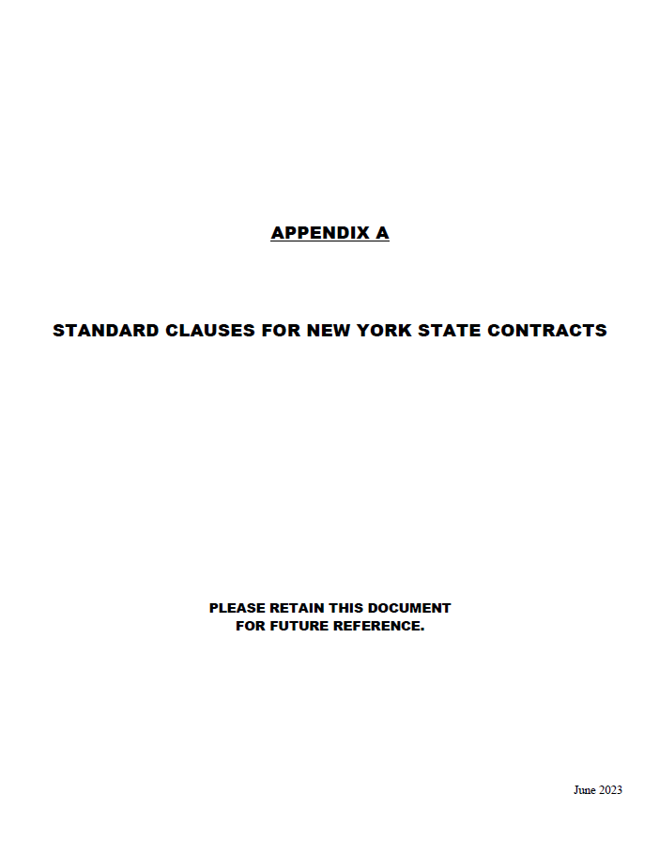

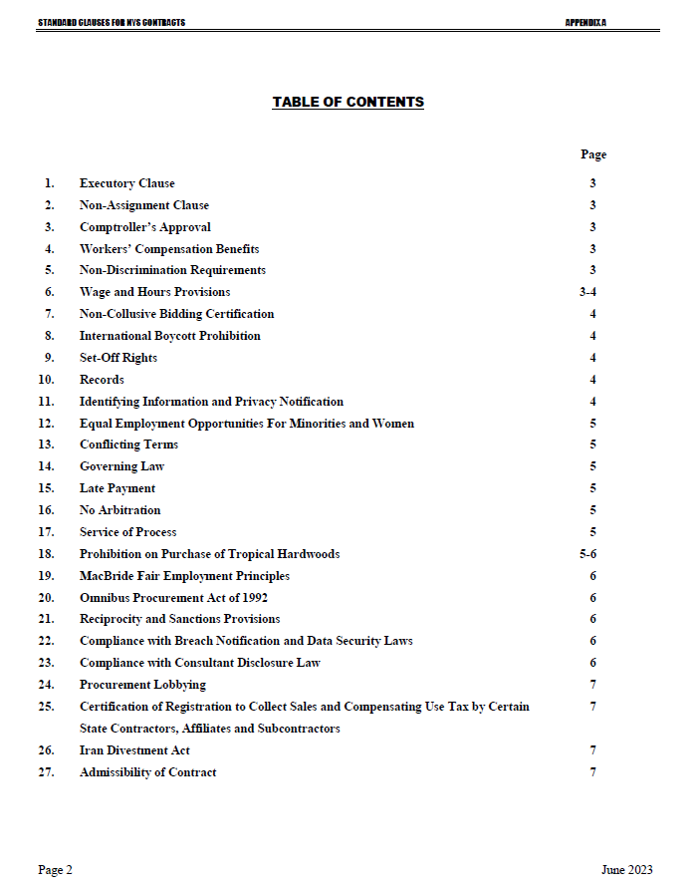

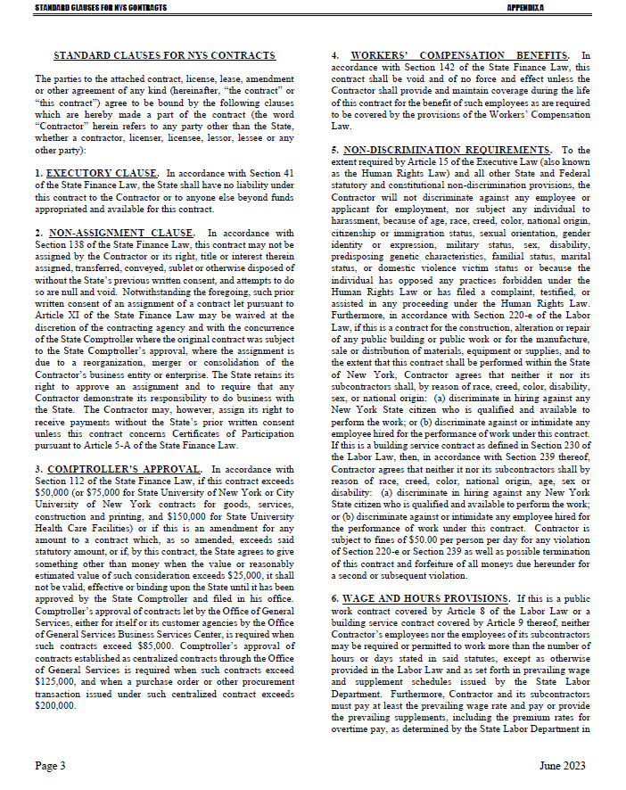

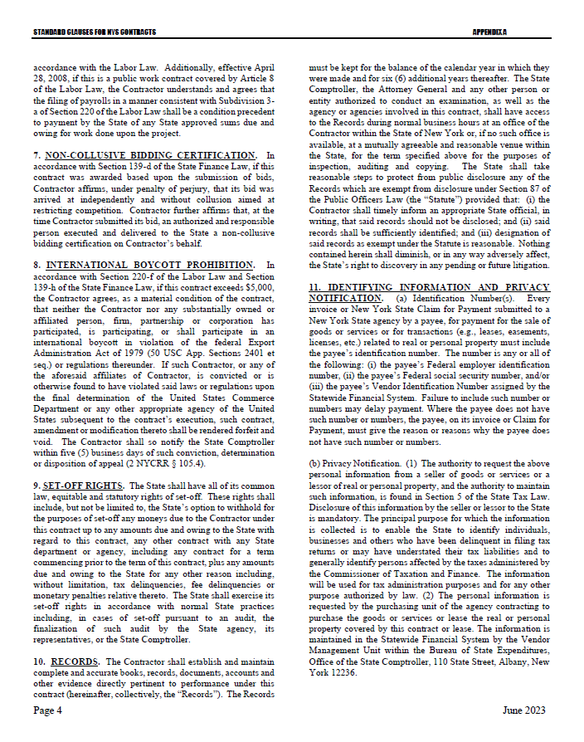

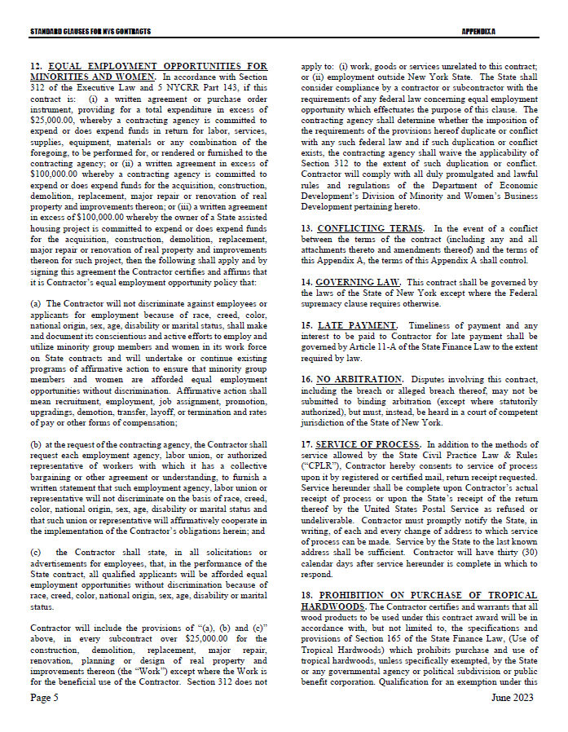

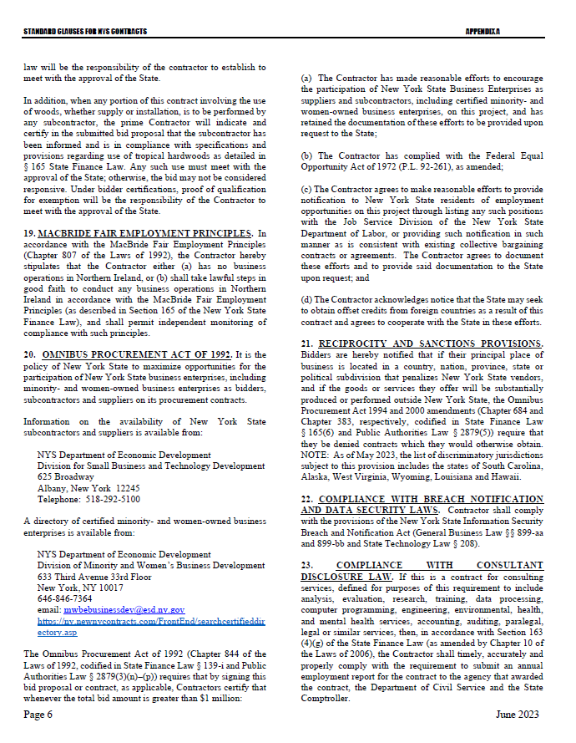

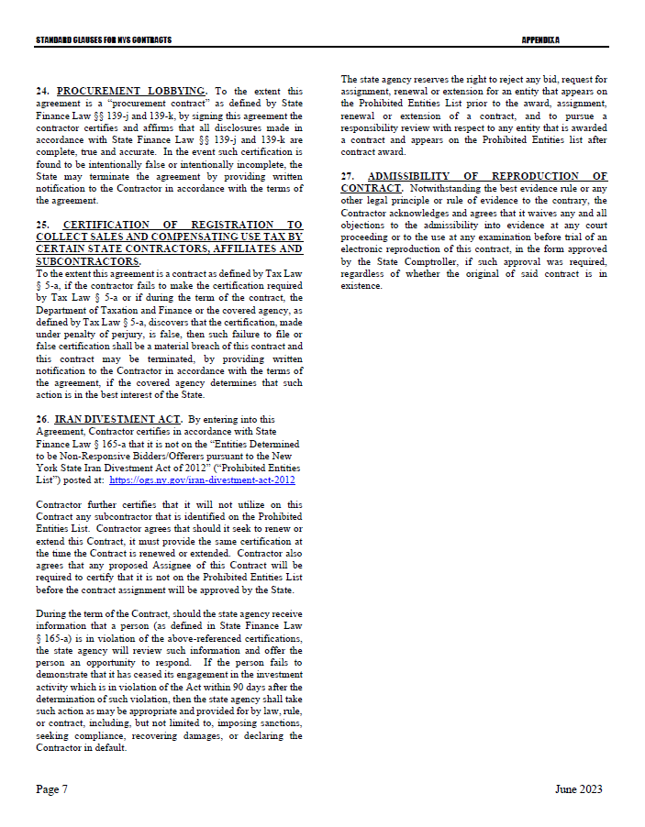

Appendix B – Bid Protest Policy

**DTF Protest Procedure**

Section 1 Applicability

Section 2 Definitions

Section 3 General Protest Guidelines

Section 4 Protest Procedure

Section 5 Appeal process

**Section 1: Applicability**

These guidelines set forth the procedure to be utilized when an Interested Party challenges a Contract Award by the New York State Department of Taxation and Finance. The guidelines shall apply to all Contract Awards made by the Department and approved by the New York State Office of the State Comptroller, including bid Solicitations, Sole Source procurements, Single Source procurements, and Emergency procurements.

**Section 2: Definitions**

1. "Contract Award" is a written determination from DTF to an Offeror indicating that the DTF has selected a particular Offeror under the procurement process.
2. “DTF” or “Department” means the New York State Department of Taxation and Finance.
3. "Emergency" means an urgent and unexpected requirement where health and public safety or the conservation of public resources is at risk (see New York State Finance Law, Section 163.1.b).
4. "Interested Party" means a participant in the procurement process and those whose participation in the procurement process has been foreclosed by the actions of the DTF and have suffered harm as a result of the manner in which the procurement was conducted.
5. “Offeror” means the entity submitting an offer to DTF.
6. "OSC" means the New York State Office of the State Comptroller.
7. "Protest" means a written challenge by an Interested Party of a Contract Award that is subject to the approval of OSC.
8. “Protesting Party” means an Interested Party who has filed a Protest.
9. "Single Source" means a procurement in which, although two or more offerors can supply the required commodities or services, DTF, upon written findings setting forth the material and substantial reasons therefor, awards the contract to one offeror over the other (see New York State Finance Law, Section 163.1.h).
10. "Sole Source" means a procurement in which only one offeror is capable of supplying the required commodities or services (see New York State Finance Law, Section 163.1.g).
11. “Solicitation” means a document issued by DTF, requesting a response to a procurement need, including an Invitation for Bids, a Request for Proposals, or another written method seeking a bid or Proposal for a specified purpose.
12. "Successful Bidder" means the Bidder or offeror whose Bid or Proposal has been selected for Contract Award by DTF.

**Section 3: General Protest Guidelines**

* 1. Any Interested Party will be given the opportunity to participate in the protest procedure.

A Protest submitted to DTF must be in writing and must contain specific factual and legal allegations setting forth the basis on which the Protesting Party challenges the Contract Award by DTF. A Protest must include:

1. a statement of all legal and/or factual grounds for disagreement with a DTF procurement determination;
2. a description of all remedies or relief requested; and
3. copies of all applicable supporting documentation.
   1. DTF may, at its sole discretion, waive any deadline or requirement set forth in these guidelines, or consider any materials submitted beyond the time periods set forth in these guidelines.
   2. Where DTF deems appropriate, DTF may require the Protesting Party, DTF staff involved in the procurement, the Successful Bidder, or any other Interested Party, to address and/or submit further information with respect to additional issues raised by any DTF review of the procurement.
   3. Nothing herein shall preclude DTF from obtaining information relevant to the procurement from any other source, as it may deem appropriate.

**Section 4: Protest Procedure**

* 1. Any Interested Party may file, by mail or electronic mail, a Protest with the DTF Director of Procurement. The following statement must be clearly and prominently displayed on the envelope or package or header of electronic transmittal: “Bid Protest of DTF Solicitation (Reference Number)” when being submitted in regards to a Solicitation and “Protest of DTF Contract Award (Reference Number)” when being submitted in regards to a contract being entered into on a non-competitive basis.
  2. Timing of Protest submission:

1. Concerning Errors, Omissions or Prejudice in the Bid Specifications, Requirements or Documents - Protests which concern the drafting of bid specifications must be received by DTF at least ten Business Days before the date set in the Solicitation for receipt of bids. If the date set in the Solicitation for receipt of bids is less than ten Business Days from the date of issue, Protests concerning the specifications must be received by DTF at least 48 hours before the time designated for receipt of bids.
2. Concerning Proposed Contract Award - Protests concerning a pending Contract Award must be received within ten Business Days after the notice of Contract Award or five Business Days after receiving a debriefing.
   1. The DTF Director of Procurement may summarily deny a Protest that fails to contain specific factual or legal allegations, or where the Protest raises only issues of law that have already been decided by the courts or by the OSC Bureau of Contracts.
   2. An Interested Party may file only one Protest with respect to a specific Solicitation.
   3. The DTF Director of Procurement shall issue a written determination addressing all issues raised by the Protest, as well as any relevant issues raised by his/her review of the procurement or contract. The determination shall make findings of fact and conclusions of law on any issues in dispute. All participants in the Protest and the Successful Bidder shall be provided a copy of the determination. The determination shall be made part of the procurement record.

**Section 5: Appeal Process**

* 1. The protest determination of DTF shall be deemed a final and conclusive agency determination unless a written notice of appeal is received no more than five Business Days after the date the written Protest decision is sent to the Offeror. Such notice of appeal must be filed in writing at the address set forth below:

Chief Financial Officer

New York State Department of Taxation and Finance

Reference: Bid Protest of DTF Solicitation (provide procurement reference number) (or, Protest of DTF Contract Award [Reference Number])

Building 9 W.A. Harriman Campus

Albany, NY 12227

* 1. The Chief Financial Officer shall review and make a final written determination on all appeals within ten Business Days of the date the Appeal is received. A protest appeal may not introduce new facts or legal allegations unless responding to issues newly raised as a result of the written protest determination.

**Section 6: OSC Appeal Process**

* 1. An Interested Party must file an appeal of the Department’s determination of a Protest with the OSC Bureau of Contracts within ten Business Days of receiving DTF’s final written determination on appeal.
  2. In its appeal, the Interested Party shall set forth the basis on which it challenges DTF’s protest determination. The Interested Party shall also include, as an exhibit to its appeal, a copy of the initial bid Protest submitted to the Department and the determination of such bid Protest issued by DTF.

The appeal must be in writing and a copy must be delivered to DTF and the Successful Bidder (unless the Successful Bidder is the appealing party in which case a copy of the appeal must be delivered to the original Protesting Party), and any other party that participated in the Protest conducted by DTF.

The appeal must be filed with:

Bureau Director at [bidprotests@osc.state.ny.us](mailto:bidprotests@osc.state.ny.us)

or

Bureau of Contracts

New York State Office of the State Comptroller

110 State Street, 11th Floor

Albany, NY 12236

**July 2020**

***[The Remainder of this Page is Intentionally Left Blank]***

# 

# Exhibit A – Detailed Specifications

**PRODUCTION CONTROL AND SECURITY:**

The Contractor shall use all means required to ensure that no documents shall be lost during production and storage and that none shall be reproduced unlawfully. All manufacturing shall be done by the Contractor only in the Contractor’s plant (or, in the designated disaster recovery plant, as necessary) and the storage area shall be adequately protected against damage or loss of documents. The Contractor shall establish a thorough procedure for the immediate destruction and disposal of all damaged or mutilated documents. Completed documents will be stored in a secured area at all times.

Bidders must complete **Attachment 5, *Plant Locations*,** indicating the plant location where work is to be done as well as distance of its disaster recovery plant from original plant of manufacturing. Contractor must notify DTF of any change in manufacturing location and receive security clearance from DTF prior to the start of the manufacturing process. Also, if some part of the work is to be done at another location, DTF must be notified before work begins and security clearance must be obtained.

DTF reserves the right to enter the Contractor’s premises at any time during business hours, prior to production and at any time during production to evaluate plant security and storage facilities and inspect methods of production and full compliance with all specifications herein. All bidders must agree to a security clearance inspection prior to consideration of bids. The steps detailed below are to be utilized in evaluating security measures.

**Plant Security**

**1.** The physical plant should be constructed so that the ingress and egress of the public and its employees may be controlled. In those areas where security items are maintained or manufactured, public access should be precluded.

**2.** Construction of the plant should be of a permanent nature with a minimum of fire hazards and with the ability to be secured both during and after working hours.

**3. During Working Hours**

During working hours, those areas in which security items are maintained or manufactured should be secured with controlled access limited to employees only. Said employee(s) are to be identified as having authority to enter the area.

**4. After Working Hours**

After working hours, the premises should be secured with either an alarm system integrated with an enforcement agency or a duly recognized security force. In lieu of an alarm system, security guards (from either a recognized security agency or private security personnel meeting the standards of a recognized security agency) need to be sufficient to patrol the area.

In the case of manufacturing facilities, the area allocated and used for the manufacturing and/or storage of the completed product and necessary plates, etc., used in the production of the item should be secured in the fashion named above both during and after working hours.

Provisions must be made for the security of the documents and their accountability during production, storage while in the plant, and a secure method and accountability for the disposal of waste and overruns. All waste is to be destroyed on site under dual custody by Contractor’s employees.

In all the above, inspections of the premises must indicate that the security measures are fully utilized at all times and not just merely available. Secure storage and accountability of the finished product while in the manufacturer’s hands and provisions for the secure shipment of the completed items to their destination must be provided.

* Contractor must have a disaster recovery plant of manufacture. Such plant must be capable of starting production of forms, which meet all the same specifications as set forth in this document, within 24 hours of disaster.

**PROOFS:**

A copy of the form will be provided to the Contractor in electronic format (Adobe PDF). Within ten (10) business days of receipt of the PDF file, the Contractor shall supply standard proofs in triplicate showing exact registration of text and perforations. An order will not be placed until the proof has been approved by DTF.

**TESTS:**

DTF requires stock to test the registration of the form, MICR alignment, imaging capability; and check deposit functions (requires approval from the Bank Contractor responsible for deposits) (see also Section 6. Document Testing Requirements). Within fourteen (14) calendar days of receipt of Department approval of the Contractor’s colored proof, the Contractor will supply a sample test roll of a minimum of 12,500 forms (two wide). The control numbers used on the test items will begin with the first number DTF supplies the contactor within the control number beginning sequence. Test documents will not be approved unless all printing and handling testing has been completed in accordance with the specifications outlined in the document. DTF will send the Contractor written confirmation at the conclusion of the test to authorize the printing of the production run.

DTF reserves the right to request additional test stock if substantial changes are made to the form.

**DELIVERY:**

Delivery Address:

New York State Department of Taxation and Finance

Attn: Green Island Manager

90 Cohoes Ave

Green Island, NY 12183

The Contractor or truck carrier service must contact the Green Island Manager at [PMCU-GREEN.ISLAND@tax.ny.gov](mailto:PMCU-GREEN.ISLAND@tax.ny.gov) two (2) days in advance of every delivery.

All deliveries must be made prior to 2:00 p.m. on the scheduled delivery date. If necessary, deliveries on the day prior to the scheduled delivery are acceptable.

The Department will accept partial deliveries as rolled stock is produced.

The Contractor must maintain the order and the remainder of any order in secure storage, until released. DTF will not pre-pay for forms in storage, but will pay for forms ordered and delivered to the specified user destination. No additional storage charges will be allowed. Price shall be net F.O.B. destination, include all customs duties and charges, including storage of forms at Contractor’s warehouse and all costs necessary or incidental to proper execution of job including dock delivery to New York State Department of Taxation and Finance, 90 Cohoes Ave, Green Island, NY 12183.

**Note: For delivery, roll #1 must contain the lowest sequence number on the outside.**

The Contractor shall ship all Products on new hardwood pallets with no more than two shrink-wrapped rolls per pallet. Pallet board thickness must be a minimum of ¾”. Individual rolls may not exceed 1,100 lbs. The Contractor shall attach in information sheet to each roll specifying the following information:

1. Product type,
2. the order number,
3. the roll number,
4. the first and last sequence numbers of each roll,
5. Paper characteristics (e.g., 2 up, 24#), and
6. the total volume per roll.

After the truck has been loaded, it must be padlocked, and then the padlock must be sealed. This seal is only to be broken by authorized DTF employees. The truck must come directly from the printing facility to DTF. If the truck arrives at DTF’s loading docks with the seal broken, then DTF reserves the right to refuse acceptance of the delivery. In such an instance, the Contractor shall arrange for another delivery within 3 business days.

The following information should be included on the Bill of Lading: Purchase Order Number, Form Name, and Quantity of checks shipped with starting and ending consecutive control number listed. (A complete or partial shipment should be noted.)

Any changes to these delivery instructions will be provided, in writing, to the Contractor at least ten (10) days prior to the scheduled delivery date.

**Receipt of Shipment:**

DTF will verify the information listed on the Purchase Order and Bill of Lading upon delivery of the checks and then notify the Contractor of the findings. It shall be the obligation of the Contractor to replace any missing or defective items.

ITEM: ROLLED CHECK STOCK

**FORM SPECIFICATIONS:**

**Style:**

One part continuous pin feed form (printed 2-up) constructed as a pressure seal self-mailer.

Forms will be supplied on rolls measuring approximately 50 inches in diameter with 6-inch core. Rolls are not to exceed 1,000 lbs. each with no splices. Rolls are to be a continuous form with no joining of forms using splicing tape or other bonding media and no timing marks.

**Stock:**

• 24# custom paper with a unique water mark not available on the open market

• Laser qualified pressure stock

• Moisture content between 4.2% and 5.5%

• Timing marks are not allowed.

**Size:**

Overall size is 18” (width) x 11” (height).

**Quantity:**

15 million (15,000 M)

**Over and/or Under-runs:**

Over and/or Under-runs Shipments cannot exceed 10% over or under the quantity ordered.

**Presswork:**

Prints two color-two sides with reverse printing and various screens.

**Ink:**

Two ink colors will be printed on the front (PMS colors: 199 red, and 286 blue; Blue – Red – Blue Iridescent Merging of Inks). Two ink colors will be printed on the back (PMS 404 gray and red consecutive control numbers).

Inks used must be capable of withstanding the fusing temperatures and mechanical action of the InfoPrint 4100 Laser Printer and the Ricoh VC40000 ink jet printers without:

• Emitting volatile components to the environment at a level that creates an industrial hygiene safety exposure; and

• Transferring ink to machine components.

Any lithographic inks used in production of PIT Regular Refund Check Stock must contain the following minimum percentages of vegetable oil: News Inks – 40%; Sheet Fed Inks – 20%; Forms Inks – 20%; Heat Set Inks – 10%.

**Control Numbering:**

Contractor will be required to print consecutive control numbers in red ink vertically along the outside edge of the check stubs. Exact placement of the numbering will be determined in conjunction with the Contractor. DTF will supply the contactor with the control number beginning and ending sequence.

**Pin Feed Holes:**

Standard marginal punching along both edges.

**Perforations:**

Horizontal: at ½”; 3 5/8”; 4”; 6 7/8”; 7 3/8”/ 7 7/8”; and 11” from top edge.

Vertical: at 1”; 8 ½”; 9”; 9 ½”; and 17” from left edge.

**Trigger Mark:**

Shall be 3.5 mm (width) by 3.5 mm (height) and solid black. Placement shall be 210 mm horizontal from the top edge and 423.4 mm vertical from the left edge.

**Tracking:**

There are cohesive spots that must match up, so that when pressure is applied by high speed pressure-seal equipment, they will stick together.

**Face:**

One (1) horizontal row of cohesive strips arranged just above the bottom 3 2/3” positioned perforation that will match up with another horizontal row at the bottom of the form.

**Back:**

• One (1) horizontal row of cohesive strips arranged just below the top 3 2/3” panel at a position just above the 7 1/3” positioned perforation that will match up with another horizontal row at the bottom of the form. There are vertical cohesive strips on both sides located within the pin feed strips on left and right edges as well as within the center area of the form.

• The placement of the cohesion must be in such a manner that the vertical cohesion pattern will not come in contact while in the roll.

• The cohesion must be placed in such a manner that when the form is opened it does not damage (tear into) printed areas of the document.

• The cohesion must have a bonding pressure of 150 lbs. per linear inch.

• The cohesion strips must be guaranteed to run through Moore Laser Mate Model LM-20-D folder/sealer equipment, and any other commercially produced pressure seal product.

• The Contractor must guarantee a one-year shelf life on the cohesion strips.

**SECURITY FEATURES:**

**See Exhibit B, *Check Stock Security Features*.**

**USAGE:**

Form will be imaged on an InfoPrint 4100 Laser Printer and a Ricoh VC40000. Subsequently, the 2-up forms will be processed on a Moore Laser Mate Model LM-20-D folder/sealer including a Moore 3400 Detacher.

.

# Exhibit B – Check Stock Security Features

The Bidder must meet all the security features listed below.

|  |  |  |
| --- | --- | --- |
| **Check Stock Security Features** | | **Description** |
| **1** | **Gradient Color Background** | This feature contains a multicolored (pastel), printed background with gradations that are difficult to accurately reproduce on most color copiers or desktop scanners. |
| **2** | **Chemical Reactive Paper** | If chemicals from the families of oxidants, polar solvents, non-polar solvents, acids, or alkalis are applied to attempt localized chemical alteration, noticeable colored stains will appear through the paper and be visible from either side. |
| **3** | **Paper Mill Watermark** | Watermark design is embedded in the paper fibers during the paper making process. The design is pressed into wet paper, displacing some fibers, thereby achieving various levels of light transmission which become visible from either side. When held up to any light, the watermark can be seen through the document but cannot be reproduced using photocopiers or scanners. The design must be acceptable to the State. |
| **4** | **Toner Adhesion** | Paper treatment used to enhance adhesion of toner to the paper. Attempts to modify any character printed on the check using lift-off tape, scraping, or other abrasive technique will result in the inability to effectively remove toner printed images, without a perceptible disruption of the printed image, paper fibers, or the gradient background colors. |
| **5** | **VOID Pantograph** | This security feature conceals the word **‘VOID’** behind the gradient background colors and is useful in deterring counterfeiters. When the check is photocopied, imaged, or scanned, these words become visible making the copy or scanned image non-negotiable. |
| **6** | **Security Fibers** | Two invisible fibers are embedded, randomly distributed throughout the paper, and cannot be photocopied or scanned. When held under UV light, one blue and one yellow/green fibers are visible. |
| **7** | **Microprint Logo Line** | Appears as a solid line in the signature area of the document. It cannot be seen with the naked eye or replicated by most copiers or desktop scanners. Under high magnification, the words ‘State of New York’ appear on the repeat. |
| **8** | **Security Block** | The amount box (right corner) is printed with a white background (no gradient color). |
| **9** | **Endorsement Warning** | Alerts the teller and payee of the presence of security features which can be verified before processing the check. |
| **10** | **Padlock Icon** | The enhanced security features padlock icon is a small padlock symbol printed on the front and back of each check to indicate that the security features on the check have been approved by the Check Payment Systems Association (CPSA). |
| **11** | **Pre-Printed Inventory Controls Numbers** | Printed in sequence on the back of all checks. The control number is completely independent of the check number that will be printed on the face of the check. |
| **12** | **Warning Band** | Printed along the top border of each check notifying the payee and banks that **‘THIS DOCUMENT HAS MULTIPLE SECURITY FEATURES INCLUDING HEAT SENSITIVE, COLOR CHANGING INK ON THE BACK OF THE DOCMENT.’** |
| **13** | **Heat Sensitive Ink** | Heat sensitive ink that temporarily changes from color to colorless when rubbed or exposed to warm breath. This security feature cannot be reproduced on a photocopier or printer and is intended to provide check cashers with an additional tool to identify counterfeit checks. This feature must be on the back of the check, significantly below the endorsement block so as not to obscure teller endorsement stamps, and must be sized approximately 1” x 1”. Color change must occur at a medium temperature. |
| **14** | **Mobile Deposit Check Box** | The mobile deposit check box must appear on the back of the check. The enhanced security feature allows for the individual depositing the check to enter the date of the deposit and deters against the same check being deposited twice. The mobile deposit check box is now required by some banks when mobile deposit is being utilized. |

**Note: The seal of the State of New York is printed on the back of the remittance advice.**

**Exhibit C – Workforce Utilization Report**

The Workforce Utilization Report is published as a separate file and can be found at: <https://www.tax.ny.gov/about/procure>.

**Exhibit D – New York State Office of the State Comptroller Substitute Form W-9**

**This form is available at the NYS Office of the State Comptroller website:**

[https://www.osc.state.ny.us/vendors/forms/ac3237s_fe.pdf](http://www.osc.state.ny.us/vendors/forms/ac3237s_fe.pdf)

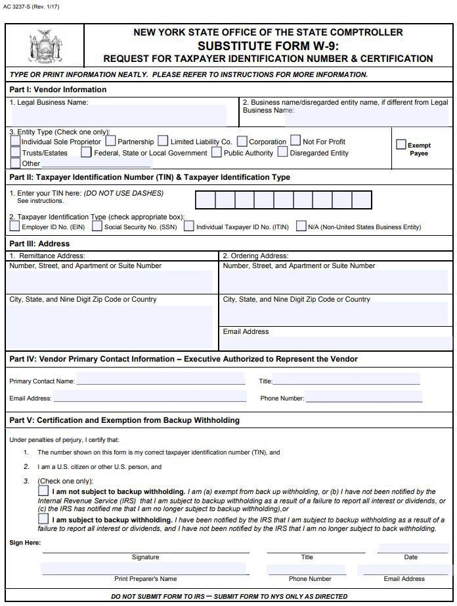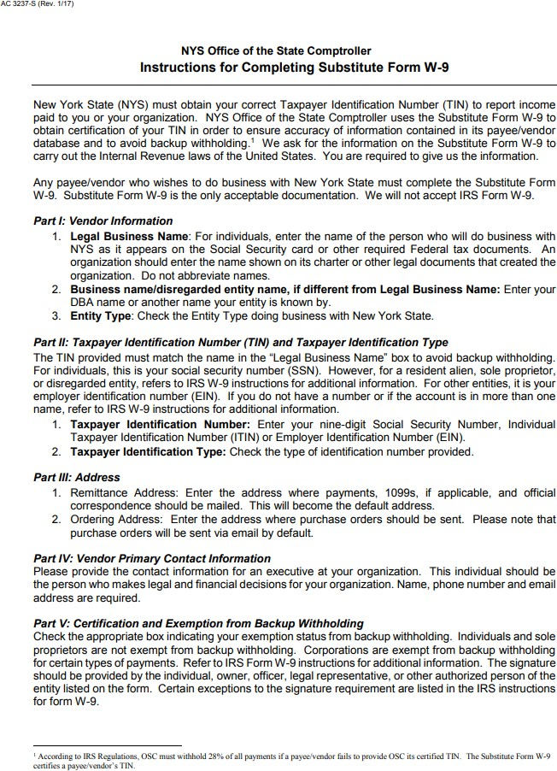

# Attachment 1 – Bidder’s Checklist

Bids must be submitted in an 8-1/2” x 11” 3-ring binder, with the following Attachments in the order presented: Two original signed copies of all are required.

Cover Page (page 1 of this IFB) completed with all requested information

Attachment 1 – Bidder’s Checklist (*showing all provided items checked*)

Sample paper stock with the proposed water mark (Section 1.2)

Third-party certification of sustainability managed resource requirement (Section 5.2.3)

Attachment 2 – Offerer Understanding of, and Compliance with, Procurement Lobbying

Guidelines

Attachment 3 – Offerer Disclosure of Prior Non-Responsibility Determinations

Attachment 4 – Offerer Certification of Compliance with State Finance Law 139-k(5)

Attachment 5 – Plant Locations

Attachment 6 – Experience and Reference Form

Attachment 7 – [RESERVED]

Attachment 8 – Minority and Women-Owned Business Enterprises - Equal Employment

Opportunity Policy Statement

Attachment 9 – Staffing Plan

Attachment 11 – Encouraging Use of New York State Businesses in Contract Performance

Attachment 12 – Vendor Assurance of No Conflict of Interest or Detrimental Effect

Attachment 13 – EO-177 Certification

Attachment 14 – Public Officers Law Form

Attachment 15 – Public Officers Law – Post Employment Restrictions

Attachment 17 – Sexual Harassment Prevention Certification

Attachment 18 – EO-16 Certification

Attachment 19 – Bidder’s Financial Response Form

**NOTE**: **Attachments 10 and 16 are not to be provided with the bid. These Attachments will be completed upon notification of award for contracts equal to or exceeding $100,000.**

Attachment 10 – Vendor Responsibility Response Form

*(plus hard copy of the Vendor Responsibility Questionnaire if not submitting electronically via the OSC VendRep portal).*

Attachment 16 – Contractor Sales Tax Certification Forms

*Do not include any additional information or Attachments that attempt to change and/or conflict with the Terms and Conditions of this IFB. Including any such additional information or Attachments may result in the bid being determined non-responsive and disqualified.*

# 

# Attachment 2 – Offerer Understanding of, and Compliance with, Procurement Lobbying Guidelines

New York State Finance Law §139-j(6)(b) requires the DTF seek written affirmation from all Offerers as to the Offerer’s understanding of, and agreement to comply with, the DTF procedures relating to permissible contacts during a Government Procurement pursuant to subdivision three of this section.

|  |  |  |
| --- | --- | --- |
| Procurement Description, Contract or Bid Number: | |  |
|  | | |
| Offerer Name: |  | |
|  | | |
| Offerer Address: |  | |
|  |  | |
|  |  | |
|  | | |
| Telephone Number: |  | |
|  | | |
| Email Address: |  | |

Offerer affirms it has read, understands and agrees to comply with the guidelines of the New York State Department of Taxation and Finance relative to permissible contacts as required by the State Finance Law §§139-j(3) and 139-j(6)(b).

|  |  |
| --- | --- |
| By *(signature)*: |  |
|  | |
| Name *(please print)*: |  |
|  | |
| Title *(please print)*: |  |
|  | |
| Date: |  |

# Attachment 3 – Offerer Disclosure of Prior Non-Responsibility Determinations

New York State Finance Law §139-k(2) obligates a Governmental Entity to obtain specific information regarding prior non-responsibility determinations with respect to State Finance Law §139-j. This information must be collected in addition to the information that is separately obtained pursuant to State Finance Law §163(9). In accordance with State Finance Law §139-k, an Offerer must be asked to disclose whether there has been a finding of non-responsibility made within the previous four years by any Governmental Entity due to: (a) a violation of State Finance Law §139-j or (b) the intentional provision of false or incomplete information to a Governmental Entity. The terms “Offerer” and “Governmental Entity” are defined in State Finance Law §139-k(1). State Finance Law §139-j sets forth detailed requirements about the restrictions on Contacts during the procurement process. A violation of State Finance Law §139-j includes, but is not limited to, an impermissible Contact during the restricted period (for example, contacting a person or entity other than the designated contact person, when such contact does not fall within one of the exemptions).

As part of its responsibility determination, State Finance Law §139-k(3) mandates consideration of whether an Offerer fails to timely disclose accurate or complete information regarding the above non-responsibility determination. In accordance with law, no Procurement Contract shall be awarded to any Offerer that fails to timely disclose accurate or complete information under this section, unless a finding is made that the award of the Procurement Contract to the Offerer is necessary to protect public property or public health safety, and that the Offerer is the only source capable of supplying the required Article of Procurement within the necessary timeframe. See State Finance Law §§139-j (10)(b) and 139-k(3).

A Governmental Entity must include a disclosure request regarding prior non-responsibility determinations in accordance with State Finance Law §139-k in its solicitation of proposals or bid documents or specifications or contract documents, as applicable, for Procurement Contracts. The attached form is to be completed and submitted by the individual or entity seeking to enter into a Procurement Contract. It shall be submitted to the Governmental Entity conducting the Governmental Procurement.

|  |  |  |  |  |  |  |  |  |  |  |  |  |  |  |  |  |  |  |
| --- | --- | --- | --- | --- | --- | --- | --- | --- | --- | --- | --- | --- | --- | --- | --- | --- | --- | --- |
| **Offerer Disclosure of Prior Non-Responsibility Determinations** | | | | | | | | | | | | | | | | | | |
| Procurement Description, Contract or Bid Number: | | | | | | | | | |  |  | | | | | | | |
|  | | | | | | | | | | | | | | | | | | |
|  |  | | |  | | | |  | | | | |  | | |  | | | |
| Offerer Name: | | | |  | | | | | | | | | | | | | | |
|  |  | | |  | | | |  | | | | |  | | |  | | | |
| Offerer Address: | | | |  | | | | | | | | | | | | | | |
|  |  | | |  | | | | | | | | | | | | | | |
|  |  | | |  | | | | | | | | | | | | | | |
|  |  | | |  | | | |  | | | | |  | | |  | | | |
| Phone Number: | | | |  | | | |  | | | | |  | | |  | | | |
|  |  | | |  | | | |  | | | | |  | | |  | | | |
| Email: | | | |  | | | |  | | | | |  | | |  | | | |
|  |  | | |  | | | |  | | | | |  | | |  | | | |
| Name and Title of Person Submitting This Form: | | | | |  | | | | | | | | | | | | | |
|  |  | | |  | | | |  | | | | | | | | | | |
|  |  | | |  | | | |  | | | | | | | | | | |
| 1. Has any New York State agency or authority made a finding of non-responsibility regarding the Offerer in the last four years? | | | | | | | | | | | | |  | Yes |  | | | No |
|  | | | | | | | | | | | | | | | | | | |
|  | If yes, please answer the following questions: | | | | | | | | | | |  | | | | | | |
|  | | | | | | | | | | | | | | | | | | |
|  | 1. Was the basis for the finding of the Offerer’s non-responsibility due to a violation of State Finance Law §139-j? | | | | | | | | | | | |  | Yes |  | | No | |
|  | | | | | | | | | | | | | | | | | | |
|  | 1. Was the basis for the finding of the Offerer’s non-responsibility due to the intentional provision of false or incomplete information to a Governmental Entity? | | | | | | | | | | | |  | Yes |  | | No | |
|  | | | | | | | | | | | | | | | | | | |
|  | 1. If you responded “Yes” to Questions 1, 2 or 3, please provide details regarding the finding of non-responsibility below: | | | | | | | | | | | | | | | | | |
|  |  | Government Entity: | | | |  | | | | | | | | | | | | |
|  | | | | | | | | | | | | | | | | | | |
|  |  | Date of Finding of Non-responsibility: | | | | | | |  | | | | | | | | | |
|  | | | | | | | | | | | | | | | | | | |
|  |  | Facts Underlying Finding of Non-Responsibility (Add additional pages as necessary): | | | | | | | | | | | | | | | | |
|  |  |  | | | | | | | | | | | | | | | | |
|  |  | | | | | | | | | | | | | | | | | |
|  | 1. Has any New York State agency or authority terminated a Procurement Contract with the Offerer due to the intentional provision of false or incomplete information? | | | | | | | | | | | |  | Yes |  | | No | |
|  |  |  | | | | | | | | | | | | | | | | |
|  |  | 1. If you responded “Yes” to the above question, please provide details regarding the termination below: | | | | | | | | | | | | | | | | |
|  |  |  | Government Entity: | | | |  | | | | | | | | | | | |
|  | | | | | | | | | | | | | | | | | | |
|  |  |  | Date of Finding of Non-Responsibility: | | | | | | |  | | | | | | | | |
|  | | | | | | | | | | | | | | | | | | |
|  |  |  | Facts Underlying Finding of Non-Responsibility (Add additional pages as necessary): | | | | | | | | | | | | | | | |
|  |  |  |  | | | | | | | | | | | | | | | |
|  |  |  | |  | | | | | | | | | | | | | | |
| **Offerer certifies that all information provided to the DTF with respect to State Finance Law §139-k is complete, true and accurate.** | | | | | | | | | | | | | | | | | | |
|  | | | | | | | | | | | | | | | | | | |
| By (Signature): | | | | | | | |  | | | | | | | | | | |
| Name (Please print): | | | | | | | |  | | | | | | | | | | |
| Date: | | | | | | | |  | | | | | | | | | | |

# Attachment 4 – Offerer Certification of Compliance with State Finance Law 139-k(5)

New York State Finance Law §139-k(5) requires that every Procurement Contract award subject to the provisions of State Finance Law §§139-k or 139-j shall contain a certification by the Offerer that all information provided to the procuring Government Entity with respect to State Finance Law 139-k is complete, true and accurate.

**Offerer Certification**

I certify that all information provided to the DTF with respect to State Finance Law §139-k is complete, true and accurate.

|  |  |  |  |
| --- | --- | --- | --- |
|  | By*: (signature)* | |  |
|  |  |  | |
|  | Date: |  | |

|  |  |  |
| --- | --- | --- |
|  |  |  |
|  |  |  |
| Procurement Description, Contract or Bid Number: | | |
|  | | |
|  |  |  |
|  |  |  |
| Name *(Please print)*: | |  |
|  |  |  |
| Title: |  | |
|  |  |  |
| Offerer Name: | |  |
|  |  |  |
| Offerer Address: | |  |
|  |  |  |
|  |  |  |
|  |  |  |
| Telephone Number: | |  |
|  |  |  |
| Email Address: | |  |

# Attachment 5 – Plant Locations

Bidder must list the location of its primary facility and secondary facility (if applicable) where work will be performed.

|  |
| --- |
| **PRIMARY PLANT LOCATION (required):** |
|  |
| Address (City and State): |
|  |
|  |
| **SECONDARY PLANT LOCATION (if applicable):** |
|  |
| Address (City and State) or distance from Primary Plant: |
|  |

# 

# Attachment 6 – Experience and Reference Form

Provide the following information for up to three (3) contracts under which your company has successfully produced similar products. Each contract must have an annual volume of at least two (2) million pieces and each contract must be within the last three (3) years.

**Each of the following requirements must be evidenced by at least one (1) of the references:**

A. Customer is a state or federal agency;

B. Product has Eccentric Z-Fold construction; and

C. Check stock contains security features similar to those found in  **Exhibit B, *Check Stock Security Features***.

*For example, a bidder can provide: one (1) reference that meet all three (3) requirements; two (2) references that collectively meet all three (3) requirements by one (1) reference satisfying the experience of one (1) requirement and the other reference satisfying the experience of the two (2) remaining requirements, etc.*

|  |  |  |
| --- | --- | --- |
| 1 | **Customer Name:** |  |
| **Contact Name / Title:** |  |
| **Telephone Number:** |  |
| **E-mail Address:** |  |
| **Contract Term:** |  |
| **Annual Volume:** |  |
| **Requirement(s):** Check the box to indicate which requirement is satisfied through this organization. | **A.  B.  C.** |
| 2 | **Customer Name:** |  |
| **Contact Name / Title:** |  |
| **Telephone Number:** |  |
| **E-mail Address:** |  |
| **Contract Term:** |  |
| **Annual Volume:** |  |
| **Requirement(s):**  Check the box to indicate which requirement is satisfied through this organization. | **A.  B.  C.** |
| 3 | **Customer Name:** |  |
| **Contact Name / Title:** |  |
| **Telephone Number:** |  |
| **E-mail Address:** |  |
| **Contract Term:** |  |
| **Annual Volume:** |  |
| **Requirement(s):**  Check the box to indicate which requirement is satisfied through this organization. | **A.  B.  C.** |

**Bidder Name: __________________________________________________________________**

# Attachment 8 – Minority and Women-Owned Business Enterprises – Equal Employment Opportunity Policy Statement

I, _________________________, the (awardee/contractor) ____________________ agree to adopt the following policies with respect to the project being developed or services rendered at

____________________________________________________________________________

|  |
| --- |
| **M/WBE** |

|  |
| --- |
| **EEO** |

This organization will and will cause its contractors and subcontractors to take good faith actions to achieve the M/WBE contract participations goals set by the State for that area in which the State-funded project is located, by taking the following steps:

1. Actively and affirmatively solicit bids for contracts and subcontracts from qualified State certified MBEs or WBEs, including solicitations to M/WBE contractor associations.
2. Request a list of State-certified M/WBEs from AGENCY and solicit bids from them directly.
3. Ensure that plans, specifications, request for proposals and other documents used to secure bids will be made available in sufficient time for review by prospective M/WBEs.
4. Where feasible, divide the work into smaller portions to enhanced participations by M/WBEs and encourage the formation of joint venture and other partnerships among M/WBE contractors to enhance their participation.
5. Document and maintain records of bid solicitation, including those to M/WBEs and the results thereof. Contractor will also maintain records of actions that its subcontractors have taken toward meeting M/WBE contract participation goals.
6. Ensure that progress payments to M/WBEs are made on a timely basis so that undue financial hardship is avoided, and that bonding and other credit requirements are waived or appropriate alternatives developed to encourage M/WBE participation.

a. This organization will not discriminate against any employee or applicant for employment because of race, creed, color, national origin, sex, age, disability or marital status, will undertake or continue existing programs of affirmative action to ensure that minority group members are afforded equal employment opportunities without discrimination, and shall make and document its conscientious and active efforts to employ and utilize minority group members and women in its work force on state contracts.

b. This organization shall state in all solicitation or advertisements for employees that in the performance of the State contract all qualified applicants will be afforded equal employment opportunities without discrimination because of race, creed, color, national origin, sex disability or marital status.

c. At the request of the contracting agency, this organization shall request each employment agency, labor union, or authorized representative will not discriminate on the basis of race, creed, color, national origin, sex, age, disability or marital status and that such union or representative will affirmatively cooperate in the implementation of this organizations’ obligations herein.

1. Contractor shall comply with the provisions of the Human Rights Law, all other State and Federal statutory and constitutional non-discrimination provisions. Contractor and subcontractors shall not discriminate against any employee or applicant for employment because of race, creed (religion), color, sex, national origin, sexual orientation, marital status or domestic violence victim status, and shall also follow the requirements of the Human Rights Law with regard to non-discrimination on the basis of prior criminal conviction and prior arrest.
2. This organization will include the provisions of sections (a) through (d) of this agreement in every subcontract in such a manner that the requirements of the subdivisions will be binding upon each subcontractor as to work in connection with the State contract.

Agreed to this _______ day of ____________________, 2___________

By __________________________________________

Print: _____________________________________ Title: _____________________________

_________________________________is designated as the Minority Business Enterprise Liaison

(Name of Designated Liaison)

responsible for administering the Minority and Women-Owned Business Enterprises- Equal Employment

Opportunity (M/WBE-EEO) program.

**M/WBE Contract Goals**

___0_____% Minority and Women’s Business Enterprise Participation

___0_____% Minority Business Enterprise Participation

____0____% Women’s Business Enterprise Participation

____________________________________________

(Authorized Representative)

Title: ________________________________________

Date: ________________________________________

# Attachment 9 – Staffing Plan

Submit with Bid or Proposal (Instructions attached)

|  |  |  |
| --- | --- | --- |
| **Solicitation No.:** | **Reporting Entity:** | **Report includes Contractor’s/Subcontractor’s:**  □ Work force to be utilized on this contract  □ Total work force |
| **Offeror’s Name:** | | □Offeror  □ Subcontractor  **Subcontractor’s name________________** |
| **Offeror’s Address:** | |

Enter the total number of employees for each classification in each of the EEO-Job Categories identified

|  |  |  |  |  |  |  |  |  |  |  |  |  |  |  |  |  |  |
| --- | --- | --- | --- | --- | --- | --- | --- | --- | --- | --- | --- | --- | --- | --- | --- | --- | --- |
| EEO-Job Category | Total Work force | Work force by Gender | | Work force by  Race/Ethnic Identification | | | | | | | | | |  | | | |
| Total  Male  (M) | Total  Female  (F) | White  (M) (F) | | Black  (M) (F) | | Hispanic  (M) (F) | | Asian  (M) (F) | | Native American  (M) (F) | | Disabled  (M) (F) | | Veteran  (M) (F) | |
| Officials/Administrators |  |  |  |  |  |  |  |  |  |  |  |  |  |  |  |  |  |
| Professionals |  |  |  |  |  |  |  |  |  |  |  |  |  |  |  |  |  |
| Technicians |  |  |  |  |  |  |  |  |  |  |  |  |  |  |  |  |  |
| Sales Workers |  |  |  |  |  |  |  |  |  |  |  |  |  |  |  |  |  |
| Office/Clerical |  |  |  |  |  |  |  |  |  |  |  |  |  |  |  |  |  |
| Craft Workers |  |  |  |  |  |  |  |  |  |  |  |  |  |  |  |  |  |
| Laborers |  |  |  |  |  |  |  |  |  |  |  |  |  |  |  |  |  |
| Service Workers |  |  |  |  |  |  |  |  |  |  |  |  |  |  |  |  |  |
| Temporary /Apprentices |  |  |  |  |  |  |  |  |  |  |  |  |  |  |  |  |  |
| Totals |  |  |  |  |  |  |  |  |  |  |  |  |  |  |  |  |  |

|  |  |  |  |
| --- | --- | --- | --- |
| **PREPARED BY (Signature):** | **TELEPHONE NO.:**  **EMAIL ADDRESS:** | | **DATE:** |
| **NAME AND TITLE OF PREPARER (Print or Type):** | | **Submit completed with bid or proposal M/WBE 101 (Rev 11/08)** | |

**General instructions:** All Offerors and each subcontractor identified in the bid or proposal must complete an EEO Staffing Plan (M/WBE 101) and submit it as part of the bid or proposal package. Where the work force to be utilized in the performance of the State contract can be separated out from the contractor’s and/or subcontractor’s total work force, the Offeror shall complete this form only for the anticipated work force to be utilized on the State contract. Where the work force to be utilized in the performance of the State contract cannot be separated out from the contractor’s and/or subcontractor’s total work force, the Offeror shall complete this form for the contractor’s and/or subcontractor’s total work force.

**Instructions for completing:**

1. Enter the Solicitation number that this report applies to along with the name and address of the Offeror.
2. Check off the appropriate box to indicate if the Offeror completing the report is the contractor or a subcontractor.
3. Check off the appropriate box to indicate work force to be utilized on the contract or the Offerors’ total work force.
4. Enter the total work force by EEO job category.
5. Break down the anticipated total work force by gender and enter under the heading ‘Work force by Gender’
6. Break down the anticipated total work force by race/ethnic identification and enter under the heading ‘Work force by Race/Ethnic Identification’. Contact the OM/WBE Permissible contact(s) for the solicitation if you have any questions.
7. Enter information on disabled or veterans included in the anticipated work force under the appropriate headings.
8. Enter the name, title, phone number and email address for the person completing the form. Sign and date the form in the designated boxes.

**RACE/ETHNIC IDENTIFICATION**

Race/ethnic designations as used by the Equal Employment Opportunity Commission do not denote scientific definitions of anthropological origins. For the purposes of this form, an employee may be included in the group to which he or she appears to belong, identifies with, or is regarded in the community as belonging. However, no person should be counted in more than one race/ethnic group. The race/ethnic categories for this survey are:

* **WHITE**  (Not of Hispanic origin) All persons having origins in any of the original peoples of Europe, North Africa, or the Middle East.
* **BLACK** a person, not of Hispanic origin, who has origins in any of the black racial groups of the original peoples of Africa.
* **HISPANIC** a person of Mexican, Puerto Rican, Cuban, Central or South American or other Spanish culture or origin, regardless of race.
* **ASIAN & PACIFIC** a person having origins in any of the original peoples of the Far East, Southeast Asia, the Indian subcontinent or the Pacific Islands.

**IISLANDER**

* **NATIVE INDIAN (NATIVE**  a person having origins in any of the original peoples of North America, and who maintains cultural identification through tribal

**AMERICAN/ ALASKAN NATIVE)** affiliation or community recognition.

**OTHER CATEGORIES**

* **DISABLED INDIVIDUAL** any person who: - has a physical or mental impairment that substantially limits one or more major life activity(ies)

- has a record of such an impairment; or

- is regarded as having such an impairment.

* **VIETNAM ERA VETERAN** a veteran who served at any time between and including January 1, 1963 and May 7, 1975.
* **GENDER Male or Female**

# Attachment 10 – Vendor Responsibility Response Form

Bidder’s Name: ______________________________________________

Bidders must complete a Vendor Responsibility Questionnaire in response to this IFB. Bidders are invited to file the required Vendor Responsibility Questionnaire online via the OSC New York State VendRep System or may choose to complete and submit a paper questionnaire. To enroll in and use the New York State VendRep System, see the VendRep System instructions available at [www.osc.state.ny.us/vendrep](http://www.osc.state.ny.us/vendrep) or go directly to the VendRep System online at <https://onlineservices.osc.state.ny.us/Enrollment/login?3>. For direct VendRep System user assistance, the OSC Help Desk may be reached at 866-370-4672 or 518-408-4672 or by e-mail at [itservicedesk@osc.ny.gov](mailto:itservicedesk@osc.ny.gov). Bidders opting to file a paper questionnaire can obtain the appropriate questionnaire from the VendRep website at [www.osc.state.ny.us/vendrep](http://www.osc.state.ny.us/vendrep) or may contact one of the Department’s designated contacts.

Please check one of the following:

A Vendor Responsibility Questionnaire has been filed online and has been certified/updated within the last six months.

A Vendor Responsibility Questionnaire is attached to this bid proposal.

NOTE: If a Vendor Responsibility Questionnaire has been filed online and has not been certified within the last six months, the Bidder must either update/recertify the online questionnaire or submit a new paper Vendor Responsibility Questionnaire. Upon notification of award, the Contractor will be required to update/recertify the online questionnaire.

# Attachment 11 – Encouraging Use of New York State Businesses in Contract Performance

New York State businesses have a substantial presence in State contracts and strongly contribute to the economies of the State and nation. In recognition of their economic activity and leadership in doing business in New York State, Bidders/proposers for this contract for commodities, services or technology are strongly encouraged and expected to consider New York State businesses in the fulfillment of the requirements of the Contract. Such partnering may be as subcontractors, suppliers, protégés or other supporting roles.

Bidders/proposers need to be aware that all authorized users of this Contract will be strongly encouraged to the maximum extent practical and consistent with legal requirements, to use responsible and responsive New York State businesses in purchasing commodities that are of equal quality and functionality and in utilizing services and technology. Furthermore, Bidders/proposers are reminded that they must continue to utilize small, minority- and women-owned businesses, consistent with current State law.

Utilizing New York State businesses in State contracts will help create more private sector jobs, rebuild New York’s infrastructure and maximize economic activity to the mutual benefit of the Contractor and its New York State business partners. New York State businesses will promote the Contractor’s optimal performance under the Contract, thereby fully benefitting the public-sector programs that are supported by associated procurements.

Public procurements can drive and improve the State’s economic engine through promotion of the use of New York businesses by its Contractors. The State therefore expects Bidders/proposers to provide maximum assistance to New York businesses in their use of the Contract. The potential participation by all kinds of New York businesses will deliver great value to the State and its taxpayers.

Bidders/proposers can demonstrate their commitment to the use of New York State businesses by responding to the question below:

Will New York State Businesses be used in the performance of this contract?  Yes  No

If “Yes,” identify New York State businesses that will be used and attach identifying information.

By *(signature)*: ________________________________________

Name *(Please print)*: ___________________________________

Title *(Please print)*: ____________________________________

Date: ___________________________

# Attachment 12 – Vendor Assurance of No Conflict of Interest or Detrimental Effect

The Bidder offering to provide services pursuant to this IFB attests that its performance of the services outlined does not and will not create a conflict of interest with, nor position the Bidder to breach, any other contract currently in force with the State of New York.

Furthermore, the Bidder attests that it will not act in any manner that is detrimental to any State project on which the Bidder is rendering services. Specifically, the Bidder attests that:

1. The fulfillment of obligations by the Bidder, as proposed in the response, does not violate any existing contract or agreement between the Bidder and the State;
2. The fulfillment of obligations by the Bidder, as proposed in the response, does not and will not create any conflict of interest, or perception thereof, with any current role or responsibility that the Bidder has with regard to any existing contract or agreement between the Bidder and the State;
3. The fulfillment of obligations by the Bidder, as proposed in the response, does not and will not compromise the Bidder’s ability to carry out its obligations under any existing contract between the Bidder and the State;
4. The fulfillment of any other contractual obligations that the Bidder has with the State will not affect or influence its ability to perform under any contract with the State resulting from this solicitation;
5. During the negotiation and execution of any contract resulting from this solicitation, the Bidder will not knowingly take any action or make any decision which creates a potential for conflict of interest or might cause a detrimental impact to the State as a whole including, but not limited to, any action or decision to divert resources from one State project to another;
6. In fulfilling obligations under each of its State contracts, including any contract which results from this solicitation, the Bidder will act in accordance with the terms of each of its State contracts and will not knowingly take any action or make any decision which might cause a detrimental impact to the State as a whole including, but not limited to, any action or decision to divert resources from one State project to another;
7. No former officer or employee of the State who is now employed by the Bidder, nor any former officer or employee of the Bidder who is now employed by the State, has played a role with regard to the administration of this contract procurement in a manner that may violate section 73(8)(a) of the State Ethics Law; and
8. The Bidder has not and shall not offer to any employee, member or director of the State any gift, whether in the form of money, service, loan, travel, entertainment, hospitality, thing or promise, or in any other form, under circumstances in which it could reasonably be inferred that the gift was intended to influence said employee, member or director, or could reasonably be expected to influence said employee, member or director, in the performance of the official duty of said employee, member or director or was intended as a reward for any official action on the part of said employee, member or director.

The Bidder should note that the State recognizes that conflicts may occur in the future because a Bidder may have existing or new relationships. The State will review the nature of any such new relationship and reserves the right to terminate the contract for cause if, in its judgment, a real or potential conflict of interest cannot be cured.

By *(signature)*: ____________________________________________________

Name *(please print)*: ______________________________________________

Title *(please print)*: _______________________________________________

Date: _____________________________________

This form must be signed by an authorized executive or legal representative.

# Attachment 13 – EO 177 Certification

The New York State Human Rights Law, Article 15 of the Executive Law, prohibits discrimination and harassment based on age, race, creed, color, national origin, sex, pregnancy or pregnancy-related conditions, sexual orientation, gender identity, disability, marital status, familial status, domestic violence victim status, prior arrest or conviction record, military status or predisposing genetic characteristics.

The Human Rights Law may also require reasonable accommodation for persons with disabilities and pregnancy-related conditions. A reasonable accommodation is an adjustment to a job or work environment that enables a person with a disability to perform the essential functions of a job in a reasonable manner. The Human Rights Law may also require reasonable accommodation in employment on the basis of Sabbath observance or religious practices.

Generally, the Human Rights Law applies to:

* all employers of four or more people, employment agencies, labor organizations and apprenticeship training programs in all instances of discrimination or harassment;
* employers with fewer than four employees in all cases involving sexual harassment; and,
* any employer of domestic workers in cases involving sexual harassment or harassment based on gender, race, religion or national origin.

In accordance with Executive Order No. 177, the Bidder hereby certifies that it does not have institutional policies or practices that fail to address the harassment and discrimination of individuals on the basis of their age, race, creed, color, national origin, sex, sexual orientation, gender identity, disability, marital status, military status, or other protected status under the Human Rights Law.

Executive Order No. 177 and this certification do not affect institutional policies or practices that are protected by existing law, including but not limited to the First Amendment of the United States Constitution, Article 1, Section 3 of the New York State Constitution, and Section 296(11) of the New York State Human Rights Law.

Contractor:

By (*signature*): ____________________________________

Name (*Please Print)*: _______________________________

Title: ____________________________________________

Date: ____________________

This form must be signed by an authorized executive or legal representative.

# 

**Attachment 14 – Public Officers Law Form**

Disclosure of business or professional activities by state officers and employees and party officers.

**§ 73. Business or professional activities by state officers and employees and party officers.**

4. (a) No statewide elected official, state officer or employee, member of the legislature, legislative employee or political party chairman or firm or association of which such person is a member, or corporation, ten per centum or more of the stock of which is owned or controlled directly or indirectly by such person, shall (i) sell any goods or services having a value in excess of twenty-five dollars to any state agency, or (ii) contract for or provide such goods or services with or to any private entity where the power to contract, appoint or retain on behalf of such private entity is exercised, directly or indirectly, by a state agency or officer thereof, unless such goods or services are provided pursuant to an award or contract let after public notice and competitive bidding. This paragraph shall not apply to the publication of resolutions, advertisements or other legal propositions or notices in newspapers designated pursuant to law for such purpose and for which the rates are fixed pursuant to law.

|  |  |  |  |  |  |  |  |  |  |  |  |
| --- | --- | --- | --- | --- | --- | --- | --- | --- | --- | --- | --- |
| 1. Is the Bidder a New York State officer, employee, or party officer? | | | | | |  | Yes |  | No | | |
|  | | | | | | | | | | | |
| 1. Are any of the members of Bidder’s firm or corporation, who own or control ten per centum or more of stock, a New York State officer, employee, or party officer? | | | | | |  | Yes |  | No | | |
|  | | | | | | | | | | | |
| 1. Is the proposed subcontractor (if applicable) a New York State officer, employee, or party officer? | | | | | |  | Yes |  | No | | |
|  | |  |  |  |  |  |  | | | |  |
|  | |  |  |  |  |  |  | | | |  |
| Bidder affirms it has read, understands and agrees to comply with the Guidelines of Public Officers Law § 73 (4)(a). | | | | | | | | | | | |
|  | |  |  |  |  |  |  | | | |  |
| By *(signature)*: | | |  | | | | | | | |  |
|  | |  |  |  |  |  |  | | | |  |
| Name *(please print)*: | | |  | | | | | | | |  |
|  | |  |  |  |  |  |  | | | |  |
| Title *(please print)*: | | |  | | | | | | | |  |
|  | |  |  |  |  |  |  | | | |  |
| Date: | |  | | |  |  |  | | | |  |

# Attachment 15 – Public Officers Law – Post Employment Restrictions

By signing below and submitting a proposal to this IFB, the signatory certifies, for and on behalf of the Bidder, that:

1. He/she has read and understands the provisions applicable to post employment restrictions affecting former State officers and employees, available using the link* below:
2. Public Officers Law § 73(8)(a)(i), (the two-year bar); and
3. Public Officers Law § 73(8)(a)(ii), (the life-time bar);
4. Submission of this proposal does not violate either provision;
5. He/she is familiar with or has made diligent inquiry of, the Bidder's relevant employees, and agents;
6. No violation shall occur by entering into a contract or in performance of the contractual services;
7. This certification is material to the proposal; and
8. He/she understands that the Department intends to rely on this certification.

The Bidder shall fully disclose to the Department, within its proposal and on a continuing basis, any circumstances that affect this certification or the Bidder’s ability to comply with the cited laws. Bidders shall address any questions concerning §73(8) of the Public Officers Law to:

The New York State Commission on Ethics and Lobbying in Government  
540 Broadway   
Albany, NY 12207   
Telephone #: (518) 408-3976

|  |  |  |  |  |
| --- | --- | --- | --- | --- |
| By *(signature)*: | |  | | |
|  |  |  | |  |
| Name *(please print)*: | |  | | |
|  |  |  | |  |
| Title *(please print)*: | |  | | |
|  |  |  | |  |
| Date: |  | |  | |
|  |  |  | |  |

*\*Click on this link:* [*Public Officers Law, Article 4*](http://public.leginfo.state.ny.us/menuf.cgi)*. When the page opens, click on “****Laws of New York****”. On the next page, select “****PBO Public Officers****”. When this page opens, select “****Article 4 – (60 - 79) POWERS AND DUTIES OF PUBLIC OFFICERS****” and choose* ***Sections 73 (8-a)(i)*** *and* ***73 (8-a)(ii)****.*

# Attachment 16 – Contractor Sales Tax Certification Forms

**Contractor** **Certification (ST-220-TD)**

<https://www.tax.ny.gov/pdf/current_forms/st/st220td_fill_in.pdf>

**Contractor** **Certification to Covered Agency (ST-220-CA)**

<https://www.tax.ny.gov/pdf/current_forms/st/st220ca_fill_in.pdf>

For Frequently Asked Questions Tax Law Section 5-a, please review the following:

<https://www.tax.ny.gov/pdf/publications/sales/pub223.pdf?_ga=1.182183655.1161750456.1470166341>

**Attachment 17** – **Sexual Harassment Prevention Certification**

State Finance Law §139-l requires bidders on state procurements to certify that they have a written policy addressing sexual harassment prevention in the workplace and provide annual sexual harassment training to all its employees and that such policy, at a minimum, meets the requirements of section two hundred one-g of the labor law.

By submission of this bid, each bidder and each person signing on behalf of any bidder certifies, and in the case of a joint bid each party thereto certifies its own organization, under penalty of perjury, that the bidder has and has implemented a written policy addressing sexual harassment prevention in the workplace and provides annual sexual harassment prevention training to all of its employees. Such policy shall, at a minimum, meet the requirements of section two hundred one-g of the labor law.

The Bidder’s signature below certifies its compliance with State Finance Law §139-I.

Bidder: __________________________________________

By (*signature*): ____________________________________

Name (*Please Print)*: _______________________________

Title: ____________________________________________

Date: ____________________

***This form must be signed by an authorized executive or legal representative.***

If the bidder cannot make the above certification, the bidder must provide a statement with their bid detailing the reasons therefor:

# Attachment 18 – EO 16 Certification

Executive Order No. 16 provides that “all Affected State Entities are directed to refrain from entering into any new contract or renewing any existing contract with an entity conducting business operations in Russia.” The complete text of Executive Order No. 16 can be found [here](https://www.governor.ny.gov/executive-order/no-16-prohibiting-state-agencies-and-authorities-contracting-businesses-conducting).

The Executive Order remains in effect while sanctions imposed by the federal government are in effect. Accordingly, vendors who may be excluded from award because of current business operations in Russia are nevertheless encouraged to respond to solicitations to preserve their contracting opportunities in case the sanctions are lifted during a solicitation or even after award in the case of some solicitations.

As defined in Executive Order No. 16, an “entity conducting business operations in Russia” means an institution or company, wherever located, conducting any commercial activity in Russia or transacting business with the Russian Government or with commercial entities headquartered in Russia or with their principal place of business in Russia in the form of contracting, sales, purchasing, investment, or any business partnership.

Is Vendor an entity conducting business operations in Russia, as defined above? Please answer by checking one of the following boxes:

1. No, Vendor does not conduct business operations in Russia within the meaning of Executive Order No. 16.

2.a. Yes, Vendor conducts business operations in Russia within the meaning of Executive Order No. 16 but has taken steps to wind down business operations in Russia or is in the process of winding down business operations in Russia. (Please provide a detailed description of the wind down process and a schedule for completion.)

2.b. Yes, Vendor conducts business operations in Russia within the meaning of Executive Order No. 16 but only to the extent necessary to provide vital health and safety services within Russia or to comply with federal law, regulations, executive orders, or directives. (Please provide a detailed description of the services being provided or the relevant laws, regulations, etc.)

3. Yes, Vendor conducts business operations in Russia within the meaning of Executive Order No. 16.

The undersigned certifies under penalties of perjury that they are knowledgeable about the Vendor’s business and operations and that the answer provided herein is true to the best of their knowledge and belief.

|  |  |  |
| --- | --- | --- |
| Vendor Name: |  |  |
| By *(signature)*: |  |  |
| Name: |  |  |
| Title: |  |  |
| Date: |  |  |

**Attachment 19 – Bidder’s Financial Response Form**

**Attachment 19, Bidder’s Financial Response Form**, is a Microsoft Excel spreadsheet and is published as a separate file that can be found at: <https://www.tax.ny.gov/about/procure>

This form is for the financial proposal Requirement as outlined in **Section 9, *Fees and Payments***. **The Bidder must complete the attachment in Excel.** Bidders must only use this form to present their pricing. Bidders must not modify or change this form. All costs associated with the Requirements of this IFB must be incorporated. Bidders must complete all highlighted fields on this form.

**All prices presented are firm. The Contractor will be required to fulfill all orders at the prices bid.**