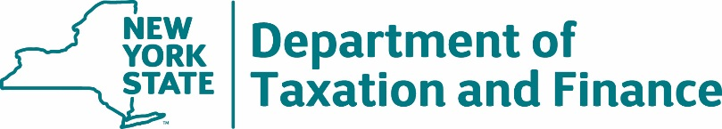

BUREAU OF FISCAL SERVICES
Procurement Unit

April 4, 2019

Request for Proposals (RFP) 18-104 Financial Institution Data Match (FIDM) Services
Amendment #3

To All Potential Bidders:
The Department is issuing Amendment #3 as clarification to:

- Amend the Schedule of Events;
Corrected pages are attached to this document. All deletions are shown as strikethrough text and additions are made in blue text.

All other requirements and conditions remain as indicated in the RFP.

Schedule of Events

Issuance of RFP | March 7, 2019
Deadline for Filing Offerer Understanding of, and Compliance with, Procurement Lobbying Guidelines Form (Attachment 2) | March 21, 2019
Deadline for Submission of Questions | March 21, 2019
Department Response to Bidder Questions | March 28, 2019  April 4, 2019  April 9, 2019
Deadline for Notification of Intent to Bid | April 9, 2019  April 11, 2019  April 18, 2019
Proposals Due | April 18, 2019  April 25, 2019  By 2:00 PM ET
Notification of Intent to Award | May 2, 2019  May 16, 2019
Deadline for Contract Signature | May 14, 2019  June 14, 2019
Anticipated Contract Start Date | August 1, 2019

