REQUEST FOR QUOTE #24-304
BID DUE TIME: June 13, 2024 by 2PM ET | TITLE: R-Series Courses
DESIGNATED CONTACTS:
Primary Contact  Daniel Bifani, Contract Management Specialist 1  Telephone No. (518) 530-4484  E-mail address: bfs.contracts@tax.ny.gov |  | Additional Contacts  Yafei Cao, Contract Management Specialist 3  Amber Alexander, Contract Management Specialist 4  Telephone No. (518) 530-4484  E-mail address: bfs.contracts@tax.ny.gov
The bid must be fully and properly executed by an authorized person. By signing you certify your express authority to sign on behalf of yourself, your company, or other entity and full knowledge and acceptance of this Request for Quote, Appendix A (Standard Clauses For New York State Contracts) and Appendix B (Bid Protest Policy) and that all information provided is complete, true and accurate. By signing, the bidder also affirms that it understands and agrees to comply with the Department of Taxation and Finance (“DTF”) procedures relative to permissible contacts as required by State Finance Law §139-j (3) and §139-j (6) (b). Information may be found on the Department’s Procurement website listed below.
DEPARTMENT PROCUREMENT WEBSITE: http://www.tax.ny.gov/about/procure

Bidder’s Federal Tax Identification Number (Do Not Use Social Security Number):
Bidder’s Ten-Digit Vendor ID Number (If Available):

Legal Business Name of Company Bidding:

D/B/A - Doing Business As (if applicable):

Street City State Zip

If you are not bidding, place an “x” in the box and return this page only.
◻ WE ARE UNABLE TO BID NOW BECAUSE:

Bidder’s Signature:  Title: | Printed or Typed Name:  Date:

GENERAL INFORMATION

IMPORTANT NOTICE TO POTENTIAL BIDDERS: Receipt of these bid documents does not indicate that the Department of Taxation and Finance has pre-determined your company's qualifications to receive a contract award. Such determination will be made after the bid opening and will be based on our evaluation of your bid submission compared to the specific requirements and qualifications contained in these bid documents. The award may be subject to the approval of the Office of the New York State Comptroller (OSC).

1.1 PURPOSE OF REQUEST FOR QUOTE (RFQ):
The New York State Department of Taxation and Finance (“DTF” or “Department”) is requesting bids (proposals) from qualified bidders to provide R-Series Courses. Bidders must meet the requirements and qualifications contained in these bid documents. They must be able to provide all the courses in order to submit a bid. One award will be made to the lowest-cost bidder.

1.2 SUBMISSION OF BIDS:
Bids must be received before the bid due time. Prepare and submit your bid in accordance with this RFQ and Attachment 1, Bidder’s Checklist.
You may email the bid to: bfs.contracts@tax.ny.gov
Or, you may mail the bid to the address located below:
New York State Department of Taxation and Finance
Procurement Unit
Attn: Amber Alexander, Procurement Director
Building 9 Room 234
W A Harriman Campus
Albany, NY 12227

Please note, if you are using a delivery service, the bid response should be addressed to the Department’s Procurement Unit, but the delivery address should be:
90 Cohoes Avenue
Green Island, New York 12183

State "BID ENCLOSED" and record the RFQ Number and Bid Due Date on the envelope containing the sealed bid. Failure to complete all information on the bid envelope may necessitate the premature opening of the bid which may compromise its confidentiality. An improperly submitted bid resulting in a late bid may not be considered.

1.3 DESIGNATED CONTACTS
All inquiries concerning this solicitation must be addressed to one of the following designated contacts:
- Daniel Bifani (Primary Contact)
- Yafei Cao
- Amber Alexander
Contacting individuals other than the designated contacts listed above may result in the disqualification of the Bidder’s proposal – please refer to the Procurement Lobbying Law and the Department guidelines posted on the Department’s procurement website provided on Page 1 of this document, and find additional requirements in Section 3, Administrative Requirements.

1.4 SUBMISSION OF BIDDER QUESTIONS
Prospective Bidders have one opportunity to submit written questions and requests for clarification regarding this solicitation. Questions and inquiries related to this solicitation must be submitted via email to bfs.contracts@tax.ny.gov or via fax to (518) 435-8413. No other method of inquiry will be accepted. Administrative issues pertaining to sending/receiving email through the designated mailbox may be reported to one of the designated contacts listed above at (518) 530-4484.
All questions regarding this solicitation must be received by the date specified in the Schedule of Events. Questions must reference the relevant page and section of the solicitation and must be directed to one of the designated contacts identified herein.
Questions submitted by Bidders should be in the following format:
# | RFQ Section | RFQ Page # | Bidder Name | Question
1
2
All clarifications and exceptions, including those relating to the terms and conditions of this solicitation, are to be resolved prior to the submission of a bid by utilizing the Question and Answer period. Also, during the Question and Answer period, Bidders should bring forward terms and conditions in this solicitation that would prohibit a Bidder from bidding. The Bidder that wins the award is expected to comply with all the terms and conditions contained herein.
The Department will post responses to all substantive questions on the Department Procurement website provided on Page 1 of this document by the date specified in the Schedule of Events.

1.5 ANNOUNCEMENTS, AMENDMENTS, AND CLARIFICATIONS
All amendments, clarifications, and any announcements related to this solicitation will be posted on the Department’s website on Page 1 of this document.
It is the responsibility of the Bidder to check the website for any amendments, response to Bidder questions, or updates. All applicable amendment information must be incorporated into the Bidder’s bid. Failure to include this information may result in the Bidder’s bid being deemed non-responsive and removed from further consideration.

1.6 SCHEDULE OF EVENTS

May 14, 2024 | Issuance of RFQ
May 23, 2024 | Deadline for Filing Offerer Understanding of, and Compliance with, Procurement Lobbying Guidelines (Attachment 2)
May 23, 2024 | Deadline for Submission of Written Questions
June 4, 2024 | Department Response to Bidder Questions Posted
June 13, 2024 by 2:00 PM ET | Bid Due Time
June 25, 2024 | Anticipated Notification of Intent to Award  (The award may be subject to the approval of the Office of the New York State Comptroller.)

PROGRAM SCOPE AND REQUIREMENTS
# | SCOPE AND REQUIREMENTS
1. | QUALIFYING MINIMUM REQUIREMENTS
1.1 | The Bidder must be listed on the New York State Department of State (DOS) website below:  Real Estate Appraiser Education | Department of State (ny.gov)
2. | GENERAL SCOPE AND REQUIREMENTS
2.1 | Program Term  DTF anticipates the courses will start around September 2024 and end before March 31, 2025.
2.2 | Required Courses  DTF requires the courses listed below. They must comply with DOS requirements for appraisal licensure.  - Residential 5 (R-5) - Basic Appraisal Principles (30 hours)  - Residential 6 (R-6) - Basic Appraisal Procedures (30 hours)  - Residential 8 (R-8) - Residential Appraisal Site Valuation and Cost Approach (15 hours)  - Residential 9 (R-9) - Residential Sales Comparison and Income Approach (30 hours)
2.3 | Estimated Number of Students  There will be approximately eighteen (18) students.
2.4 | Course Schedules  - The Bidder must teach the courses consecutively, collaborating with DTF for scheduling.  - Courses must be taught Monday through Friday.  - Courses must be taught between the hours of 8 AM and 6 PM with a maximum of 7.5 hours of instruction per day, allowing for a 10-minute break every hour and one 60-minute lunch.
2.5 | Course Delivery  The Bidder will provide the courses by livestreaming on WebEx or Zoom.
2.6 | Textbooks and Certificates  - The Bidder must provide printed textbooks for use and retention by students.  - The Bidder must provide the New York State exams for each course and a certificate of course completion to each student.
2.7 | Costs  The Bidder must submit bids by using Attachment 16 - Cost Response Form.  The Bidder must provide all pricing information requested on the Form. Any pricing information or add-on costs that do not conform to the presentation allowed on the Form cannot be evaluated, will be disregarded as extraneous, and cannot be charged to the Department after the award. All cost lines on Form must be inclusive of all costs associated with the cost lines. The fully loaded costs must include all other costs including, but not limited to, staffing, facilities, equipment, supplies, systems maintenance, management, program support activities, pass-through fees, and any indirect costs. There must be no additions, deletions, or omissions of cost lines from the Form. If the Bidder proposes a zero-value fee for any cost lines, that cost line should be marked as zero. If the Bidder leaves any cost line(s) blank, the Department will deem it a zero-value fee for that cost line.  If a student misses a course in this program, they will have the option to use the Bidder’s main offerings at the unit cost proposed by the Bidder for “13 or More Students” on the Form.  If a student does not complete a course, they will only be charged for the test book/ materials cost; they will not be charged for the course cost or the exam cost.

ADMINISTRATIVE REQUIREMENTS

  - Debriefing Sessions
Bidders will be notified in writing and, within fifteen (15) calendar days of such notification, may request the opportunity for a debriefing session. Such sessions will be limited to discussions of evaluation results as they apply to the Bidder receiving the debriefing.
  - Bid Protest Policy
The procedures for handling protests of Bid awards are set forth in Appendix B - Bid Protest Policy.
  - Reserved Rights
The New York State reserves the right to exercise the following:
- Prior to the opening of bids, amend the RFQ specifications to correct errors or oversights, or to change any of the scheduled dates, or to supply additional information, as it becomes available. Modifications to this RFQ shall be made by issuance of amendments and/or addenda.
- Prior to the opening of bids, direct Bidders to submit bid modifications addressing subsequent bid amendments.
- Withdraw the RFQ, in whole or in part.
- Eliminate any mandatory, non-material specifications with which no Bidder can comply.
- Waive any requirement(s) that is not material.
- Waive any immaterial deviation or defect in a bid. A waiver of immaterial deviation or defect shall in no way modify the RFQ documents or excuse a Bidder from full compliance with the RFQ requirements.
- Evaluate, accept and/or reject any and all bids, in whole or in part, and to waive technicalities, irregularities, and omissions if, in the State’s judgment, the best interests of the State will be served. In the event compliant bids are not received, the State reserves the right to consider late or non-conforming bids as offers.
- Require the Bidder to demonstrate, to the satisfaction of the State, any information presented as a part of their bids.
- Require clarification at any time during the procurement process, and/or require correction of arithmetic or other apparent errors, for the purpose of assuring a full and complete understanding of a Bidder’s bid and/or to determine a Bidder’s compliance with the requirements of the solicitation.
- Seek revisions of bids.
- Correct any arithmetical errors or other apparent errors in any bids and, in the event that the fees or costs in two or more bids are not comparable, to make appropriate adjustments to render the fees and costs comparable.
- Disqualify any Bidder whose conduct and/or bid fails to conform to the requirements of the solicitation.
- Negotiate with the successful Bidder within the scope of the RFQ to serve the best interests of the State.
- Proceed to the next highest ranked Bidder in the event that a Bidder who had achieved best cost prior to award cannot satisfy the requirements as stated in this RFQ.
- Utilize any and all ideas submitted in the bids received.
- Make an award under the RFQ, in whole or in part.

CONTRACT CONDITIONS
With the submission of a response to this RFQ, the Bidder agrees to all contract conditions outlined in this Section.
  - Appendix A
Appendix A – Standard Clauses for New York State Contracts (dated June 2023) will be incorporated, in its entirety, into any Agreement resulting from this RFQ.
  - Payments
All payments will be made in accordance with Article 11-A of the New York State Finance Law.
In addition, the following terms govern.
- Payment Procedures
  - Electronic Payment
Payment for invoices submitted by the Contractor will only be rendered electronically and in accordance with ordinary State procedures and practices. Contractor shall comply with the State Comptroller’s procedures to authorize electronic payments and acknowledges that Contractor will not receive payment on any invoices submitted under this Agreement if it does not comply with the State Comptroller’s electronic payment procedures. The Commissioner, in his/her sole discretion, may authorize payment by paper check, if specifically requested by the Contractor in advance, due to extenuating and documented circumstances necessitating payment by paper check.
In order to receive payment, Contractor must complete and update, as appropriate, its Vendor Record through the online Vendor Self-Service Portal with the applicable Automated Clearing House (ACH) information (e.g., bank routing number, bank account number, account type) into which the Contractor wants payment deposited. It is the Contractor’s responsibility to access the self-service portal, follow instructions provided there, and accurately supply the required information to set up electronic payments. The Contractor must input the required ACH information and not permit the payment type to default to payment by paper check. In addition to inputting the appropriate ACH information in the State Comptroller’s Vendor Record system, the Contractor must also advise DTF in writing of the ACH payment information (bank account location) into which it wants payment remitted for this Agreement. The Vendor Self-Service Portal can be found at https://esupplier.sfs.ny.gov/psp/fscm/SUPPLIER. Contractors requiring assistance with accessing or using the self-service portal should contact the NYS Statewide Financial System (SFS) by e-mail at helpdesk@sfs.ny.gov, or by telephone at (855) 233-8363.
  - Properly Submitted Invoices
Payment will be made only upon submission of proper invoices (see “Properly Submitted Invoices” below) by the Contractor, and in accordance with the provisions of Article 11-A of New York State Finance Law.
Required Information on properly submitted invoices:
    - Contractor's name.
    - Name of NYS Agency to which goods or services related to the invoice were provided.
    - Description of goods or services requesting payment for (may be in narrative or code values format).
    - Quantity of goods, property, or services delivered or rendered.
    - Amount requested.
    - A valid NYS Purchase Order (PO) Number and/or Contract number associated with the invoice.
All invoices and payments therefor are subject to the State’s review, approval, and acceptance of the Services for which billing is being made.
  - Submission
Preferred Method:
Submit invoices through the SFS Vendor Portal. (Note: Do not email or send a paper copy, in addition to submitting an invoice via the SFS Vendor Portal.)
Alternate Method:
Email invoices to the OGS-BSC at: accountspayable@ogs.ny.gov including the invoice number and the name of the agency being billed in the subject field. (Note: Do not send a paper copy in addition to the electronic invoice.)
OR
Mail invoices to OGS-BSC at the following U.S. postal address:
New York State Department of Taxation and Finance
c/o NYS OGS Business Services Center
1220 Washington Ave, Building 5, 5th Floor
Albany, NY 12226-1900
- Payment in the Event of Termination or Suspension
In the event of termination of the Agreement, the Contractor shall be compensated for Services not in dispute performed through the date of termination, in the State’s sole discretion.
In the event of suspension, the Contractor shall be compensated for non-suspended Services which are performed in a manner acceptable to the State, in its sole discretion.
- Payment Records
The Contractor must maintain adequate records as prescribed by the State to substantiate all claims for payment and must make those records available in New York State for examination and copying.
  - Public Announcements
Public announcements or news releases relating to this RFQ or the resulting Agreement shall not be made by any Bidder or its agent without the prior approval of the State. All requests for public announcements should be directed to one of the designated contacts specified herein. Such request for approval shall not be considered until a NYS purchase order is released.
  - New York State Vendor File
Prior to being awarded a contract pursuant to this Solicitation, the Bidder(s) and any designated authorized resellers who accept payment directly from the State, must be registered in the New York State Vendor File (Vendor File) administered by the Office of the State Comptroller (OSC). This is a central registry for all vendors who do business with New York State Agencies and the registration must be initiated by a State Agency. Following the initial registration, unique New York State ten-digit vendor identification numbers will be assigned to your company and to each of your authorized resellers (if any) for usage on all future transactions with New York State. Additionally, the Vendor File enables vendors to use the Vendor Self-Service application to manage all vendor information in one central location for all transactions related to the State of New York.
If the Bidder is already registered in the New York State Vendor File, list the ten-digit vendor ID number on the first page of the RFQ document. Authorized resellers already registered should list the ten-digit vendor ID number along with the authorized reseller information.
If the Bidder is not currently registered in the Vendor File, complete the enclosed Attachment 3 - New York State Office of the State Comptroller Substitute Form W-9, and submit it with your Bid. In addition, if authorized resellers are to be used, an OSC Substitute W-9 form should be completed and filed by each of the designated authorized resellers. The DTF Procurement Services Unit will initiate the vendor registration process for all Bidders recommended for contract Award and their authorized resellers. Once the process is initiated, registrants will receive an email from OSC that includes the unique ten-digit vendor identification number assigned to the company and instructions on how to enroll in the online Vendor Self-Service application.
For more information on the vendor file please visit the following website:
https://www.osc.state.ny.us/state-vendors/portal/enroll-vendor-self-service-portal
  - Contractor Requirements and Procedures for Participation by New York State-Certified Minority and Women-Owned Business Enterprises and Equal Employment Opportunities for Minority Group Members and Women
New York State Law
The Department of Taxation and Finance (“Department”) is required to implement the provisions of New York State Executive Law Article 15-A and Parts 140-145 of Title 5 of the New York Codes, Rules and Regulations (“NYCRR”) for all State contracts, as defined therein, with a value in excess of $25,000 for labor, services, equipment, materials, or any combination of the foregoing.
Business Participation Opportunities for MWBEs
For purposes of this solicitation, the Department of Taxation and Finance hereby establishes an overall goal of 0% for MWBE participation, 0% for New York State-certified Minority-owned Business Enterprise (“MBE”) participation and 0% for New York State-certified Women-owned Business Enterprise (“WBE”) participation (based on the current availability of MBEs and WBEs).
  - Equal Employment Opportunity Requirements
By submission of a Bid or Proposal in response to this solicitation, the respondent agrees with all of the terms and conditions of Appendix A – Standard Clauses for New York State Contracts including Clause 12 - Equal Employment Opportunities for Minorities and Women. The respondent is required to ensure that it and any subcontractors awarded a subcontract for the construction, demolition, replacement, major repair, renovation, planning or design of real property and improvements thereon (the "Work"), except where the Work is for the beneficial use of the respondent, undertake or continue programs to ensure that minority group members and women are afforded equal employment opportunities without discrimination because of race, creed, color, national origin, sex, age, disability or marital status. For these purposes, equal opportunity shall apply in the areas of recruitment, employment, job assignment, promotion, upgrading, demotion, transfer, layoff, termination, and rates of pay or other forms of compensation. This requirement does not apply to: (i) work, goods, or services unrelated to the Contract; or (ii) employment outside New York State.

The respondent will be required to submit a Minority and Women-Owned Business Enterprise - Equal Employment Opportunity Policy Statement, Attachment 4, to the State with its Bid or Proposal.

The Contractor shall submit Attachment 5 – Staffing Plan to document the composition of the proposed workforce to be utilized in the performance of the Contract by the specified categories listed, including ethnic background, gender, and Federal occupational categories. The Contractor shall complete Attachment 5 and submit it as part of their Bid or Proposal or within a reasonable time, as directed by the Department.

If awarded a Contract, the respondent shall submit a Workforce Utilization Report, Attachment 6, and shall require each of its subcontractors to submit a Workforce Utilization Report, in such form as shall be required by the State on a quarterly basis during the term of the Contract.

Pursuant to Executive Order #162, contractors and subcontractors are also required to report the gross wages paid to each of their employees for the work performed by such employees on the contract on a quarterly basis.

Further, pursuant to Article 15 of the Executive Law (the “Human Rights Law”), all other State and Federal statutory and constitutional non-discrimination provisions, the Contractor and sub-contractors will not discriminate against any employee or applicant for employment because of race, creed (religion), color, sex, national origin, sexual orientation, military status, age, disability, predisposing genetic characteristic, marital status or domestic violence victim status, and shall also follow the requirements of the Human Rights Law with regard to non-discrimination on the basis of prior criminal conviction and prior arrest.

Please Note: Failure to comply with the foregoing requirements may result in a finding of non-responsiveness, non-responsibility and/or a breach of the Contract, leading to the withholding of funds, suspension or termination of the Contract or such other actions or enforcement proceedings as allowed by the Contract.
  - Participation Opportunities for New York State Certified Service-Disabled Veteran-Owned Business Enterprises
Article 3 of the New York State Veterans’ Services Law provides for more meaningful participation in public procurement by certified Service-Disabled Veteran-Owned Businesses (“SDVOBs”), thereby further integrating such businesses into New York State’s economy. The Department of Taxation and Finance recognizes the need to promote the employment of service-disabled veterans and to ensure that certified service-disabled veteran-owned businesses have opportunities for maximum feasible participation in the performance of the contracts.
In recognition of the service and sacrifices made by service-disabled veterans and in recognition of their economic activity in doing business in New York State, Bidders/Contractors are strongly encouraged and expected to consider SDVOBs in the fulfillment of the requirements of the Department of Taxation and Finance contracts. Such participation may be as subcontractors or suppliers, as protégés, or in other partnering or supporting roles.
For purposes of this procurement, the Department conducted a comprehensive search and determined that the Contract does not offer sufficient opportunities to set specific goals for participation by SDVOBs as subcontractors, service providers, and suppliers to Contractor. Nevertheless, Bidder/Contractor is encouraged to make good faith efforts to promote and assist in the participation of SDVOBs on the Contract for the provision of services and materials. The directory of New York State Certified SDVOBs can be viewed at: https://ogs.ny.gov/veterans/
Bidder/Contractor is encouraged to contact the Office of General Services’ Division of Service-Disabled Veteran’s Business Development at 518-474-2015 or VeteransDevelopment@ogs.ny.gov to discuss methods of maximizing participation by SDVOBs on the Contract.
  - Permission to Investigate
In the event that the State determines it necessary to investigate evidence relative to a possible or actual 1) crime or 2) breach of confidentiality or security, Contractor and its Subcontractors shall cooperate fully with the State to the extent permitted by law to investigate and identify the responsible individuals. Contractor and its Subcontractors shall, to the extent permitted by law, make their employees and all relevant records, including personnel records and employee photographs, available to State and/or other Investigators upon request by the State.
  - Workers’ Compensation and Disability Benefits Certifications
Sections 57 and 220 of the New York State Workers’ Compensation Law (WCL) provide that the State shall not enter into any contract unless proof of workers’ compensation and disability benefits insurance coverage is produced. Prior to entering into a contract with the State, successful Bidders will be required to verify for the State, on forms authorized by the New York State Workers’ Compensation Board, the fact that they are properly insured or are otherwise in compliance with the insurance provisions of the WCL. The forms to be used to show compliance with the WCL are listed below. Any questions relating to either workers’ compensation or disability benefits coverage should be directed to the State of New York Workers’ Compensation Board, Bureau of Compliance at (518) 462-8882 or (866) 298-7830. Failure to provide verification of either of these types of insurance coverage by the time an Agreement is ready to be executed will be grounds for disqualification of an otherwise successful Proposal.
The successful Bidder must submit the following documentation within a reasonable period after notification of selection for award:
- Proof of Workers’ Compensation Coverage:
Upon notification of award, the successful Bidder will be requested to submit ONE of the following forms as Workers’ Compensation documentation:
- Form C-105.2 – Certificate of NYS Workers’ Compensation Insurance Coverage issued by private insurance carrier (or Form U-26.3 issued by the State Insurance Fund); or
- Form SI-12 – Certificate of NYS Workers’ Compensation Self-Insurance Coverage (or Form SIG-105.2 Certificate of Participation in Workers’ Compensation Group Board-Approved Self-Insurance); or
- Form CE-200 – Certificate of Attestation of Exemption from NYS Workers’ Compensation and/or Disability Benefits Coverage.
- Proof of Disability Benefits Coverage:
Upon notification of award, the successful Bidder will be requested to submit ONE of the following forms as Disability documentation:
- Form DB-120.1 – Certificate of Insurance Coverage under the NYS Disability and Paid Family Leave Benefits Law; or
- Form DB-155 – Certificate of Self-Insurance Coverage under the NYS Disability and Paid Family Leave Benefits Law; or
- Form CE-200 – Certificate of Attestation of Exemption from NYS Workers’ Compensation and/or Disability Benefits Coverage.
Further information is available at the Workers’ Compensation Board’s website, which can be accessed through this link: http://www.wcb.ny.gov.
NOTE: An ACORD form is not acceptable proof of New York State Workers’ Compensation or Disability Benefits insurance coverage.
  - Vendor Responsibility
Article XI §163(4)(d) of the State Finance Law states that “service contracts shall be awarded on the basis of best value to a responsive and responsible offerer.” Upon identification of the Bidder with the highest score, the Bidders’ Vendor Responsibility will be analyzed to ensure that the Bidder is responsible. In the event that a Bidder is found to be not responsible, the Bidder may be disqualified.
- General Responsibility
The Contractor shall at all times during the Agreement term remain responsible. The Contractor agrees, if requested by the Commissioner of Taxation and Finance, or their designee, to present evidence of its continuing legal authority to do business in New York State, integrity, experience, ability, prior performance, and organizational and financial capacity.
- Suspension of Work (for Non-Responsibility)
The Commissioner, or their designee, in their sole discretion, reserves the right to suspend any or all activities under this Agreement, at any time, when they discover information that calls into question the responsibility of the Contractor. In the event of such suspension, the Contractor will be given written notice outlining the particulars of such suspension. Upon issuance of such notice, the Contractor must comply with the terms of the suspension order. Contract activity may resume at such time as the Commissioner, or their designee, issues a written notice authorizing resumption of performance under the Agreement.
- Termination (for Non-Responsibility)
Upon written notice to the Contractor, and a reasonable opportunity to be heard with appropriate Department officials or staff, the Agreement may be terminated by the Commissioner, or their designee, at the Contractor’s expense where the Contractor is determined by the Commissioner, or their designee, to be non-responsible. In such event, the Commissioner, or their designee, may complete the contractual requirements in any manner they may deem advisable and pursue available legal or equitable remedies for breach.
  - Non-Collusive Bidding Practices Certification
A Bid shall not be considered for award nor shall any award be made where the conditions of the Non-Collusive Bidding Certification have not been complied with; provided, however, that if in any case the Bidder cannot make the foregoing certification, the Bidder shall so state and shall furnish with the Bid a signed statement which sets forth in detail the reasons therefore. Where the above conditions have not been complied with, the Bid shall not be considered for award nor shall any award be made unless the head of the purchasing unit of the State, public department or agency to which the Bid is made, or his designee, determines that such disclosure was not made for the purpose of restricting competition (Section 139-d of the State Finance Law).
The Bidder is responsible for reading, signing and submitting the Attachment 7 - Non-Collusive Bidding Certification.
  - Procurement Lobbying
Pursuant to State Finance Law §§139-j and 139-k, this solicitation includes and imposes certain restrictions on communications between the State and an Offerer/Bidder during the procurement process. An Offerer/Bidder is restricted from making contacts from the earliest notice of intent to solicit offers/Bids through final award and approval of the Procurement Contract by the State and, if applicable, the Office of the State Comptroller (“restricted period”) to other than designated staff unless it is a contract that is included among certain statutory exceptions set forth in State Finance Law §139-j (3) (a). Designated DTF staff, as of the date hereof, are identified on the first page of this RFQ document. DTF employees are also required to obtain certain information when contacted during the restricted period and make a determination of the responsibility of the Offerer/Bidder pursuant to these two statutes. Certain findings of non-responsibility can result in rejection for contract award and, in the event of two findings within a four-year period, the Offerer/Bidder is debarred from obtaining governmental Procurement Contracts. Information related to the Procurement Lobbying Law and the guidelines can be found on the Department’s Procurement website at: http://www.tax.ny.gov/about/procure.
Contacting individuals other than the designated contacts listed in the Preface Section of this document during the restricted period may result in disqualification of the Bidder’s Proposal – please refer to the Procurement Lobbying Law and the guidelines posted on the Department’s website at: http://www.tax.ny.gov/about/procure.
- Offerer Disclosure of Prior Non-Responsibility Determinations
New York State Finance Law §139-k(2) obligates a Governmental Entity to obtain specific information regarding prior non-responsibility determinations with respect to State Finance Law §139-j. This information must be collected in addition to the information that is separately obtained pursuant to State Finance Law §163(9). In accordance with State Finance Law §139-k, an Offerer must be asked to disclose whether there has been a finding of non-responsibility made within the previous four (4) years by any Governmental Entity due to: (1) a violation of State Finance Law §139-j or (2) the intentional provision of false or incomplete information to a Governmental Entity. The terms “Offerer” and “Governmental Entity” are defined in State Finance Law §139-k(1). State Finance Law §139-j sets forth detailed requirements about the restrictions on Contacts during the procurement process. A violation of State Finance Law §139-j includes, but is not limited to, an impermissible Contact during the restricted period (for example, contacting a person or entity other than the designated contact person, when such contact does not fall within one of the exemptions).
As part of a Governmental Entity’s responsibility determination, State Finance Law §139-k(3) mandates consideration of whether an Offerer fails to timely disclose accurate or complete information regarding the above non-responsibility determination. In accordance with law, no Procurement Contract shall be awarded to any Offerer that fails to timely disclose accurate or complete information under this Section, unless a finding is made that the award of the Procurement Contract to the Offerer is necessary to protect public property or public health or safety, and that the Offerer is the only source capable of supplying the required Article of Procurement within the necessary timeframe. See State Finance Law §§139-j(10)(b) and 139-k(3).
A Governmental Entity must include a disclosure request regarding prior non-responsibility determinations in accordance with State Finance Law §139-k in its solicitation of Proposals or Bid documents or specifications or Contract documents, as applicable, for Procurement Contracts. The attached form is to be completed and submitted by the individual or entity seeking to enter into a Procurement Contract. It shall be submitted to the Governmental Entity conducting the Governmental Procurement.
Bidder must complete and submit the Attachment 8 - Offerer Disclosure of Prior Non-Responsibility Determinations.
- Offerer’s Certification of Compliance with State Finance Law §139-k(5)
New York State Finance Law §139-k(5) requires that every Procurement Contract Award subject to the provisions of State Finance Law §§139-k or 139-j shall contain a certification by the Offerer that all information provided to the procuring Governmental Entity with respect to State Finance Law §139-k is complete, true and accurate.
The State reserves the right to terminate any Contract award as a result of this RFQ in the event it is found that the certification filed by the Offerer/Bidder in accordance with New York State Finance Law §139-k was intentionally false or intentionally incomplete.
Each Bidder must complete and submit Attachment 9 - Offerer’s Certification of Compliance with State Finance Law §139-k(5).
  - Ethics Compliance
All Bidders/Contractors and their employees must comply with Public Officers Law §§73 and 74 to the extent applicable, Chapter 1 of the Laws of 2005, the Procurement Lobbying Reform Act, and other State statutes, rules, regulations and executive orders establishing ethical standards for the conduct of business with New York State. In signing the Bid, the Bidder certifies full compliance with those provisions for any present or future dealings, transactions, sales, Contracts, services, offers, relationships, etc., involving New York State and/or its employees. Failure to comply with those provisions may result in disqualification from the bidding process, termination of Contracts, and/or other civil or criminal proceedings as required by law.
Each Bidder must complete and submit Attachment 10 - Public Officers Law Form and Attachment 11 - Public Officers Law – Post Employment Restrictions which addresses business or professional activities by current or past state officers and employees and party officers. These forms shall be made part of the resultant Agreement.
  - Assurance of No Conflict of Interest
The Bidder offering to provide Services pursuant to this RFQ as a Contractor, or Subcontractor, as applicable, attests that its performance of the Services outlined in this RFQ does not and will not create a conflict of interest with nor position the Bidder to breach any other contract currently in force with the State of New York. Upon request to the Contractor, the Department may require this form to be executed and submitted by any Subcontractor working under this Agreement. The Bidder will complete and submit Attachment 12 - Vendor Assurance of No Conflict of Interest or Detrimental Effect
  - Prime Contractors/Subcontractors
If any subcontracting is allowed with respect to any services to be provided under a State contract, the successful Bidder shall act as Prime Contractor under the Agreement, and shall be held solely responsible for contract performance by the Bidder, its partners, officers, employees, Subcontractors and agents. The Bidder shall be responsible for payment of all Subcontractors and suppliers, including all third-party service providers contracted by or through the Bidder in performance of the Agreement.
Where services are supplied by or through the Contractor under the Agreement, it is mandatory for the Contractor to assume full integration responsibility for delivery, installation, maintenance, performance and support services for such items, as applicable. The Contractor shall also be responsible for payment of any license fees, rents or other monies due third parties for services or materials provided under this Agreement.

  - Executive Order No. 177 Certification
In accordance with Executive Order No. 177, the Bidder must certify that it does not have institutional policies or practices that fail to address the harassment and discrimination of individuals on the basis of their age, race, creed, color, national origin, sex, sexual orientation, gender identity, disability, marital status, military status or other protected status under the Human Rights Law.
The Bidder is responsible for reading, signing and submitting the Attachment 13 – EO 177 Certification.
  - Sexual Harassment Prevention Certification
State Finance Law §139-l requires Bidders on state procurements to certify that they have a written policy addressing sexual harassment prevention in the workplace and provide annual sexual harassment training to all their employees and that such policy, at a minimum, meets the requirements of Section two hundred one-g of the labor law.
The Bidder must complete and submit Attachment 14 – Sexual Harassment Prevention Certification.
  - Executive Order No. 16 Certification
In accordance with Executive Order No. 16, the Bidder must certify that it does not conduct any commercial activity in Russia or transact business with the Russian Government or with commercial entities headquartered in Russia or with their principal place of business in Russia in the form of contracting, sales, purchasing, investment, or any business partnership.
The Bidder is responsible for reading, signing and submitting the Attachment 15 – EO 16 Certification.

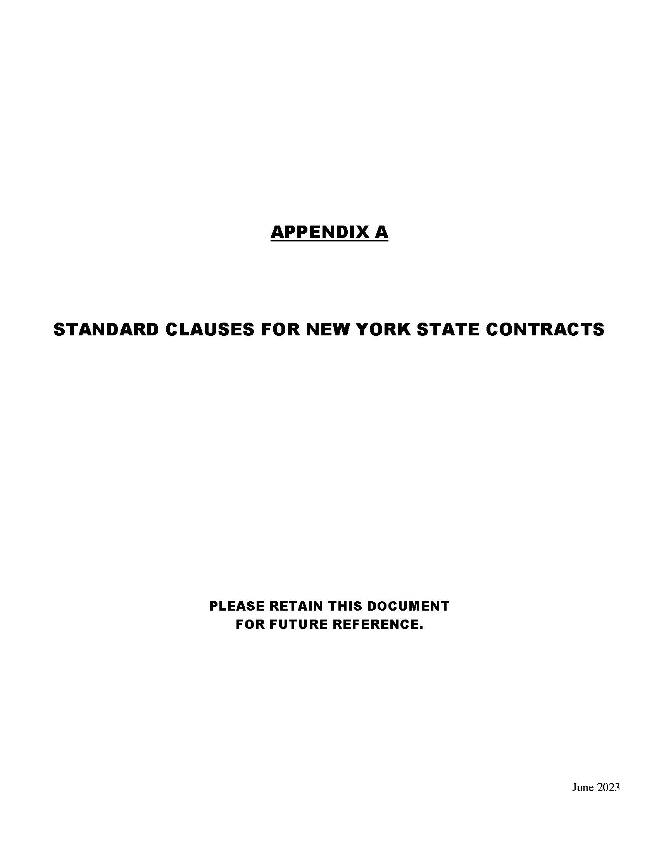
Appendix A – Standard Clauses for New York State Contracts
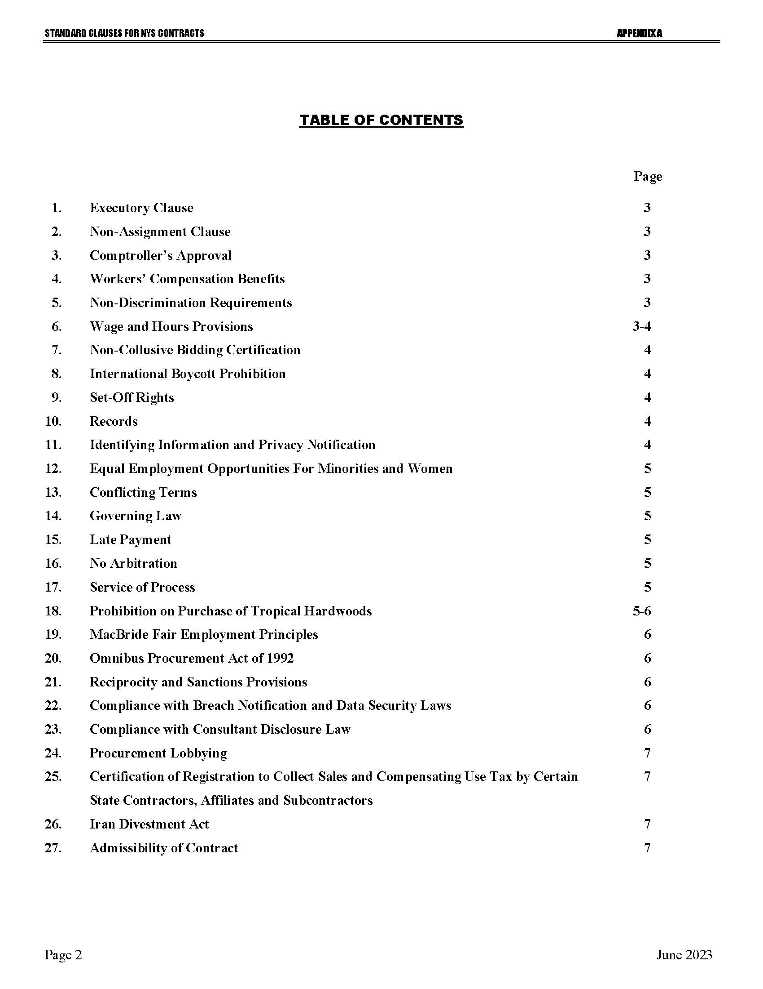
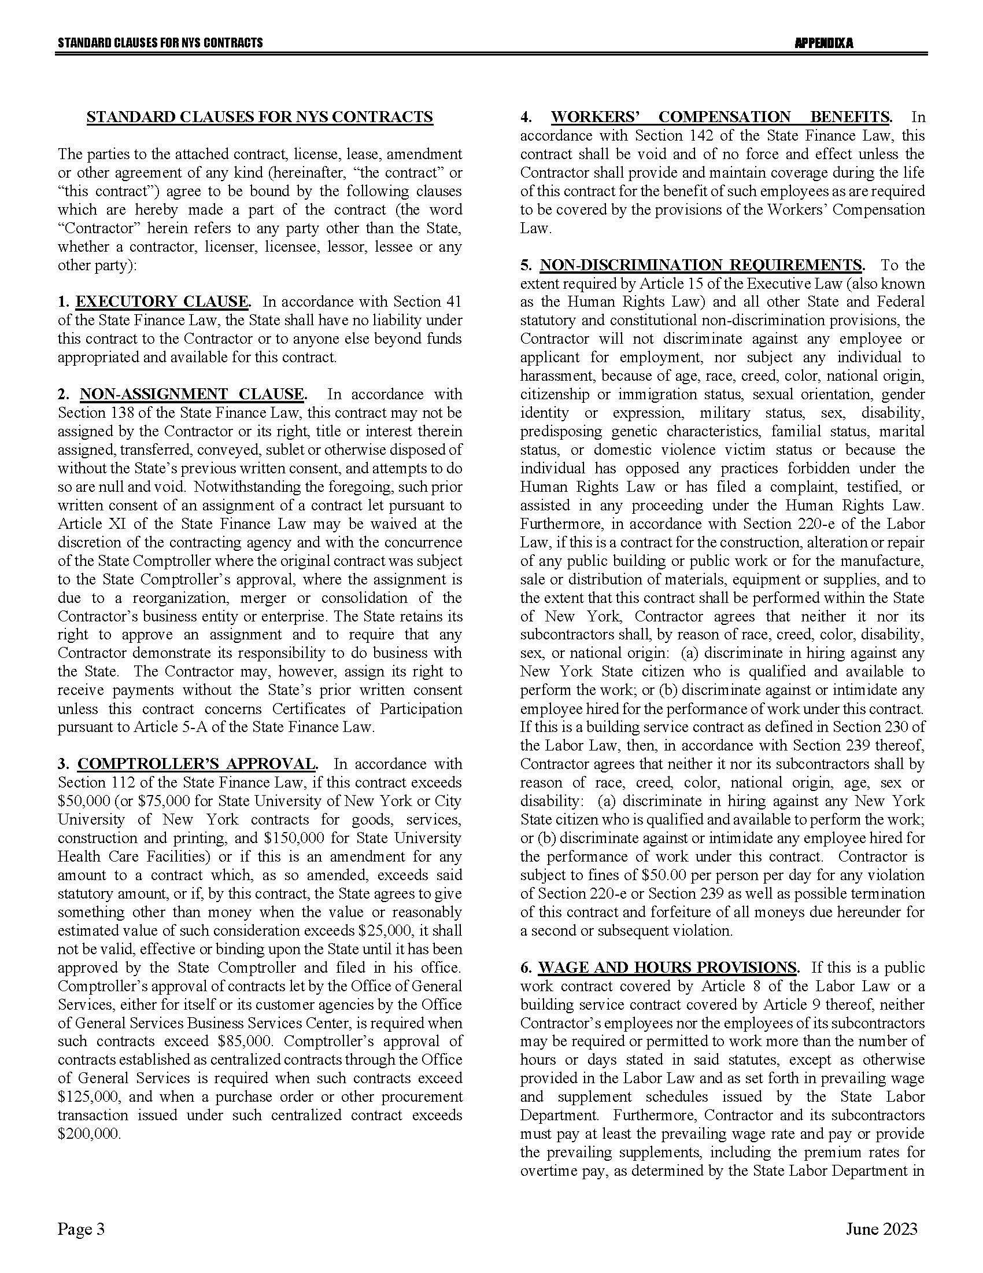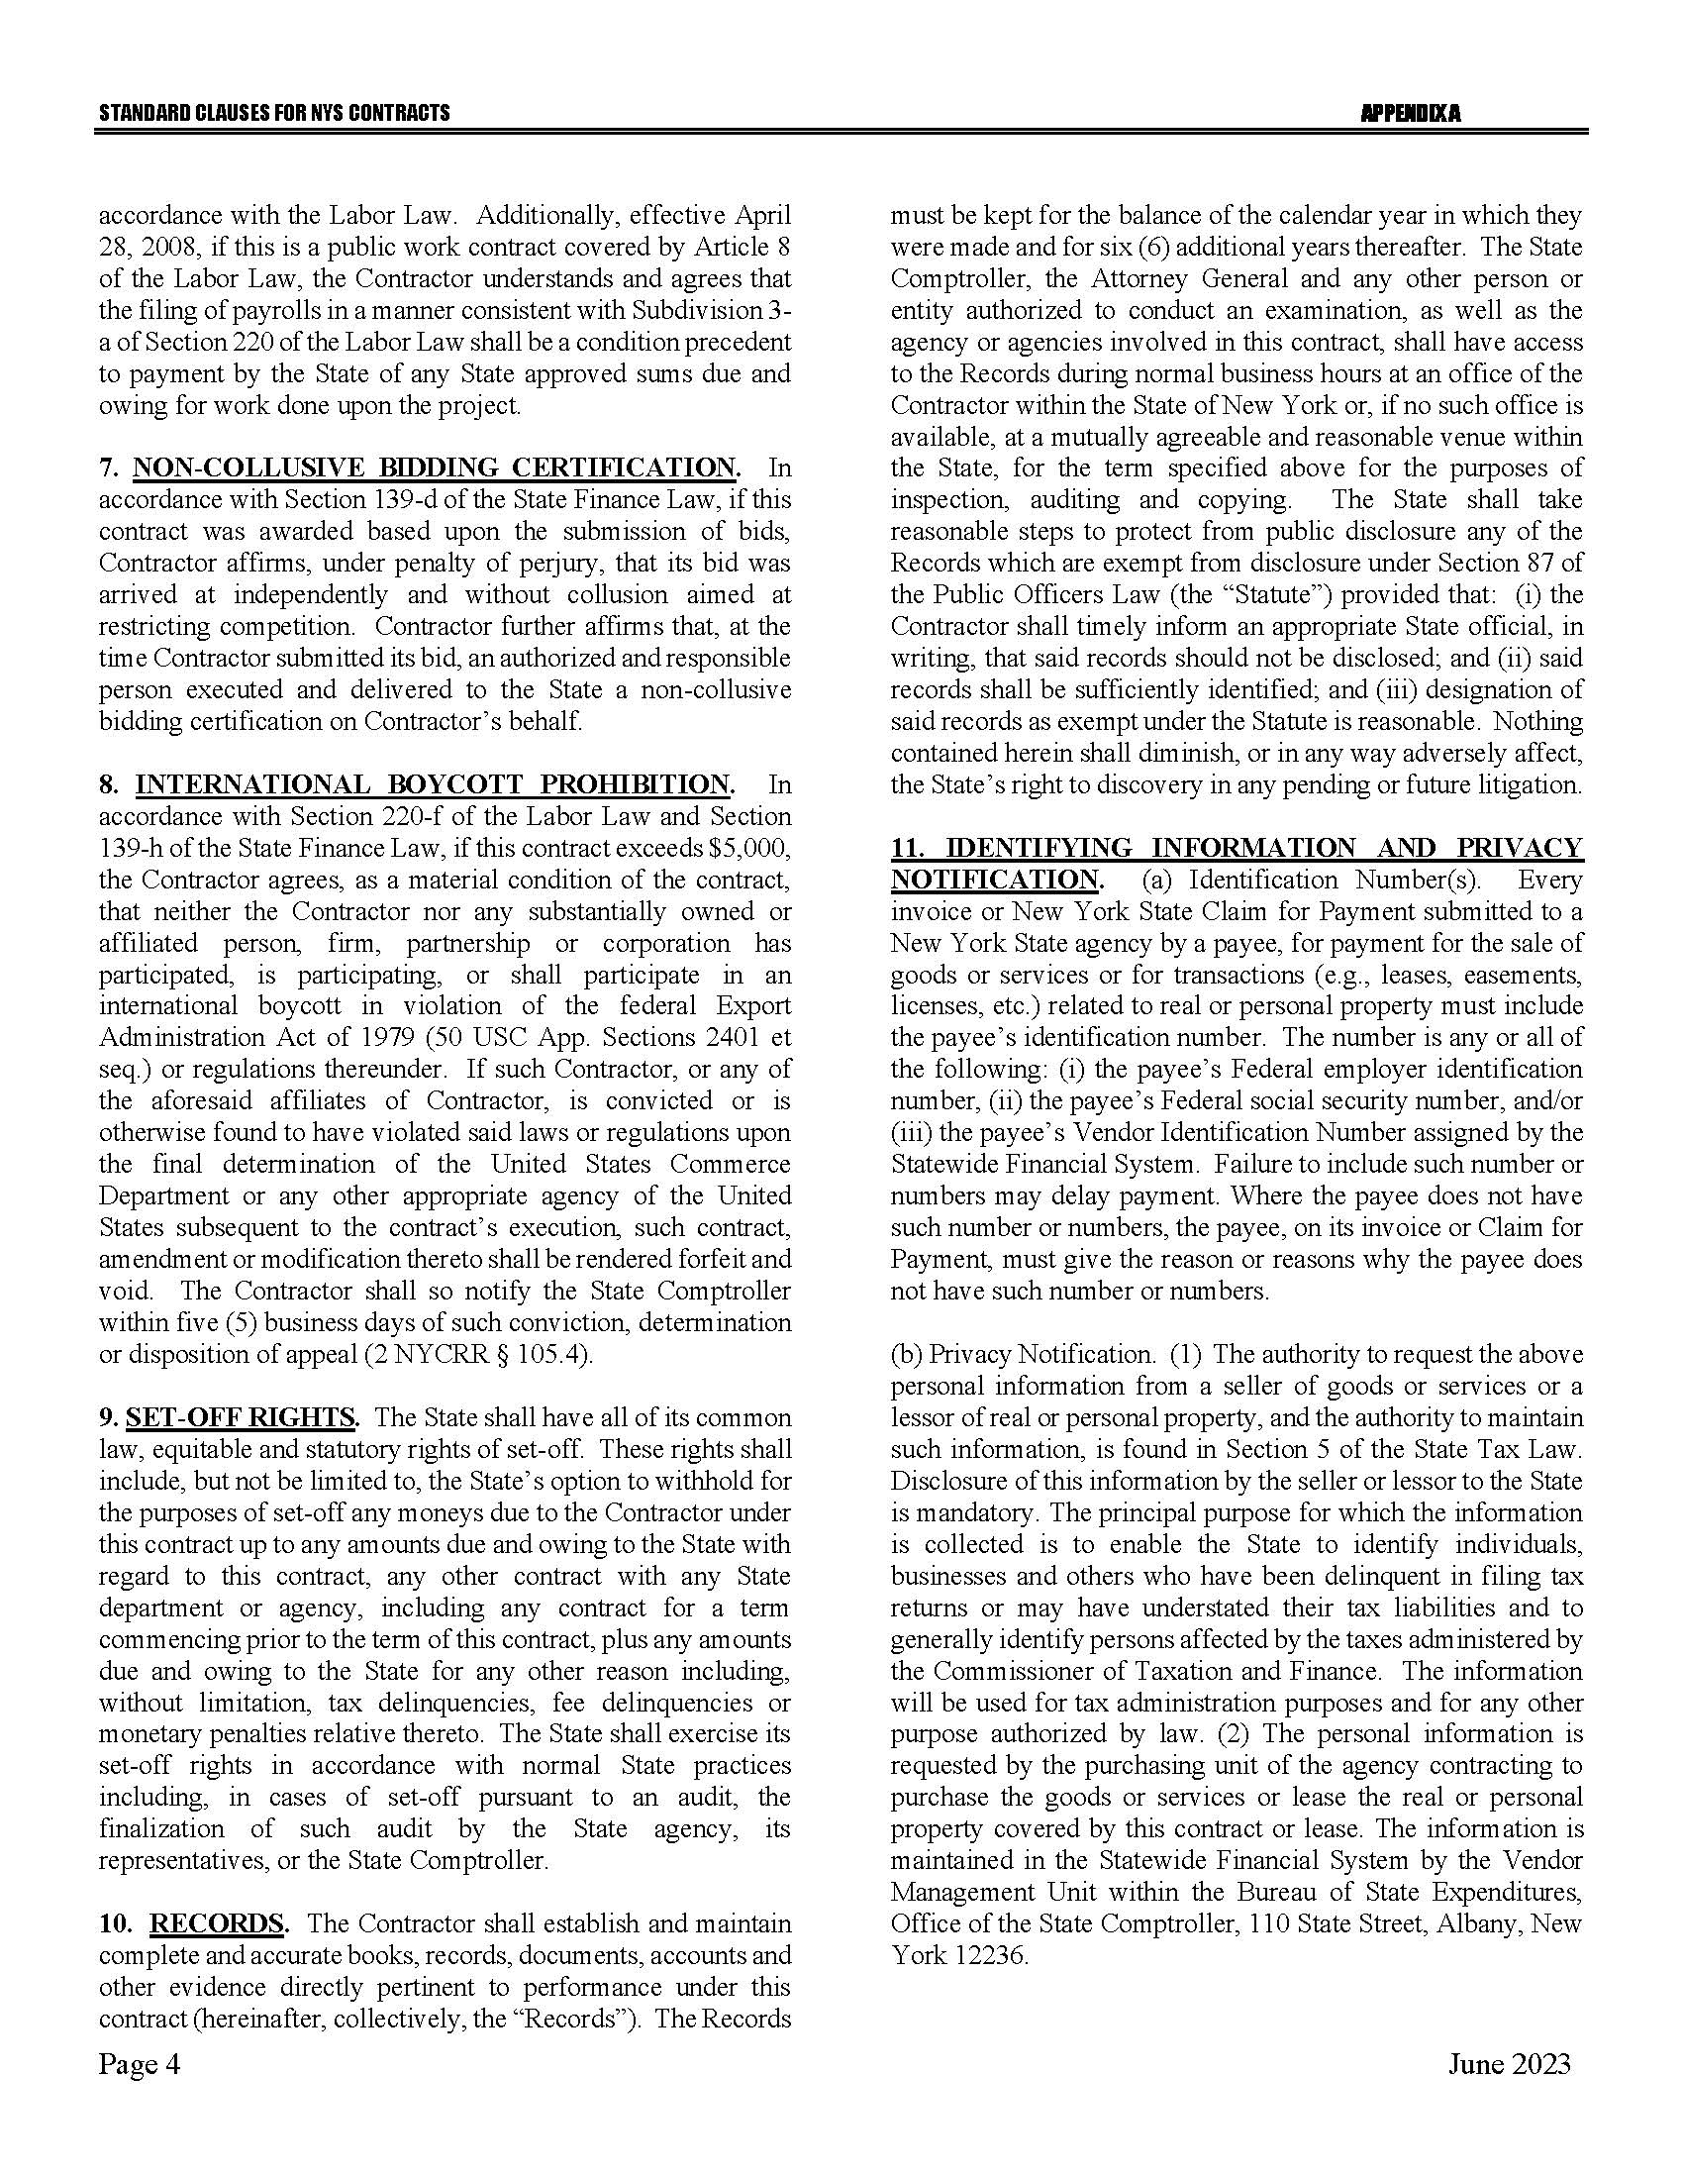
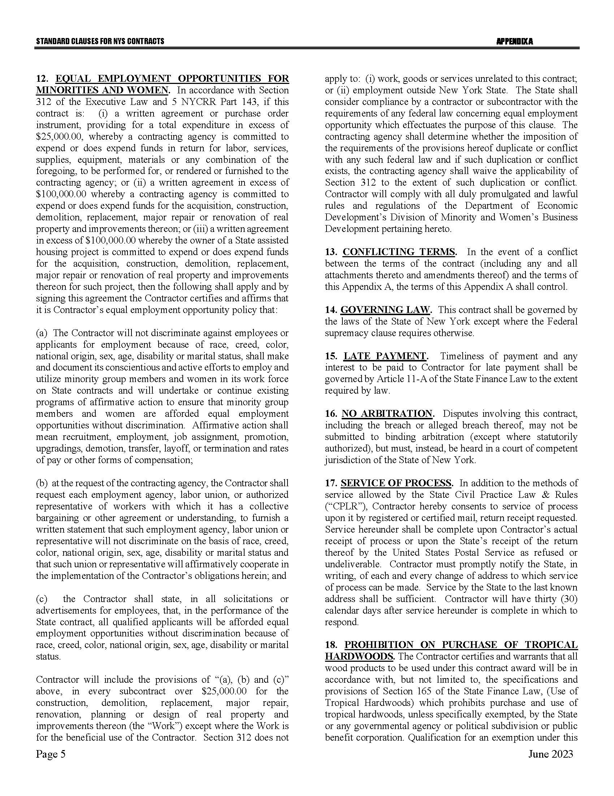
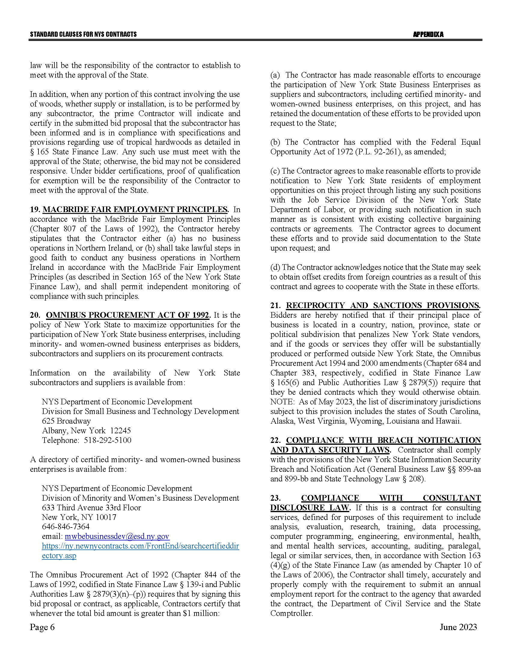
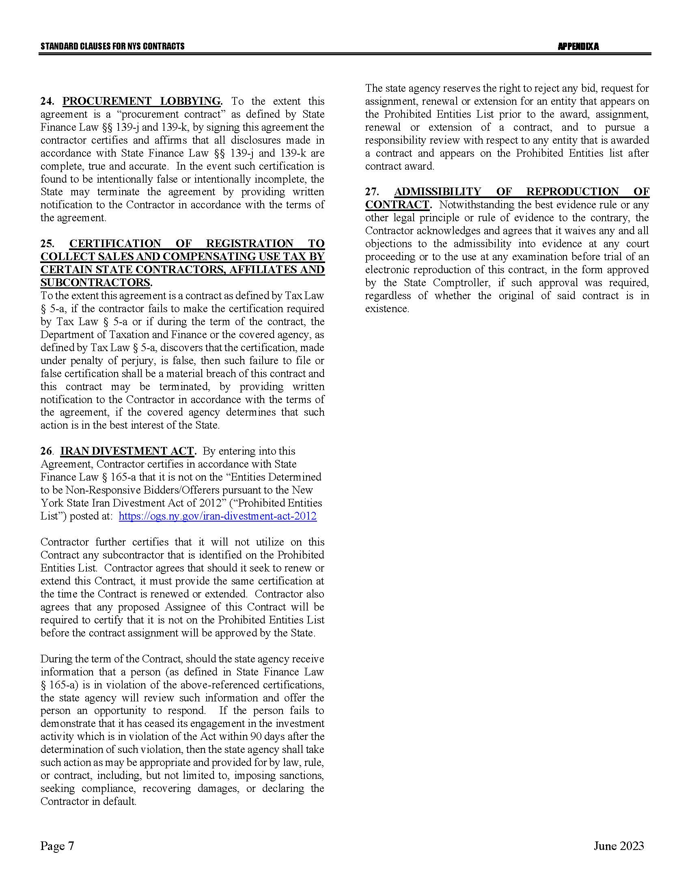

Appendix B – Bid Protest Policy
DTF Protest Procedure
Section 1 Applicability
Section 2 Definitions
Section 3 General Protest Guidelines
Section 4 Protest Procedure
Section 5 Appeal process
Section 1: Applicability
These guidelines set forth the procedure to be utilized when an Interested Party challenges a Contract Award by the New York State Department of Taxation and Finance. The guidelines shall apply to all Contract Awards made by the Department and approved by the New York State Office of the State Comptroller, including bid Solicitations, Sole Source procurements, Single Source procurements, and Emergency procurements.
Section 2: Definitions
- "Contract Award" is a written determination from DTF to an Offeror indicating that the DTF has selected a particular Offeror under the procurement process.
- “DTF” or “Department” means the New York State Department of Taxation and Finance.
- "Emergency" means an urgent and unexpected requirement where health and public safety or the conservation of public resources is at risk (see New York State Finance Law, Section 163.1.b).
- "Interested Party" means a participant in the procurement process and those whose participation in the procurement process has been foreclosed by the actions of the DTF and have suffered harm as a result of the manner in which the procurement was conducted.
- “Offeror” means the entity submitting an offer to DTF.
- "OSC" means the New York State Office of the State Comptroller.
- "Protest" means a written challenge by an Interested Party of a Contract Award that is subject to the approval of OSC.
- “Protesting Party” means an Interested Party who has filed a Protest.
- "Single Source" means a procurement in which, although two or more offerors can supply the required commodities or services, DTF, upon written findings setting forth the material and substantial reasons therefor, awards the contract to one offeror over the other (see New York State Finance Law, Section 163.1.h).
- "Sole Source" means a procurement in which only one offeror is capable of supplying the required commodities or services (see New York State Finance Law, Section 163.1.g).
- “Solicitation” means a document issued by DTF, requesting a response to a procurement need, including an Invitation for Bids, a Request for Proposals, or another written method seeking a Bid or Proposal for a specified purpose.
- "Successful Bidder" means the Bidder or offeror whose Bid or Proposal has been selected for Contract Award by DTF.
Section 3: General Protest Guidelines

  - Any Interested Party will be given the opportunity to participate in the Protest procedure.
A Protest submitted to DTF must be in writing and must contain specific factual and legal allegations setting forth the basis on which the Protesting Party challenges the Contract Award by DTF. A Protest must include:
- a statement of all legal and/or factual grounds for disagreement with a DTF procurement determination;
- a description of all remedies or relief requested; and
- copies of all applicable supporting documentation.
  - DTF may, at its sole discretion, waive any deadline or requirement set forth in these guidelines, or consider any materials submitted beyond the time periods set forth in these guidelines.
  - Where DTF deems appropriate, DTF may require the Protesting Party, DTF staff involved in the procurement, the Successful Bidder, or any other Interested Party, to address and/or submit further information with respect to additional issues raised by any DTF review of the procurement.
  - Nothing herein shall preclude DTF from obtaining information relevant to the procurement from any other source, as it may deem appropriate.
Section 4: Protest Procedure

  - Any Interested Party may file, by mail or electronic mail, a Protest with the DTF Director of Procurement. The following statement must be clearly and prominently displayed on the envelope or package or header of electronic transmittal: “Bid Protest of DTF Solicitation (Reference Number)” when being submitted regarding a Solicitation and “Protest of DTF Contract Award (Reference Number)” when being submitted regarding a contract being entered into on a non-competitive basis.
  - Timing of Protest submission:
- Concerning Errors, Omissions or Prejudice in the Bid Specifications, Requirements or Documents - Protests which concern the drafting of Bid specifications must be received by DTF at least ten business days before the date set in the Solicitation for receipt of Bids. If the date set in the Solicitation for receipt of Bids is less than ten business days from the date of issue, Protests concerning the specifications must be received by DTF at least 48 hours before the time designated for receipt of Bids.
- Concerning Proposed Contract Award - Protests concerning a pending Contract Award must be received within ten business days after the notice of Contract Award or five business days after receiving a debriefing.
  - The DTF Director of Procurement may summarily deny a Protest that fails to contain specific factual or legal allegations, or where the Protest raises only issues of law that have already been decided by the courts or by the OSC Bureau of Contracts.
  - An Interested Party may file only one Protest with respect to a specific Solicitation.
  - The DTF Director of Procurement shall issue a written determination addressing all issues raised by the Protest, as well as any relevant issues raised by his/her review of the procurement or contract. The determination shall make findings of fact and conclusions of law on any issues in dispute. All participants in the Protest and the Successful Bidder shall be provided a copy of the determination. The determination shall be made part of the procurement record.
Section 5: Appeal Process

  - The Protest determination of DTF shall be deemed a final and conclusive agency determination unless a written notice of appeal is received no more than five business days after the date the written Protest decision is sent to the Offeror. Such notice of appeal must be filed in writing at the address set forth below:
Chief Financial Officer
New York State Department of Taxation and Finance
Reference: Bid Protest of DTF Solicitation (provide procurement reference number) (or, Protest of DTF Contract Award [Reference Number])
Building 9 W.A. Harriman Campus
Albany, NY 12227
  - The Chief Financial Officer shall review and make a final written determination on all appeals within ten business days of the date the Appeal is received. A Protest appeal may not introduce new facts or legal allegations unless responding to issues newly raised as a result of the written Protest determination.
Section 6: OSC Appeal Process

  - An Interested Party must file an appeal of the Department’s determination of a Protest with the OSC Bureau of Contracts within ten business days of receiving DTF’s final written determination on appeal.
  - In its appeal, the Interested Party shall set forth the basis on which it challenges DTF’s Protest determination. The Interested Party shall also include, as an exhibit to its appeal, a copy of the initial Bid Protest submitted to the Department and the determination of such Bid Protest issued by DTF.
The appeal must be in writing and a copy must be delivered to DTF and the Successful Bidder (unless the Successful Bidder is the appealing party in which case a copy of the appeal must be delivered to the original Protesting Party), and any other party that participated in the Protest conducted by DTF.
The appeal must be filed with:
Bureau Director at bidprotests@osc.ny.gov
or
Bureau of Contracts
New York State Office of the State Comptroller
110 State Street, 11th Floor
Albany, NY 12236

January 2024

Attachment 1 – Bidder’s Checklist

 | ☐ | Attachment 1 | – | Bidder’s Checklist
 | ☐ | Attachment 2 | – | Offerer Understanding of, and Compliance with, Procurement Lobbying Guidelines (if not already submitted with Bidder Questions)
 | ☐ | Attachment 3 | – | New York State Office of the State Comptroller Substitute Form W-9 (if Bidder does not have a New York State ten-digit Vendor ID number)
 | ☐ | Attachment 4 | – | Minority and Women-Owned Business Enterprises - Equal Employment Opportunity Policy Statement
 | ☐ | Attachment 5 | – | Staffing Plan
 | ☐ | Attachment 7 | – | Non-Collusive Bidding Certification
 | ☐ | Attachment 8 | – | Offerer Disclosure of Prior Non-Responsibility Determinations
 | ☐ | Attachment 9 | – | Offerer Certification of Compliance with State Finance Law 139-k(5)
 | ☐ | Attachment 10 | – | Public Officers Law Form
 | ☐ | Attachment 11 | – | Public Officers Law – Post Employment Restrictions
 | ☐ | Attachment 12 | – | Vendor Assurance of No Conflict of Interest or Detrimental Effect
 | ☐ | Attachment 13 | – | EO 177 Certification
 | ☐ | Attachment 14 | – | Sexual Harassment Prevention Certification
 | ☐ | Attachment 15 | – | Certification Under Executive Order No. 16
 | ☐ | Attachment 16 | – | Cost Response Form

Attachment 2 – Offerer Understanding of, and Compliance with, Procurement Lobbying Guidelines
New York State Finance Law 139-j(6)(b) requires the DTF seek written affirmation from all Offerers as to the Offerer’s understanding of, and agreement to comply, with the DTF procedures relating to permissible contacts during a Government Procurement pursuant to subdivision three of this section.

Procurement Description, Contract or Bid Number:
Request for Quote #24-304 R-Series Courses
Offerer Name
Offerer Address:
Telephone Number:
Email Address:

Offerer affirms it has read, understands and agrees to comply with the Guidelines of the New York State Department of Taxation and Finance relative to permissible contacts as required by the State Finance Law 139-j(3) and 139-j(6)(b).

By (signature):
Name (please print):
Title (please print):
Date:

Attachment 3 – New York State Office of the State Comptroller Substitute Form W-9
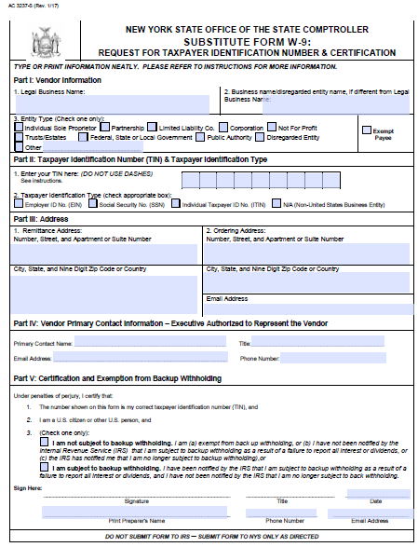
Note: This form is available at the NYS Office of State Comptroller website: https://www.osc.state.ny.us/vendors/forms/ac3237s_fe.pdf

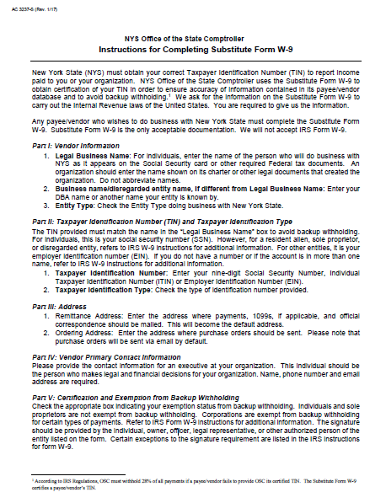

Attachment 4 – Minority and Women-Owned Business Enterprises – Equal Employment Opportunity Policy Statement
I, _________________________, the (awardee/contractor) ____________________ agree to adopt the following policies with respect to the project being developed or services rendered at
____________________________________________________________________________.
M/WBE

EEO

This organization will and will cause its contractors and subcontractors to take good faith actions to achieve the M/WBE contract participations goals set by the State for that area in which the State-funded project is located, by taking the following steps:

- Actively and affirmatively solicit bids for contracts and subcontracts from qualified State certified MBEs or WBEs, including solicitations to M/WBE contractor associations.

- Request a list of State-certified M/WBEs from AGENCY and solicit bids from them directly.

- Ensure that plans, specifications, request for proposals and other documents used to secure bids will be made available in sufficient time for review by prospective M/WBEs.

- Where feasible, divide the work into smaller portions to enhanced participations by M/WBEs and encourage the formation of joint venture and other partnerships among M/WBE contractors to enhance their participation.

- Document and maintain records of bid solicitation, including those to M/WBEs and the results thereof. Contractor will also maintain records of actions that its subcontractors have taken toward meeting M/WBE contract participation goals.

- Ensure that progress payments to M/WBEs are made on a timely basis so that undue financial hardship is avoided, and that bonding and other credit requirements are waived or appropriate alternatives developed to encourage M/WBE participation.

a. This organization will not discriminate against any employee or applicant for employment because of race, creed, color, national origin, sex, age, disability or marital status, will undertake or continue existing programs of affirmative action to ensure that minority group members are afforded equal employment opportunities without discrimination, and shall make and document its conscientious and active efforts to employ and utilize minority group members and women in its work force on state contracts.

b. This organization shall state in all solicitation or advertisements for employees that in the performance of the State contract all qualified applicants will be afforded equal employment opportunities without discrimination because of race, creed, color, national origin, sex disability or marital status.

c. At the request of the contracting agency, this organization shall request each employment agency, labor union, or authorized representative will not discriminate on the basis of race, creed, color, national origin, sex, age, disability or marital status and that such union or representative will affirmatively cooperate in the implementation of this organizations’ obligations herein.

d. Contractor shall comply with the provisions of the Human Rights Law, all other State and Federal statutory and constitutional non-discrimination provisions. Contractor and subcontractors shall not discriminate against any employee or applicant for employment because of race, creed (religion), color, sex, national origin, sexual orientation, marital status or domestic violence victim status, and shall also follow the requirements of the Human Rights Law with regard to non-discrimination on the basis of prior criminal conviction and prior arrest.

- This organization will include the provisions of sections (a) through (d) of this agreement in every subcontract in such a manner that the requirements of the subdivisions will be binding upon each subcontractor as to work in connection with the State. contract.

Agreed to this _____ day of ___________________, 20____
By (signature) _______________________________________
Print: __________________________________ Title:__________________________________
_________________________________is designated as the Minority Business Enterprise Liaison
(Name of Designated Liaison)
responsible for administering the Minority and Women-Owned Business Enterprises- Equal
Employment Opportunity (M/WBE-EEO) program.

M/WBE Contract Goals
____0____% Minority and Women’s Business Enterprise Participation
____0____% Minority Business Enterprise Participation
____0____% Women’s Business Enterprise Participation

____________________________________________
(Authorized Representative)

Title: ________________________________________
Date: ____________________________________

Attachment 5 – Staffing Plan
Instructions on Page 2 of this form

Solicitation No.: | Reporting Entity: | Report includes Contractor’s/Subcontractor’s:  ☐ Work force to be utilized on this contract  ☐ Total work force
Offerer’s Name: |  | ☐ Offerer  ☐ Subcontractor
Offerer’s Address: |  |  | Subcontractor’s name
Enter the total number of employees for each classification in each of the EEO-Job Categories identified
EEO-Job Category | Total Work force | Work force by Gender |  |  | Work force by  Race/Ethnic Identification
 |  | Total  Male  (M) | Total  Female  (F) |  | White |  | Black |  | Hispanic |  | Asian |  | Native American |  | Disabled |  |  | Veteran
 |  |  |  |  | (M) | (F) | (M) | (F) | (M) | (F) | (M) | (F) | (M) | (F) | (M) |  | (F) | (M) | (F)
Officials/ Administrators
Professionals
Technicians
Sales Workers
Office/Clerical
Craft Workers
Laborers
Service Workers
Temporary /Apprentices
Totals

PREPARED BY (Signature): | TELEPHONE NO.:  EMAIL ADDRESS: |  | DATE:
NAME AND TITLE OF PREPARER (Print or Type): |  | Submit completed with bid or proposal M/WBE 101 (Rev 11/08)

General Instructions: All Offerers and each subcontractor identified in the bid or proposal must complete an EEO Staffing Plan (M/WBE 101) and submit it as part of the bid or proposal package. Where the work force to be utilized in the performance of the State contract can be separated out from the contractor’s and/or subcontractor’s total work force, the Offerer shall complete this form only for the anticipated work force to be utilized on the State contract. Where the work force to be utilized in the performance of the State contract cannot be separated out from the contractor’s and/or subcontractor’s total work force, the Offerer shall complete this form for the contractor’s and/or subcontractor’s total work force.
Instructions for completing:
- Enter the Solicitation number that this report applies to along with the name and address of the Offerer.
- Check off the appropriate box to indicate if the Offerer completing the report is the contractor or a subcontractor.
- Check off the appropriate box to indicate work force to be utilized on the contract or the Offerers’ total work force.
- Enter the total work force by EEO job category.
- Break down the anticipated total work force by gender and enter under the heading ‘Work force by Gender’
- Break down the anticipated total work force by race/ethnic identification and enter under the heading ‘Work force by Race/Ethnic Identification’. Contact the OM/WBE Permissible contact(s) for the solicitation if you have any questions.
- Enter information on disabled or veterans included in the anticipated work force under the appropriate headings.
- Enter the name, title, phone number and email address for the person completing the form. Sign and date the form in the designated boxes.
RACE/ETHNIC IDENTIFICATION
Race/ethnic designations as used by the Equal Employment Opportunity Commission do not denote scientific definitions of anthropological origins. For the purposes of this form, an employee may be included in the group to which he or she appears to belong, identifies with, or is regarded in the community as belonging. However, no person should be counted in more than one race/ethnic group. The race/ethnic categories for this survey are:
 |  | WHITE | (Not of Hispanic origin) All persons having origins in any of the original peoples of Europe, North Africa, or the Middle East.
 |  | BLACK | a person, not of Hispanic origin, who has origins in any of the black racial groups of the original peoples of Africa.
 |  | HISPANIC | a person of Mexican, Puerto Rican, Cuban, Central or South American or other Spanish culture or origin, regardless of race.
ASIAN & PACIFIC ISLANDER |  |  | a person having origins in any of the original peoples of the Far East, Southeast Asia, the Indian subcontinent or the Pacific Islands.
NATIVE INDIAN (NATIVE AMERICAN/ ALASKAN NATIVE) |  |  | a person having origins in any of the original peoples of North America, and who maintains cultural identification through tribal affiliation or community recognition.
OTHER CATEGORIES
 |  | DISABLED INDIVIDUAL | any person who: | - has a physical or mental impairment that substantially limits one or more major life activity(ies)
 |  |  |  | - has a record of such an impairment; or
 |  |  |  | - is regarded as having such an impairment.
 |  | VIETNAM ERA VETERAN | a veteran who served at any time between and including January 1, 1963 and May 7, 1975.
 |  | GENDER | Male or Female

Attachment 6 – Workforce Utilization Report

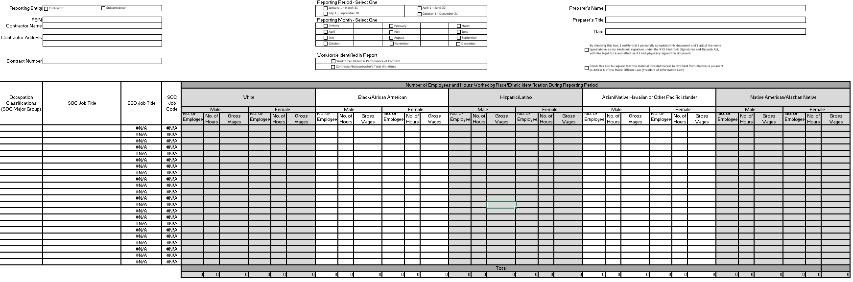
Note: An Excel file of this form will be provided to the Contractor after contract execution.

M/WBE 101 (Rev 11/08)

Attachment 7 – Non-Collusive Bidding Certification
In accordance with Section 139-d of the State Finance Law:
- By submission of this Bid, the Bidder and each person signing on behalf of the Bidder certifies, and in the case of a joint Bid, each party thereto certifies as to its own organization, under penalty of perjury, that to the best of their knowledge and belief:
- The prices in this Bid have been arrived at independently, without collusion, consultation, communication, or agreement, for the purpose of restricting competition, as to any matter relating to such prices with any other Bidder or with any competitor;
- Unless otherwise required by law, the prices which have been quoted in this Bid have not been knowingly disclosed by the Bidder and will not knowingly be disclosed by the Bidder prior to opening, directly or indirectly, to any other Bidder or to any competitor; and
- No attempt has been made or will be made by the Bidder to induce any other person, partnership or corporation to submit or not to submit a Bid for the purpose of restricting competition.
- A Bid shall not be considered for award nor shall any award be made where (a), (1), (2), and (3) above have not been complied with; provided however, that if in any case the Bidder cannot make the foregoing certification, the Bidder shall so state and shall furnish with the bid a signed statement which sets forth in detail the reasons therefor. Where (a), (1), (2), and (3) above have not been complied with, the Bid shall not be considered for award nor shall any award be made unless the head of the purchasing unit of the state, public department or agency to which the Bid was made, or his/her designee, determines that such disclosure was not made for the purpose of restricting competition.
The fact that a Bidder has published price lists, rates, or tariffs covering items or services being procured, has informed prospective customers of proposed or pending publication of new or revised price lists for such items, or has sold the same items to other customers at the same prices being Bid, does not constitute a disclosure within the meaning stated above.

The Bidder certifies adherence to all conditions in the Non-Collusive Bidding Practices subsection of this RFQ.
Bidder Name
Bidder Address:
Authorized Signature:
Name:
Title:

Attachment 8 – Offerer Disclosure of Prior Non-Responsibility Determinations

New York State Finance Law §139-k(2) obligates a Governmental Entity to obtain specific information regarding prior non-responsibility determinations with respect to State Finance Law §139-j. This information must be collected in addition to the information that is separately obtained pursuant to State Finance Law §163(9). In accordance with State Finance Law §139-k, an Offerer must be asked to disclose whether there has been a finding of non-responsibility made within the previous four (4) years by any Governmental Entity due to: (a) a violation of State Finance Law §139-j or (b) the intentional provision of false or incomplete information to a Governmental Entity. The terms “Offerer” and “Governmental Entity” are defined in State Finance Law § 139-k(1). State Finance Law §139-j sets forth detailed requirements about the restrictions on contacts during the procurement process. A violation of State Finance Law §139-j includes, but is not limited to, an impermissible contact during the restricted period (for example, contacting a person or entity other than the designated contact person, when such contact does not fall within one of the exemptions).
As part of its responsibility determination, State Finance Law §139-k(3) mandates consideration of whether an Offerer fails to timely disclose accurate or complete information regarding the above non-responsibility determination. In accordance with State Finance Law, no Procurement Contract shall be awarded to any Offerer that fails to timely disclose accurate or complete information under this section, unless a finding is made that the award of the Procurement Contract to the Offerer is necessary to protect public property or public health safety, and that the Offerer is the only source capable of supplying the required article of procurement within the necessary timeframe. See State Finance Law §§139-j (10)(b) and 139-k(3).

A Governmental Entity must include a disclosure request regarding prior non-responsibility determinations in accordance with State Finance Law §139-k in its solicitation of Proposals or Bid documents or specifications or contract documents, as applicable, for procurement contracts. The attached form is to be completed and submitted by the individual or entity seeking to enter into a Procurement Contract. It shall be submitted to the Governmental Entity conducting the Governmental Procurement.
Procurement Description, Contract or Bid Number:
Request for Quote #24-304 R-Series Courses
Offerer Name
Offerer Address:
Phone Number:
Email Address:
Name and Title of Person Submitting This Form:

- Has any New York State agency or authority made a finding of non-responsibility regarding the Offerer in the last four (4) years? (Please circle):
No Yes
If “Yes” please answer the following questions:
- Was the basis for the finding of the Offerer’s non-responsibility due to a violation of State Finance Law 139-j? (Please circle):
No Yes
- Was the basis for the finding of the Offerer’s non-responsibility due to the intentional provision of false or incomplete information to a Governmental Entity? (Please circle):
No Yes
- If you responded “Yes” to Questions 1, 2 or 3, please provide details regarding the finding of non-responsibility below:
Government Entity:
Date of Finding of Non-responsibility :
Facts Underlying Finding of Non-Responsibility (Add additional pages as necessary):

- Has any New York State agency or authority terminated a procurement contract with the Offerer due to the intentional provision of false or incomplete information? (Please circle):
No Yes
If “Yes” to Question 5, please provide details below:
Government Entity:
Date of Termination or Withholding of Contract :
Basis of Termination or Withholding of Contract:

Offerer certifies that all information provided to the DTF with respect to State Finance Law 139-k is complete, true and accurate.
Authorized Signature:
Name:
Date:

Attachment 9 – Offerer Certification of Compliance with State Finance Law 139-k(5)
New York State Finance Law 139-k(5) requires that every Procurement Contract Award subject to the provisions of State Finance Law 139-k or 139-j shall contain a certification by the Offerer that all information provided to the procuring Government Entity with respect to State Finance Law 139-k is complete, true and accurate.

Offerer Certification
I certify that all information provided to the DTF with respect to State Finance Law 139-k is complete, true and accurate.

Offerer’s Signature:
Date:

Procurement Description, Contract or Bid Number:
Request for Quote #24-304 R-Series Courses
Name:
Title:
Offerer Name:
Offerer Address:
Email Address:
Phone Number:

Attachment 10 – Public Officers Law Form
Disclosure of business or professional activities by state officers and employees and party officers.
§ 73. Business or professional activities by state officers and employees and party officers.
4. (a) No statewide elected official, state officer or employee, member of the legislature, legislative employee or political party chairman or firm or association of which such person is a member, or corporation, ten per centum or more of the stock of which is owned or controlled directly or indirectly by such person, shall (i) sell any goods or services having a value in excess of twenty-five dollars to any state agency, or (ii) contract for or provide such goods or services with or to any private entity where the power to contract, appoint or retain on behalf of such private entity is exercised, directly or indirectly, by a state agency or officer thereof, unless such goods or services are provided pursuant to an award or contract let after public notice and competitive bidding. This paragraph shall not apply to the publication of resolutions, advertisements or other legal propositions or notices in newspapers designated pursuant to law for such purpose and for which the rates are fixed pursuant to law.
- Is the Bidder a New York State officer, employee, or party officer?
YES ☐ NO ☐

- Are any of the members of Bidder’s firm or corporation, who own or control ten per centum or more of stock, a New York State officer, employee, or party officer?
YES ☐ NO ☐

- Is the proposed subcontractor (if applicable) a New York State officer, employee, or party officer?
YES ☐ NO ☐

Bidder affirms it has read, understands and agrees to comply with the Guidelines of Public Officers Law § 73 (4)(a).
By (signature):
Name:
Title:
Date:

Attachment 11 – Public Officers Law – Post Employment Restrictions
By signing below and submitting a proposal to this RFQ, the signatory certifies, for and on behalf of the Bidder, that:
- He/she/they has read and understands the provisions applicable to post employment restrictions affecting former State officers and employees, available using the link* below:
- Public Officers Law § 73(8)(a)(i), (the two-year bar); and
- Public Officers Law § 73(8)(a)(ii), (the life-time bar);
- Submission of this proposal does not violate either provision;
- He/she/they is familiar with or has made diligent inquiry of, the Bidder's relevant employees, and agents;
- No violation shall occur by entering into a contract or in performance of the contractual services;
- This certification is material to the proposal; and
- He/she/they understands that the Department intends to rely on this certification.
The Bidder shall fully disclose to the Department, within its proposal and on a continuing basis, any circumstances that affect this certification or the Bidder’s ability to comply with the cited laws. Bidders shall address any questions concerning §73(8) of the Public Officers Law to:
New York State
Commission on Ethics and Lobbying in Government
540 Broadway
Albany, NY 12207
Telephone #: (518) 408-3976
By (signature):
Name:
Title:
Date:
*Click on this link: Public Officers Law, Article 4. When the page opens, click on “Laws of New York”. On the next page, select “PBO Public Officers”. When this page opens, select “Article 4 – (60 - 79) POWERS AND DUTIES OF PUBLIC OFFICERS” and see Sections 73 (8-a)(i) and 73 (8-a)(ii

Attachment 12 – Vendor Assurance of No Conflict of Interest or Detrimental Effect
The Bidder offering to provide services pursuant to this RFQ attests that its performance of the services outlined does not and will not create a conflict of interest with, nor position the Bidder to breach, any other contract currently in force with the State of New York.
Furthermore, the Bidder attests that it will not act in any manner that is detrimental to any State project on which the Bidder is rendering services. Specifically, the Bidder attests that:
- The fulfillment of obligations by the Bidder, as proposed in the response, does not violate any existing contract or agreement between the Bidder and the State;
- The fulfillment of obligations by the Bidder, as proposed in the response, does not and will not create any conflict of interest, or perception thereof, with any current role or responsibility that the Bidder has with regard to any existing contract or agreement between the Bidder and the State;
- The fulfillment of obligations by the Bidder, as proposed in the response, does not and will not compromise the Bidder’s ability to carry out its obligations under any existing contract between the Bidder and the State;
- The fulfillment of any other contractual obligations that the Bidder has with the State will not affect or influence its ability to perform under any contract with the State resulting from this solicitation;
- During the negotiation and execution of any contract resulting from this solicitation, the Bidder will not knowingly take any action or make any decision which creates a potential for conflict of interest or might cause a detrimental impact to the State as a whole including, but not limited to, any action or decision to divert resources from one State project to another;
- In fulfilling obligations under each of its State contracts, including any contract which results from this solicitation, the Bidder will act in accordance with the terms of each of its State contracts and will not knowingly take any action or make any decision which might cause a detrimental impact to the State as a whole including, but not limited to, any action or decision to divert resources from one State project to another;
- No former officer or employee of the State who is now employed by the Bidder, nor any former officer or employee of the Bidder who is now employed by the State, has played a role with regard to the administration of this contract procurement in a manner that may violate section 73(8)(a) of the State Ethics Law; and
- The Bidder has not and shall not offer to any employee, member or director of the State any gift, whether in the form of money, service, loan, travel, entertainment, hospitality, thing or promise, or in any other form, under circumstances in which it could reasonably be inferred that the gift was intended to influence said employee, member or director, or could reasonably be expected to influence said employee, member or director, in the performance of the
official duty of said employee, member or director or was intended as a reward for any official action on the part of said employee, member or director.
The Bidder should note that the State recognizes that conflicts may occur in the future because a Bidder may have existing or new relationships. The State will review the nature of any such new relationship and reserves the right to terminate the contract for cause if, in its judgment, a real or potential conflict of interest cannot be cured.
By (Signature): |  |  |  | Name:
 | Date: |  | Title:

This form must be signed by an authorized executive or legal representative.
Attachment 13 – EO 177 Certification
The New York State Human Rights Law, Article 15 of the Executive Law, prohibits discrimination and harassment based on age, race, creed, color, national origin, sex, pregnancy or pregnancy-related conditions, sexual orientation, gender identity, disability, marital status, familial status, domestic violence victim status, prior arrest or conviction record, military status or predisposing genetic characteristics.
The Human Rights Law may also require reasonable accommodation for persons with disabilities and pregnancy-related conditions. A reasonable accommodation is an adjustment to a job or work environment that enables a person with a disability to perform the essential functions of a job in a reasonable manner. The Human Rights Law may also require reasonable accommodation in employment on the basis of Sabbath observance or religious practices.
Generally, the Human Rights Law applies to:
- all employers of four or more people, employment agencies, labor organizations and apprenticeship training programs in all instances of discrimination or harassment;
- employers with fewer than four employees in all cases involving sexual harassment; and,
- any employer of domestic workers in cases involving sexual harassment or harassment based on gender, race, religion or national origin.

In accordance with Executive Order No. 177, the Bidder hereby certifies that it does not have institutional policies or practices that fail to address the harassment and discrimination of individuals on the basis of their age, race, creed, color, national origin, sex, sexual orientation, gender identity, disability, marital status, military status, or other protected status under the Human Rights Law.
Executive Order No. 177 and this certification do not affect institutional policies or practices that are protected by existing law, including but not limited to the First Amendment of the United States Constitution, Article 1, Section 3 of the New York State Constitution, and Section 296(11) of the New York State Human Rights Law.
Contractor :
By (signature):
Name:
Title:
Date:

This form must be signed by an authorized executive or legal representative.

Attachment 14 – Sexual Harassment Prevention Certification
State Finance Law §139-l requires Bidders on state procurements to certify that they have a written policy addressing sexual harassment prevention in the workplace and provide annual sexual harassment training to all its employees and that such policy, at a minimum, meets the requirements of section two hundred one-g of the labor law.
Check one:
☐ | By submission of this Bid, each Bidder and each person signing on behalf of any Bidder certifies, and in the case of a joint bid each party thereto certifies as to its own organization, under penalty of perjury, that the Bidder has and has implemented a written policy addressing sexual harassment prevention in the workplace and provides annual sexual harassment prevention training to all of its employees. Such policy shall, at a minimum, meet the requirements of section two hundred one-g of the labor law.
 | OR
☐ | If the Bidder cannot make the above certification, the Bidder must provide a signed statement with their Bid detailing the reasons therefor.

Offerer’s Name:
By (signature):
Name:
Title:
Date:
This form must be signed by an authorized executive or legal representative.

Attachment 15 – EO 16 Certification
Executive Order No. 16 provides that “all Affected State Entities are directed to refrain from entering into any new contract or renewing any existing contract with an entity conducting business operations in Russia.” The complete text of Executive Order No. 16 can be found here.
The Executive Order remains in effect while sanctions imposed by the federal government are in effect. Accordingly, vendors who may be excluded from award because of current business operations in Russia are nevertheless encouraged to respond to solicitations to preserve their contracting opportunities in case the sanctions are lifted during a solicitation or even after award in the case of some solicitations.
As defined in Executive Order No. 16, an “entity conducting business operations in Russia” means an institution or company, wherever located, conducting any commercial activity in Russia or transacting business with the Russian Government or with commercial entities headquartered in Russia or with their principal place of business in Russia in the form of contracting, sales, purchasing, investment, or any business partnership.
Is Vendor an entity conducting business operations in Russia, as defined above? Please answer by checking one of the following boxes:
☐ 1. No, Vendor does not conduct business operations in Russia within the meaning of Executive Order No. 16.
☐ 2.a. Yes, Vendor conducts business operations in Russia within the meaning of Executive Order No. 16 but has taken steps to wind down business operations in Russia or is in the process of winding down business operations in Russia. (Please provide a detailed description of the wind down process and a schedule for completion.)
☐ 2.b. Yes, Vendor conducts business operations in Russia within the meaning of Executive Order No. 16 but only to the extent necessary to provide vital health and safety services within Russia or to comply with federal law, regulations, executive orders, or directives. (Please provide a detailed description of the services being provided or the relevant laws, regulations, etc.)
☐ 3. Yes, Vendor conducts business operations in Russia within the meaning of Executive Order No. 16.
The undersigned certifies under penalties of perjury that they are knowledgeable about the Vendor’s business and operations and that the answer provided herein is true to the best of their knowledge and belief.
Vendor Name:
By (signature):
Name:
Title:
Date:

Attachment 16 - Cost Response Form
R-Series Courses Cost
Course | Cost Line Description | Unit of Measure | Bidder Proposed Cost ($)
Residential 5 (R-5) - Basic Appraisal Principles (30 hours) | 1-6 Students | Flat Fee for up to 6 Students
 | 7-12 Students | Per Student
 | 13 or More Students | Per Student
 | Textbook/Materials | Per Student
 | NYS Exam | Per Student
Residential 6 (R-6) - Basic Appraisal Procedures (30 hours) | 1-6 Students | Flat Fee for up to 6 Students
 | 7-12 Students | Per Student
 | 13 or More Students | Per Student
 | Textbook/Materials | Per Student
 | NYS Exam | Per Student
Residential 8 (R-8) - Residential Appraisal Site Valuation and Cost Approach (15 hours) | 1-6 Students | Flat Fee for up to 6 Students
 | 7-12 Students | Per Student
 | 13 or More Students | Per Student
 | Textbook/Materials | Per Student
 | NYS Exam | Per Student
Residential 9 (R-9) - Residential Sales Comparison and Income Approach (30 hours) | 1-6 Students | Flat Fee for up to 6 Students
 | 7-12 Students | Per Student
 | 13 or More Students | Per Student
 | Textbook/Materials | Per Student
 | NYS Exam | Per Student

