June 17, 2024

Request for Quotes (RFQ) # 24-312
2nd Annual ORPTS Symposium

The New York State Department of Taxation and Finance (the “Department) is seeking a facility in Albany, Schenectady, Saratoga, or Rensselaer County to host the 2nd Annual Office of Real Property Tax Services (“ORPTS”) Symposium (the “Symposium,” “Conference,” or ”Event”). The Conference will take place during one of the two timeframes identified below. Bidders are invited to bid on one timeframe or both timeframes based on its availability. The timeframe in which the Conference will be held will be determined at the Department’s sole discretion.

Conference Timeframes:
The first option will be from September 17, 2024 through September 19, 2024 (“Block A”).
The second option will be from October 8, 2024 through October 10, 2024 (“Block B”).

Lots:
As the Department has not yet made a final determination of need, Bidders may propose to provide:
- just the conference room space, food and beverage, and equipment; and/or
- the conference room space, food and beverage, equipment and the overnight accommodations.
Lots will be evaluated separately.
Note: The Department has posted the two blocks of dates to canvass availability for the Conference. The Department will only be awarding this RFQ to one Bidder for either Block A OR Block B (not both). Unless otherwise specified, requirements in this RFQ apply to both Block A and Block B.

Responses to this Request for Quotes # 24-312 should be received by June 28, 2024 by 2:00 PM ET. You may fax your response to 518-435-8413 or email to BFS.Contracts@tax.ny.gov.

All specific requirements and conditions are included on the following pages. If you have any questions, please contact Dan Bifani at 518-530-4484 or email at Daniel.Bifani@tax.ny.gov.
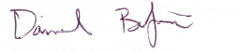
Sincerely,

Daniel Bifani
Contract Management Specialist
Bureau of Fiscal Services
New York State Department of Taxation and Finance
W A Harriman Campus, Building 9, Room 234, Albany NY 12227 www.tax.ny.gov
CONFERENCE INFORMATION
DATES | BLOCK A CONFERENCE BEGIN CONFERENCE END  Tuesday 9/17/2024 Half Day 12:00 PM ET 4:00 PM ET  Wednesday 9/18/2024 Full Day 8:00 AM ET 4:00 PM ET  Thursday 9/19/2024 Half Day 8:00 AM ET 12:30 PM ET  BLOCK B CONFERENCE BEGIN CONFERENCE END  Tuesday 10/08/2024 Half Day 12:00 PM ET 4:00 PM ET  Wednesday 10/09/2024 Full Day 8:00 AM ET 4:00 PM ET  Thursday 10/10/2024 Half Day 8:00 AM ET 12:30 PM ET
CONFERENCE LOCATION | The Conference location must:  - include parking or vouchers for free parking for all Conference attendees  - be located within thirty-five (35) miles of the Department’s Wade Road location in Latham, NY:  299 OLD NISKAYUNA ROAD  LATHAM, NY 12110
NUMBER OF ATTENDEES | Approximately 215-220
NUMBER OF ATTENDEES REQUIRING MEALS  (AND LODGING FOR LOT 2) | BLOCK A AM Break¹ Lunch² PM Break¹ Lodging  Day 1, Tuesday, 9/17/2024 -- -- -- 57  Day 2, Wednesday, 9/18/2024 215 215 215 57  Day 3, Thursday, 9/19/2024 -- -- -- 0  BLOCK B AM Break¹ Lunch² PM Break¹ Lodging  Day 1, Tuesday, 10/08/2024 -- -- -- 57  Day 2, Wednesday, 10/09/2024 215 215 215 57  Day 3, Thursday, 10/10/2024 -- -- -- 0  ¹ The Department requires water and coffee accessible for AM and PM Breaks for all Conference attendees.  ² Kosher, Halal, gluten-free, and vegetarian meal options are required. Please see the attached New York State Department of Taxation and Finance Hotel and Lodging Requirements (Exhibit 1) for further details.  Note: Lodging (if chosen) and meal counts contained in this Request for Quotes are estimated based on expected attendance and subject to change.
CONFERENCE ROOM AND BREAKOUT ROOMS | Conference Room: One (1) conference room to accommodate approximately 220 individuals; preferably set-up classroom style if lunch will not be served in this room or banquet style if lunch will be served in this room.  Breakout Rooms: This Conference will also require three (3) breakout rooms with a minimum capacity of 72 people in each breakout room. The breakout rooms must have tables set-up and be preferably classroom style to accommodate at least 72 people. One (1) of the breakout rooms may be the conference room if the conference room is not also where lunch is being served. All breakout rooms must be separate from each other.  The Department will require access to the conference room, and breakout rooms at least two (2) hours before Day 1 of the Conference to allow for setup and two (2) hours after Day 3 of the Conference to allow for breakdown of equipment.
EQUIPMENT | Conference Room:  - Projector & Screen(s), must be visible to all attendees  - Podium  - Microphone  Breakout Rooms:  - Projector & Screen(s), must be visible to all attendees  - Podium  - Microphone  Conference room and breakout room costs must include any cost for the use of the equipment.
OTHER FACILITY REQUIREMENTS | Wi-Fi capabilities for the presenters in the conference room must be available. The Department will need the capability to connect our NYS-issued laptops.  The Department will conduct a test of the Wi-Fi capabilities prior to the event. The timing of this test will be mutually agreed upon by the Department and the vendor, however, the test must occur within the three (3) to (5) business days prior to the beginning of the Conference.  New York State reserves the right to inspect the site prior to award in order to verify acceptable form, function and utility for the proposed event.
LOT 2:  OVERNIGHT ROOMS | Fifty-seven (57) single rooms will be needed across two (2) nights as follows:  BLOCK A Single Rooms Required³  Day 1, Tuesday, 9/17/2024 57 rooms  Day 2, Wednesday, 9/18/2024 57 rooms  Day 3, Thursday, 9/19/2024 0 rooms  BLOCK B Single Rooms Required³  Day 1, Tuesday, 10/08/2024 57 rooms  Day 2, Wednesday, 10/09/2024 57 rooms  Day 3, Thursday, 10/10/2024 0 rooms  ³ Non-smoking rooms will be required. Please see the attached New York State Department of Taxation and Finance Hotel and Lodging Requirements (Exhibit 1) for further details.
RECEIPT OF QUOTES | Please complete the attached Quote Response Form (Attachment 4) and Procurement Lobbying forms (Attachments 1, 2 and 3) when responding to this request.  Gratuity/Services Charges cannot be listed as separate line items on the bid response form. The prices bid for each item (e.g., lunch, overnight rooms, etc.) must be inclusive of all gratuities and/or services charges.  Prices as they appear on submitted bids must be guaranteed by the vendor for a minimum of 30 days from the deadline for bid submissions.
INVOICING | Invoices and/or Booking Estimates cannot reflect charges in excess of the totals bid on the Quote Response Form unless the additionally incurred costs are mutually agreed upon in writing between the Bidder and an authorized Department representative.  Final invoices may only include charges for services and facilities actually utilized.
CONTRACT CONDITIONS | This Request for Quotes and the resulting Purchase Order, including Appendix A, Standard Clauses for New York State Contracts (dated June 2023) constitutes the entirety of the Agreement.  The Department will not sign any additional agreements for this conference.  In the event the Department terminates the conference in whole or in part, payment will be due for all services provided up to the termination date. The Department will not be subject to any termination or cancellation penalties.
DESIGNATED CONTACTS | The Designated Contacts for the RFQ are:  - Daniel Bifani  - Matthew Brownell  - Yafei Cao  - Amber Alexander
RESPONSE SUBMISSION | Responses to this Request for Quotes # 24-312 should be received by June 28, 2024 by 2:00 PM ET. You may fax your response to 518-435-8413 or email to BFS.Contracts@tax.ny.gov.  If you have any questions, please contact Dan Bifani at 518-530-4484 or email at Daniel.Bifani@tax.ny.gov.

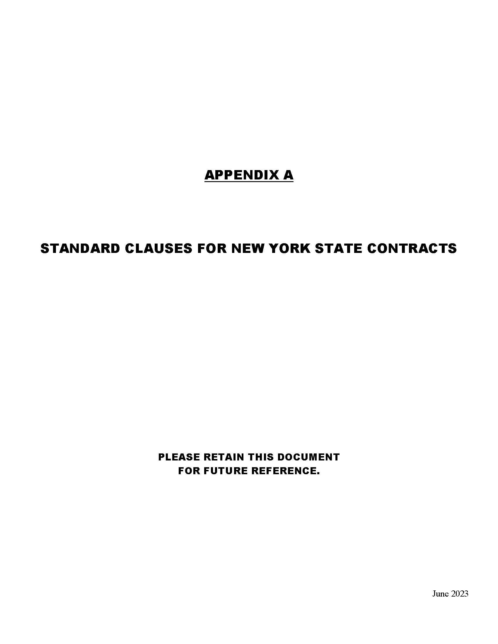
APPENDIX A STANDARD CLAUSES FOR NEW YORK STATE CONTRACTS
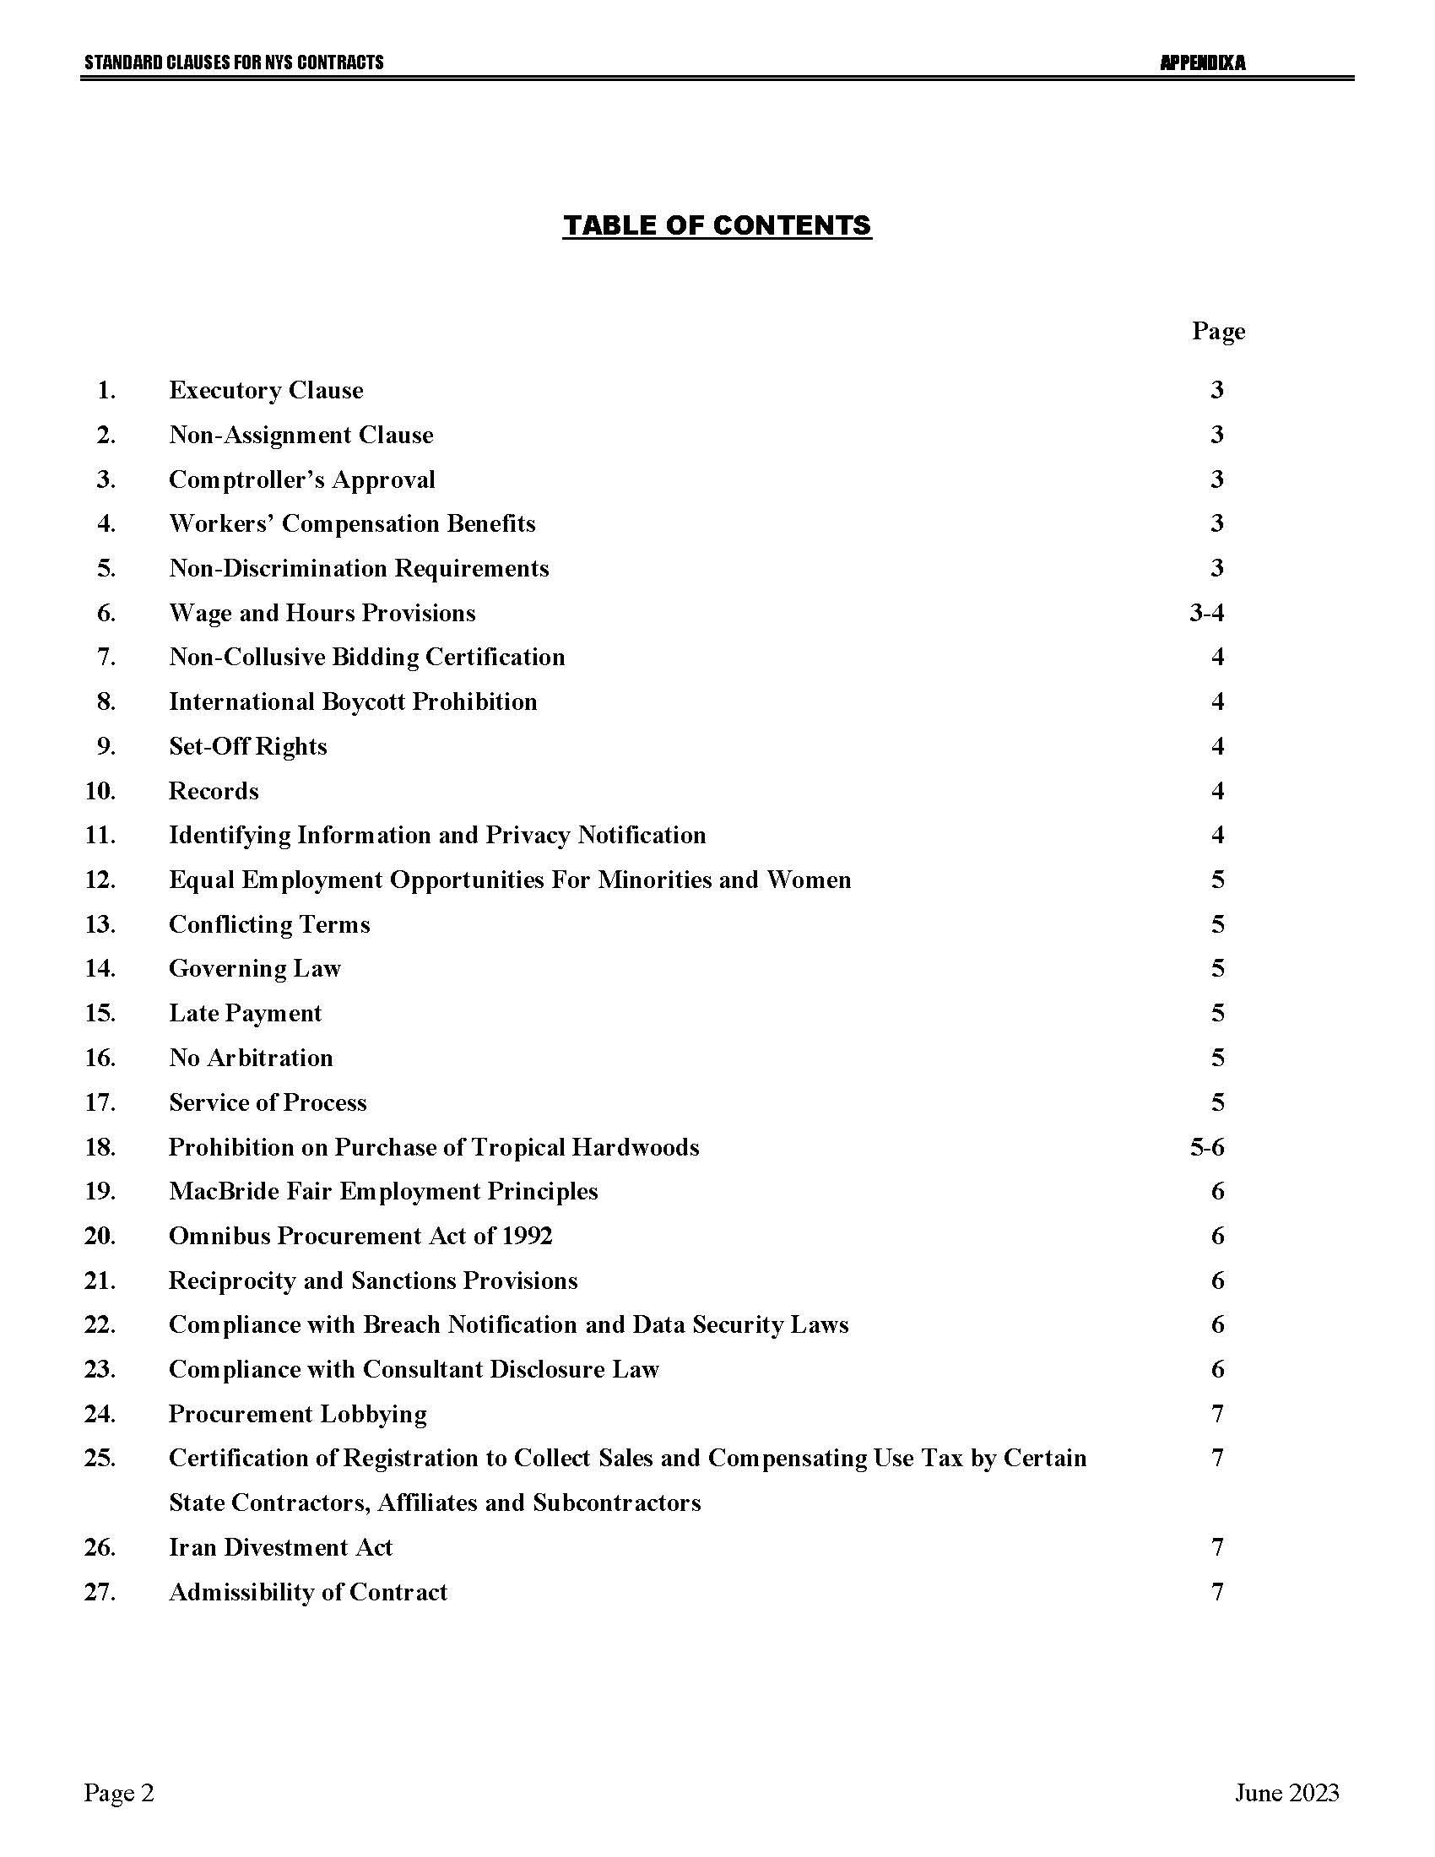
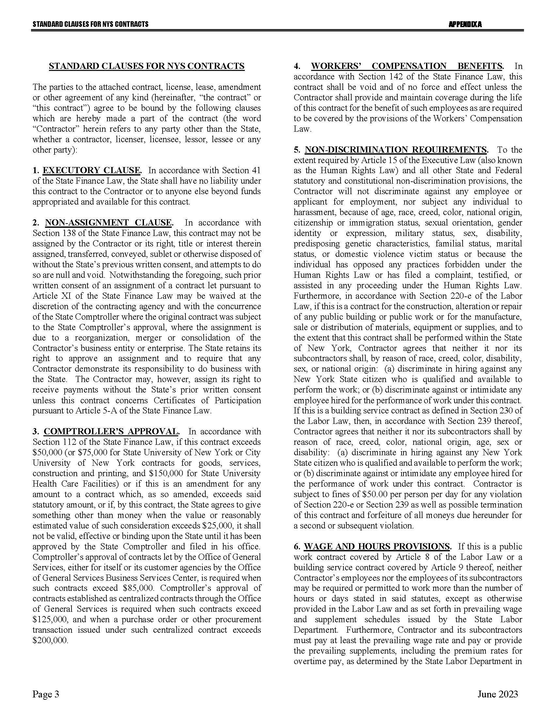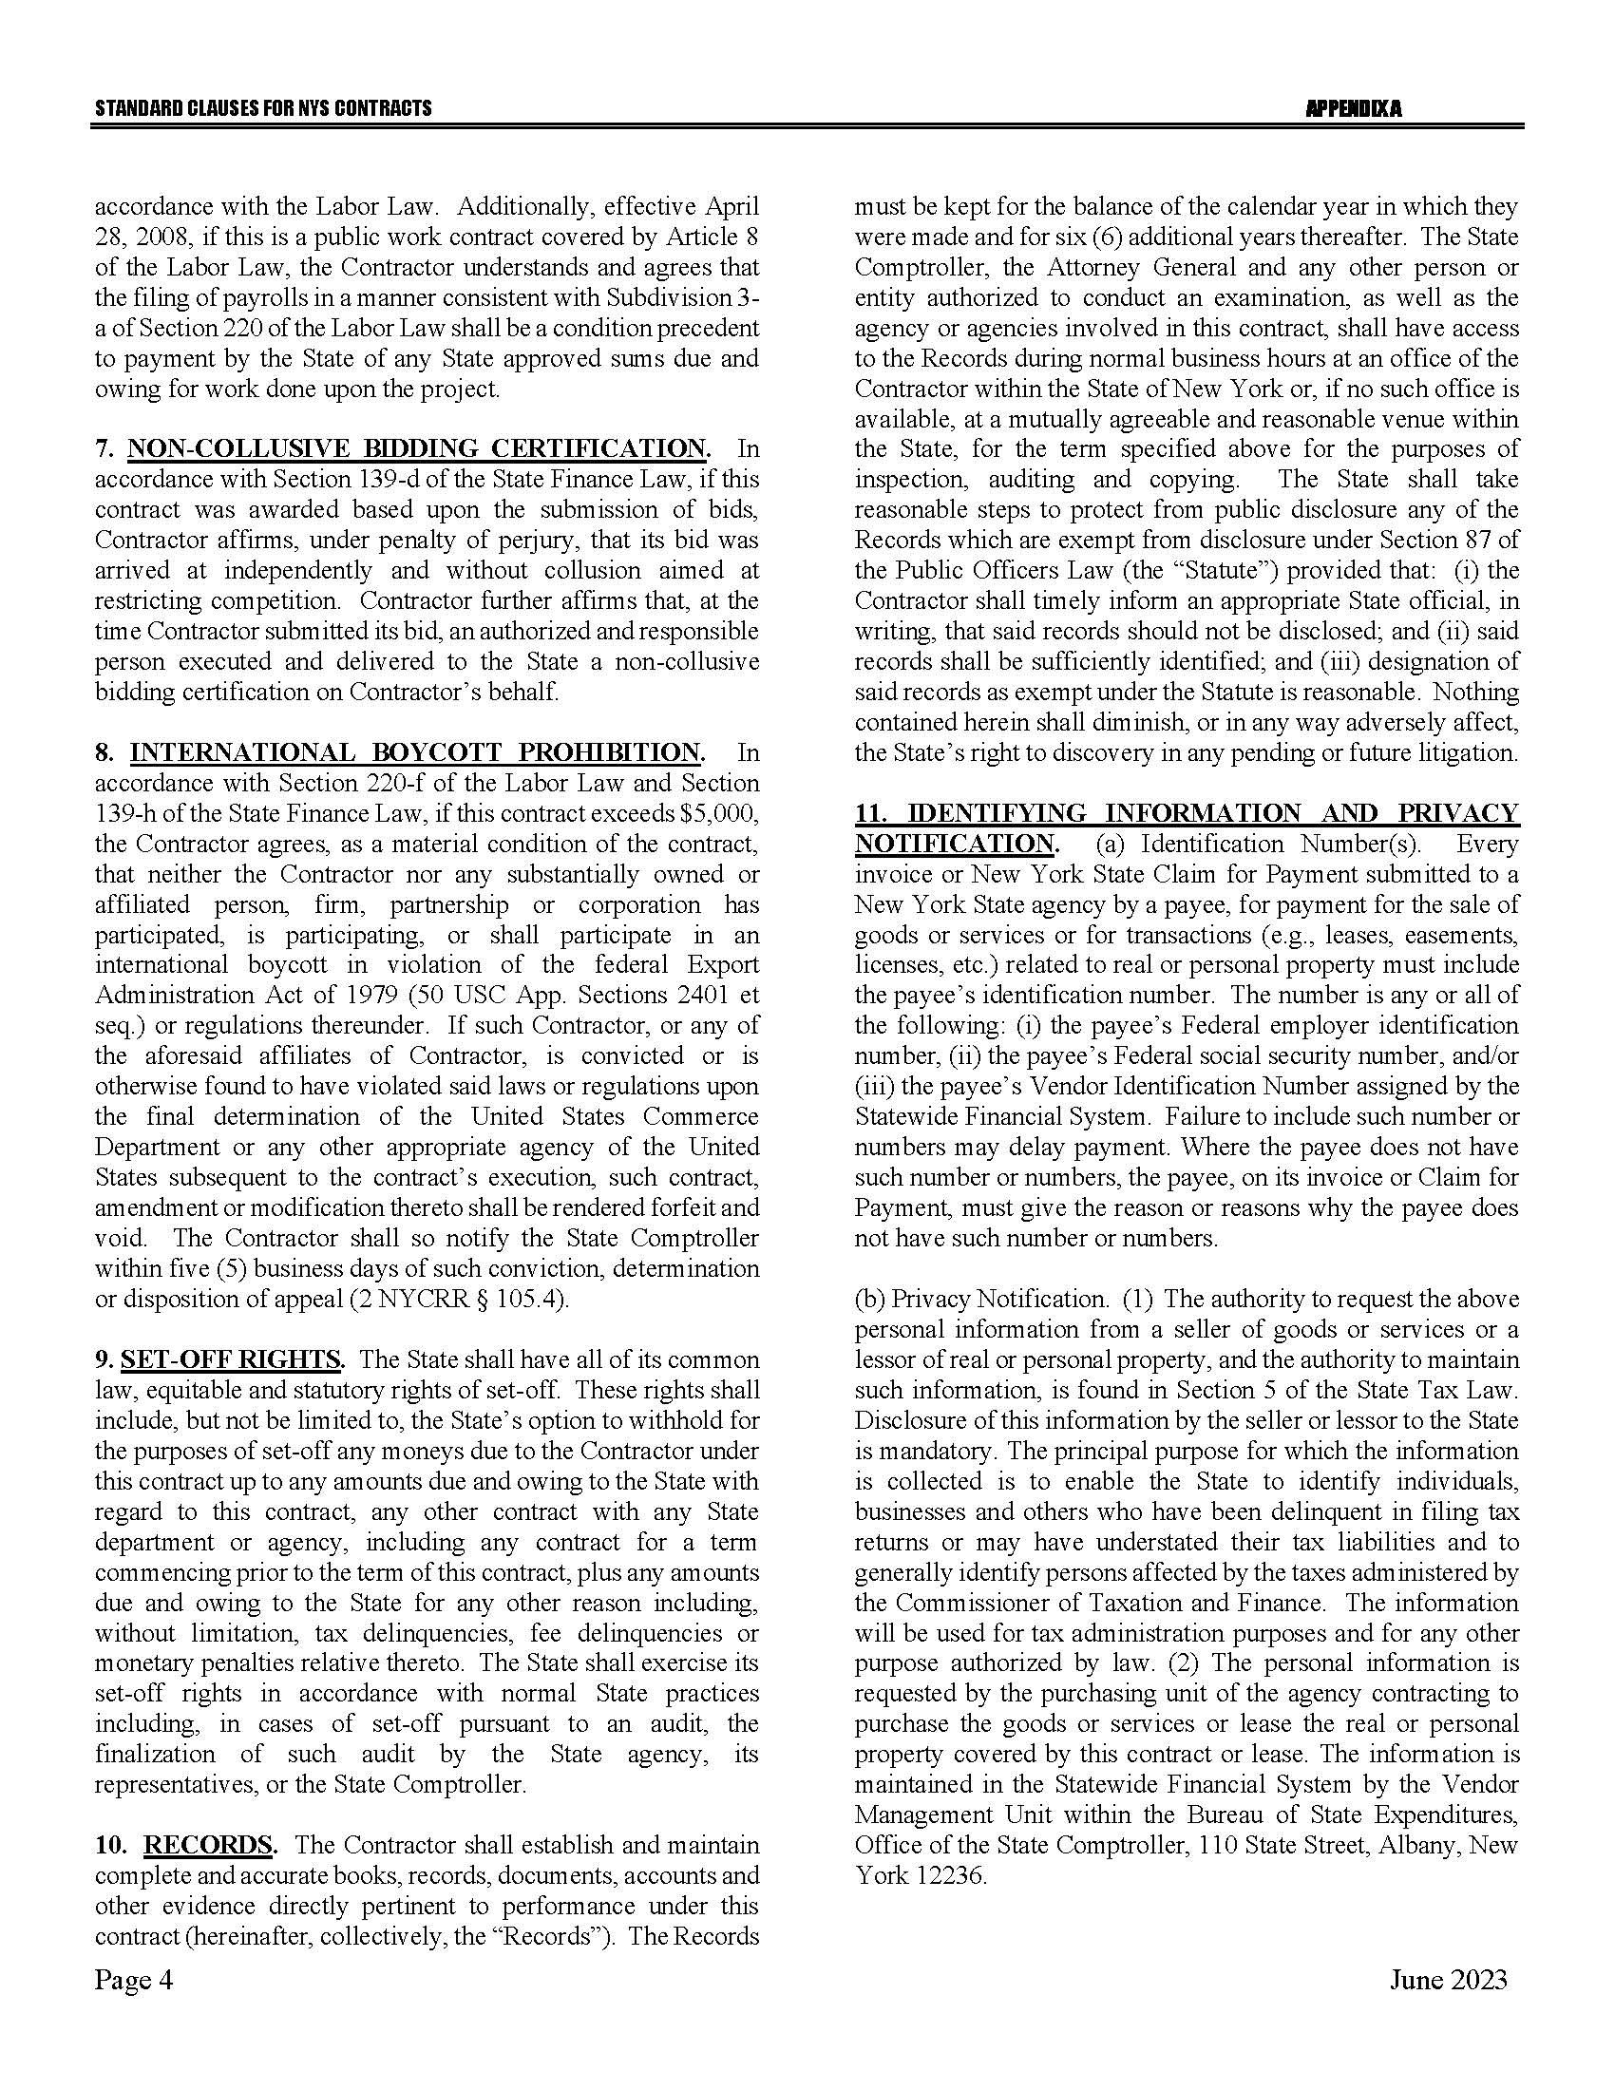
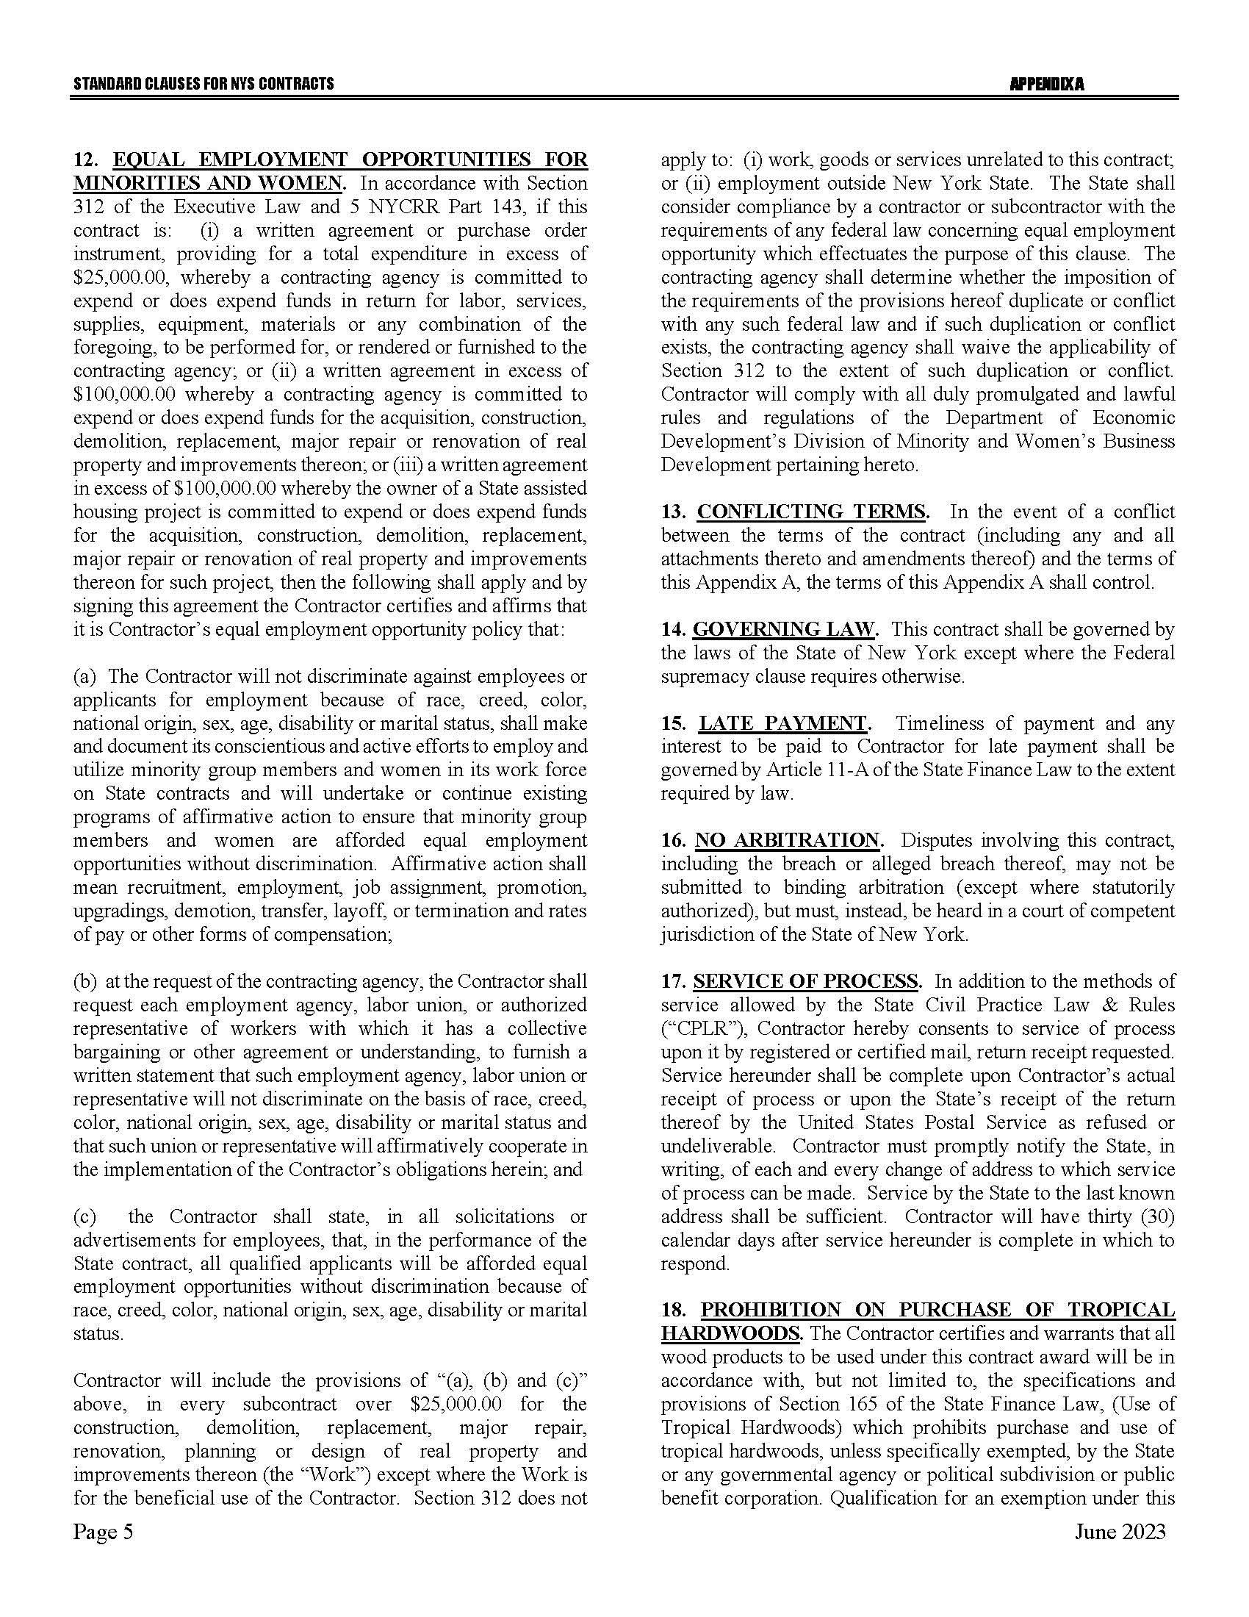
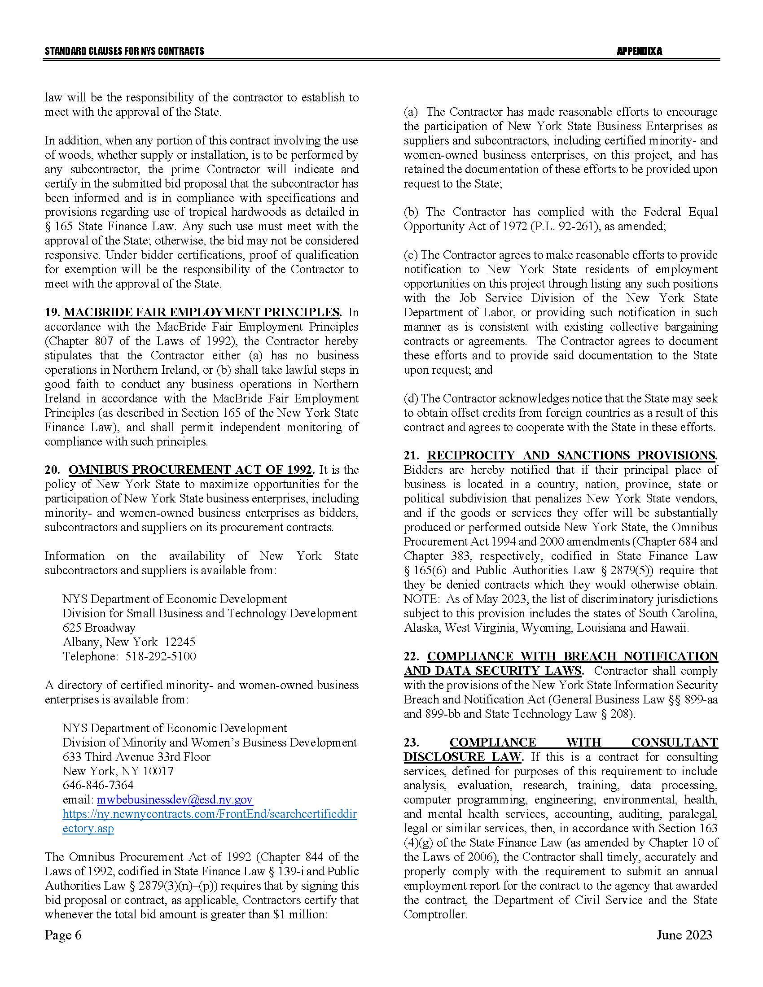
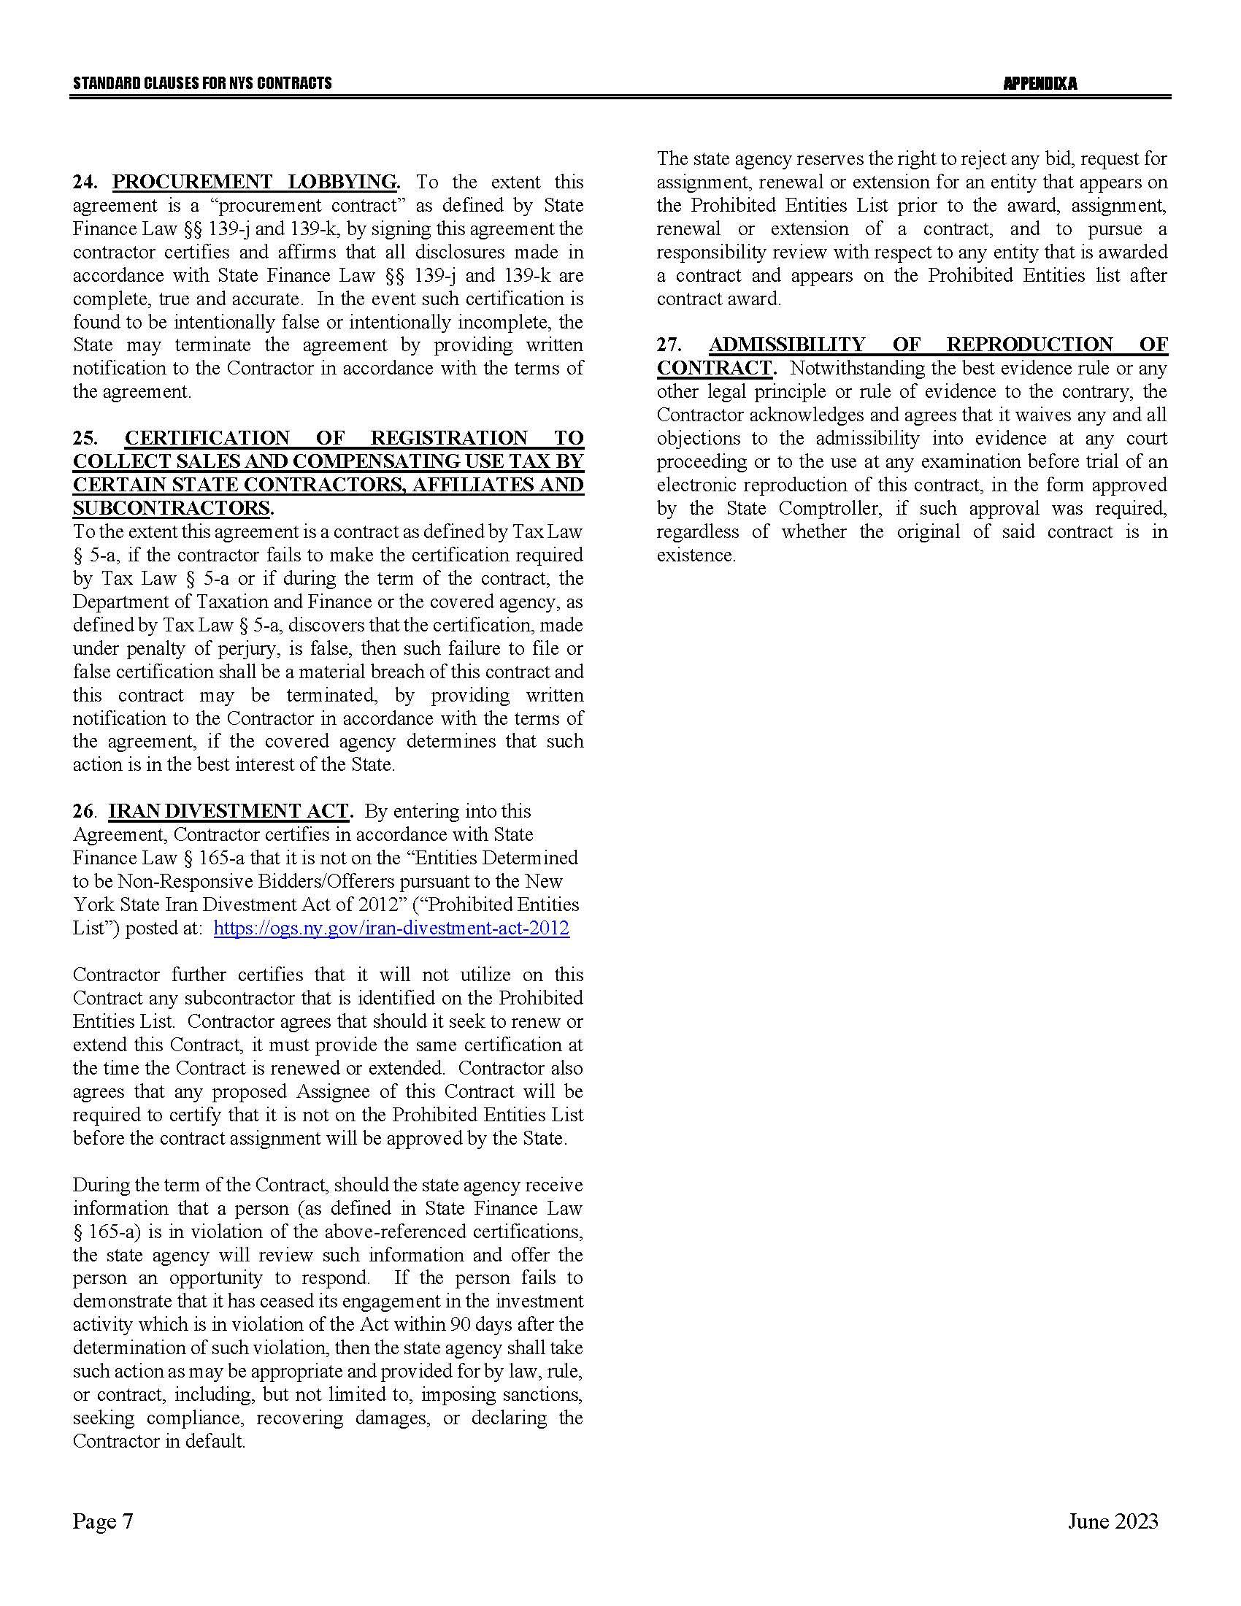

Exhibit 1 – New York State Department of Taxation and Finance
Hotel and Lodging Requirements
- Overnight Lodging Requirements (if applicable):
- Facilities must meet the basic needs of comfort and cleanliness.
- Single occupancy guest rooms are required; each room must be clean and in good repair. Non-smoking rooms are required.
- Each room must have a private bath; a full, queen, or king bed; and adequate towels and supplies.
- Air conditioning, heat, running hot and cold water, color TV, and cable must be fully functional in each guest room.
- Each room must have a direct dial touch tone phone, no service charge for 800 #'s, and modular phone jacks.
- Parking must be on site, and any parking fees must be included in the daily room rate.
- Ideally, costs will be below New York State’s per diem; however, costs at the per diem will be considered.
B. Food Requirements. The Department wants its employees to be provided with choices of healthy food. Entrees are expected to be fresh and not pre-packaged frozen foods (Frozen vegetables are acceptable). It is preferred that lunch is served in a room separate from the meeting rooms and at times to conform to meeting needs. Lunch must be available for at least a one hour timeframe.
Quotes that deviate from this specification will be considered only if the Department determines that the proposed setup does not interfere with or detract from the training sessions being conducted. Such determination shall be made at the sole discretion of the Department.
1. Lunch must be as follows: A sit-down type lunch or buffet style with choice of beverage (should include but not be limited to coffee [regular & decaf], tea [regular & herbal], soda including diet & decaffeinated, and water.
- A soup
- fresh salad with choice of dressings
- 3-4 protein based entrees – must include at least 1 baked or broiled fish and 1 chicken dish (not fried)
- 2 types of grains and/or starches (not including French fries)
- choice of cooked vegetables
2. Specialty meals such as Kosher, Halal, gluten-free, and vegetarian must be available upon request.
C. Gratuity must be included in the price shown on Quote Response form.
D. The Department of Taxation & Finance cannot pay deposit fees or cancellation charges.
E. Save Harmless Clause
The selected vendor agrees and stipulates that it will assume all risks of liability in the performance of services to be provided under this proposal and that it will be solely responsible and liable for damages resulting from all accidents and injuries to person(s) or property. The selected vendor agrees to indemnify, keep and hold harmless the State of New York, its officers and employees for any and all claims for injury or damage to persons or property, arising out of the service to be performed under this proposal, including negligence, active or passive, or wrongful or improper conduct of the selected vendor, its agents or employees.
F. Invariable Provisions
1. The vendor will accept Appendix A (Standard Clauses for NYS Contracts), which will be incorporated as part of the contract without revision.
2. All outstanding tax liabilities, if any, against the vendor in favor of the State of New York must be satisfied prior to contract execution or a payment schedule for their speedy satisfaction.
G. Please use the attached Quote Response Form for your response.

Attachment 1 – Offerer Understanding of, and Compliance with, Procurement Lobbying Guidelines

New York State Finance Law 139-j(6)(b) requires the DTF seek written affirmation from all Offerers as to the Offerer’s understanding of, and agreement to comply with, the DTF procedures relating to permissible contacts during a Government Procurement pursuant to subdivision three of this section.
Procurement Description, Contract or Bid Number: |  | RFQ 24-312, 2nd Annual ORPTS Symposium
Offerer Name:
Offerer Address:
Telephone Number:
Email Address:
Offerer affirms it has read, understands and agrees to comply with the guidelines of the New York State Department of Taxation and Finance relative to permissible contacts as required by the State Finance Law 139-j(3) and 139-j(6)(b).
By (signature):
Name (please print):
Title (please print):
Date:

Attachment 2 – Offerer Disclosure of Prior Non-Responsibility Determinations

New York State Finance Law §139-k(2) obligates a Governmental Entity to obtain specific information regarding prior non-responsibility determinations with respect to State Finance Law §139-j. This information must be collected in addition to the information that is separately obtained pursuant to State Finance Law §163(9). In accordance with State Finance Law §139-k, an Offerer must be asked to disclose whether there has been a finding of non-responsibility made within the previous four years by any Governmental Entity due to: (a) a violation of State Finance Law §139-j or (b) the intentional provision of false or incomplete information to a Governmental Entity. The terms “Offerer” and “Governmental Entity” are defined in State Finance Law § 139-k(1). State Finance Law §139-j sets forth detailed requirements about the restrictions on Contacts during the procurement process. A violation of State Finance Law §139-j includes, but is not limited to, an impermissible Contact during the restricted period (for example, contacting a person or entity other than the designated contact person, when such contact does not fall within one of the exemptions).
As part of its responsibility determination, State Finance Law §139-k(3) mandates consideration of whether an Offerer fails to timely disclose accurate or complete information regarding the above non-responsibility determination. In accordance with law, no Procurement Contract shall be awarded to any Offerer that fails to timely disclose accurate or complete information under this section, unless a finding is made that the award of the Procurement Contract to the Offerer is necessary to protect public property or public health safety, and that the Offerer is the only source capable of supplying the required Article of Procurement within the necessary timeframe. See State Finance Law §§139-j (10)(b) and 139-k(3).
A Governmental Entity must include a disclosure request regarding prior non-responsibility determinations in accordance with State Finance Law §139-k in its solicitation of proposals or bid documents or specifications or contract documents, as applicable, for Procurement Contracts. The attached form is to be completed and submitted by the individual or entity seeking to enter into a Procurement Contract. It shall be submitted to the Governmental Entity conducting the Governmental Procurement.

Offerer Disclosure of Prior Non-Responsibility Determinations
Procurement Description, Contract or Bid Number: |  |  |  |  |  | RFQ 24-312, 2nd Annual ORPTS Symposium
Offerer Name:
Offerer Address:
Phone Number:
Email:
Name and Title of Person Submitting This Form:
- Has any New York State agency or authority made a finding of non-responsibility regarding the Offerer in the last four years?
 | ☐ | No |  |  |  | ☐ |  | Yes
If yes, please answer the following questions:

- Was the basis for the finding of the Offerer’s non-responsibility due to a violation of State Finance Law 139-j?
 | ☐ | No |  |  |  | ☐ |  | Yes
- Was the basis for the finding of the Offerer’s non-responsibility due to the intentional provision of false or incomplete information to a Governmental Entity?
 | ☐ | No |  |  |  | ☐ |  | Yes
- If you responded “Yes” to Questions 1, 2 or 3, please provide details regarding the finding of non-responsibility below:
 | Government Entity:
 | Date of Finding of Non-Responsibility:
Facts Underlying Finding of Non-Responsibility
(Add additional pages as necessary):
- Has any New York State agency or authority terminated a Procurement Contract with the Offerer due to the intentional provision of false or incomplete information?
 | ☐ |  | No |  |  | ☐ | Yes
- If you responded “Yes” to the above question, please provide details regarding the termination below:
 | Government Entity:
 | Date of Finding of Non-Responsibility:
Facts Underlying Finding of Non-Responsibility
(Add additional pages as necessary):

Offerer certifies that all information provided to the DTF with respect to State Finance Law 139-k is complete, true and accurate.

By (signature):
Name (please print):
Date:

Attachment 3 – Offerer’s Certification of Compliance with State Finance Law 139-k (5)

New York State Finance Law 139-k(5) requires that every Procurement Contract award subject to the provisions of State Finance Law 139-k or 139-j shall contain a certification by the Offerer that all information provided to the procuring Government Entity with respect to State Finance Law 139-k is complete, true and accurate.

Offerer Certification
I certify that all information provided to the DTF with respect to State Finance Law 139-k is complete, true and accurate.
By (signature):
Date:

Procurement Description, Contact or Bid Number: |  |  | RFQ 24-312, 2nd Annual ORPTS Symposium
Name (please print):
Title:
Offerer Name:
Offerer Address:
Telephone Number:
Email Address:

Attachment 4 – Quote Response Form
Vendor Name |  |  |  |  |  |  |  |  |  |  | Vendor Phone Number
Email Address |  |  |  |  |  |  |  |  |  |  | FAX #
Street Address of event facility |  |  |  |  |  |  |  |  |  |  | Contact Name/Title
City, State, Zip |  |  |  |  |  |  |  |  |  |  | Federal ID#
1. Identify which timeframe this quote is for
Note: If providing quotes for both timeframes and there is a difference in cost, please duplicate this form and submit separately.
This Quote Response Form is for: |  |  |  |  |  |  |  |  | ☐ Block A: September 17, 2024 to September 19, 2024
 |  |  |  |  |  |  |  |  | ☐ Block B: October 8, 2024 to October 10, 2024
2. Cost of the Conference Room and Breakout Rooms
Note: Conference room and breakout room costs must include any cost for the use of the equipment.
 |  |  | A. Conference Room
 |  |  | Duration: |  |  |  |  | 2 Half Days & 1 Full Day |  |  |  |  | Capacity: |  | 220 |  | Cost: |  |  | $
 |  |  | B. Breakout Room #1
 |  |  | Duration: |  |  |  |  | 2 Half Days & 1 Full Day |  |  |  |  | Capacity: |  | 72 |  | Cost: |  |  | $
 |  |  | C. Breakout Room #2
 |  |  | Duration: |  |  |  |  | 2 Half Days & 1 Full Day |  |  |  |  | Capacity: |  | 72 |  | Cost: |  |  | $
D. Breakout Room #3
The cost for Breakout Room #3 should only be provided if the Conference Room in A above will not be used as Breakout Room #3.
 |  |  | Duration: |  |  |  |  | 2 Half Days & 1 Full Day |  |  |  |  | Capacity: |  | 72 |  | Cost (if applicable): |  |  | $
 |  |  |  |  |  |  |  |  |  |  |  |  |  |  |  |  | OR
 |  |  | The Conference Room will be used as Breakout Room #3 and no additional cost is necessary: |  |  |  |  |  |  |  |  |  |  |  |  |  |  |  |  | ☐
3. Cost for Lunches, AM Break, and PM Break
 |  |  | A. Lunch (Day 2 Only)
 |  |  |  | Quantity: |  |  |  | 215 | Cost Per Attendee: |  |  |  | $ |  |  |  | Total Cost: |  |  | $
 |  |  | B. AM Break (Day 2 Only)
 |  |  |  | Quantity: |  |  |  | 215 | Cost Per Attendee: |  |  |  | $ |  |  |  | Total Cost: |  |  | $
 |  |  | C. PM Break (Day 2 Only)
 |  |  |  | Quantity: |  |  |  | 215 | Cost Per Attendee: |  |  |  | $ |  |  |  | Total Cost: |  |  | $
4. Optional Overnight Hotel Accommodations
Note: If the cost of the conference space and meals is different because of the inclusion of overnight hotel accommodations, Bidders should duplicate this form and submit one form for just conference space and meals and one form for conference space, meals and overnight hotel accommodations.
 |  |  |  | Quantity: |  |  |  | 114 single rooms |  |  |  | Cost Per Room: |  |  | $ |  |  | Total Cost: |  | $
 | BIDDER SIGNATURE: |  |  |  |  |  |  |  |  |  |  |  |  |  |  | DATE:
 | IF NOT BIDDING, PLEASE SELECT ONE OF THE FOLLOWING:
 | ☐ | NO QUOTE AT THIS TIME, BUT RETAIN COMPANY ON LIST.
 |  | REASON FOR NO QUOTE:
 | ☐ | PLEASE REMOVE MY NAME FROM THIS LIST.

